**ORIGIN NAME:** JDBC Multitable Consumer

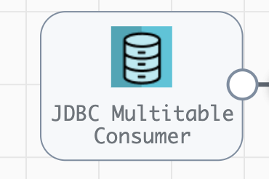

**Engine Type**: Data Collector

**Pipeline Name**: D_JDBC_orgn_Dest_Snglestre_Pipeline_CredStr_URL

**Description**: JDBC Multitable Consumer origin reads data from **products** table in an **ot** database through a JDBC connection string **jdbc:mysql://mysqldb:3306/ot**

We need to configure the JDBC details in a JDBC Multitable Consumer origin with the following steps.

Step 1: Click on **JDBC Multitable Consumer**, then give a valid **JDBC Connection String** on JDBC Tab.

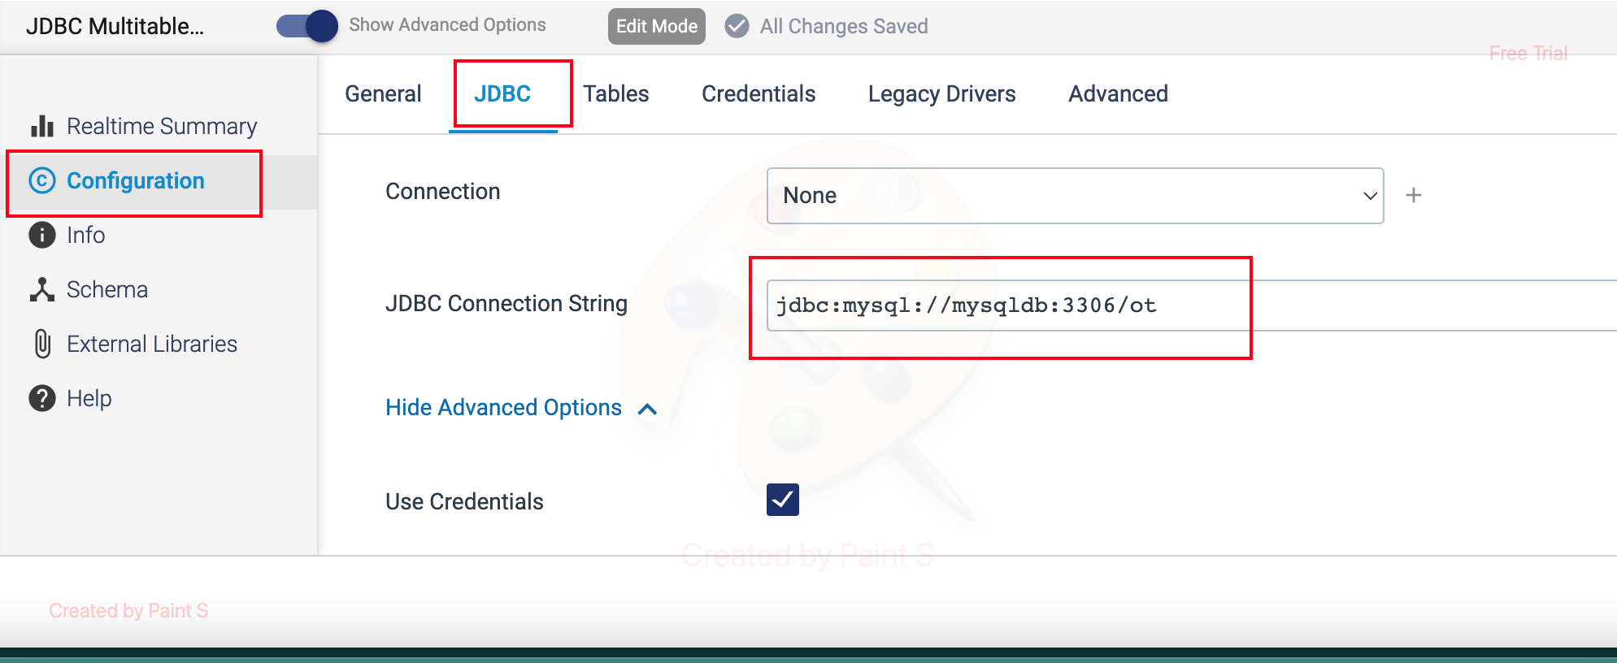

Step 2: Need to give the table name details by clicking **Enable Table Name List** checkbox in **Tables** Tab.

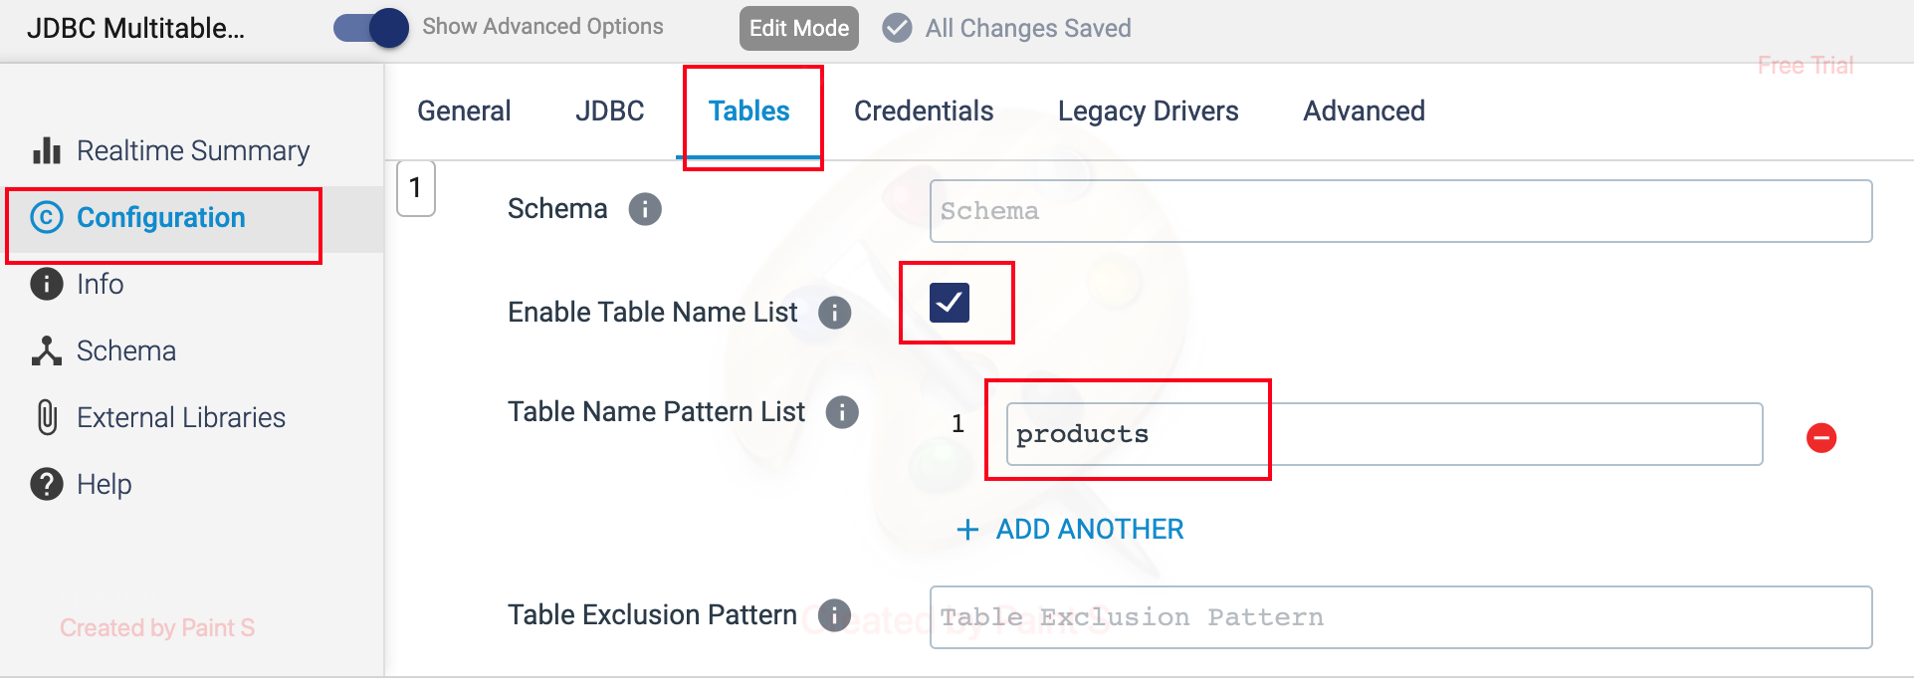

Step 3: Need to give the database credentials in a **Credentials** Tab.

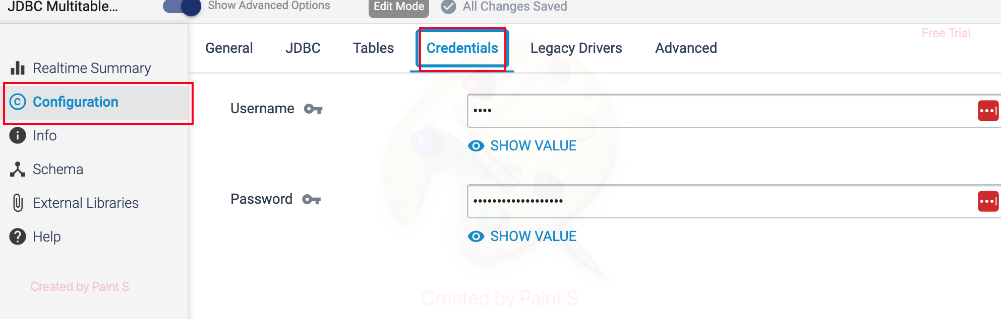

**Another way of creating JDBC Connection:**

We can also use a predefined **JDBC connection** in a pipeline by using following steps.

Step 1: To create a Predefined JDBC Connection. Go to **Setup ->Connections->Create a Connection** or click **+** symbol on right side.

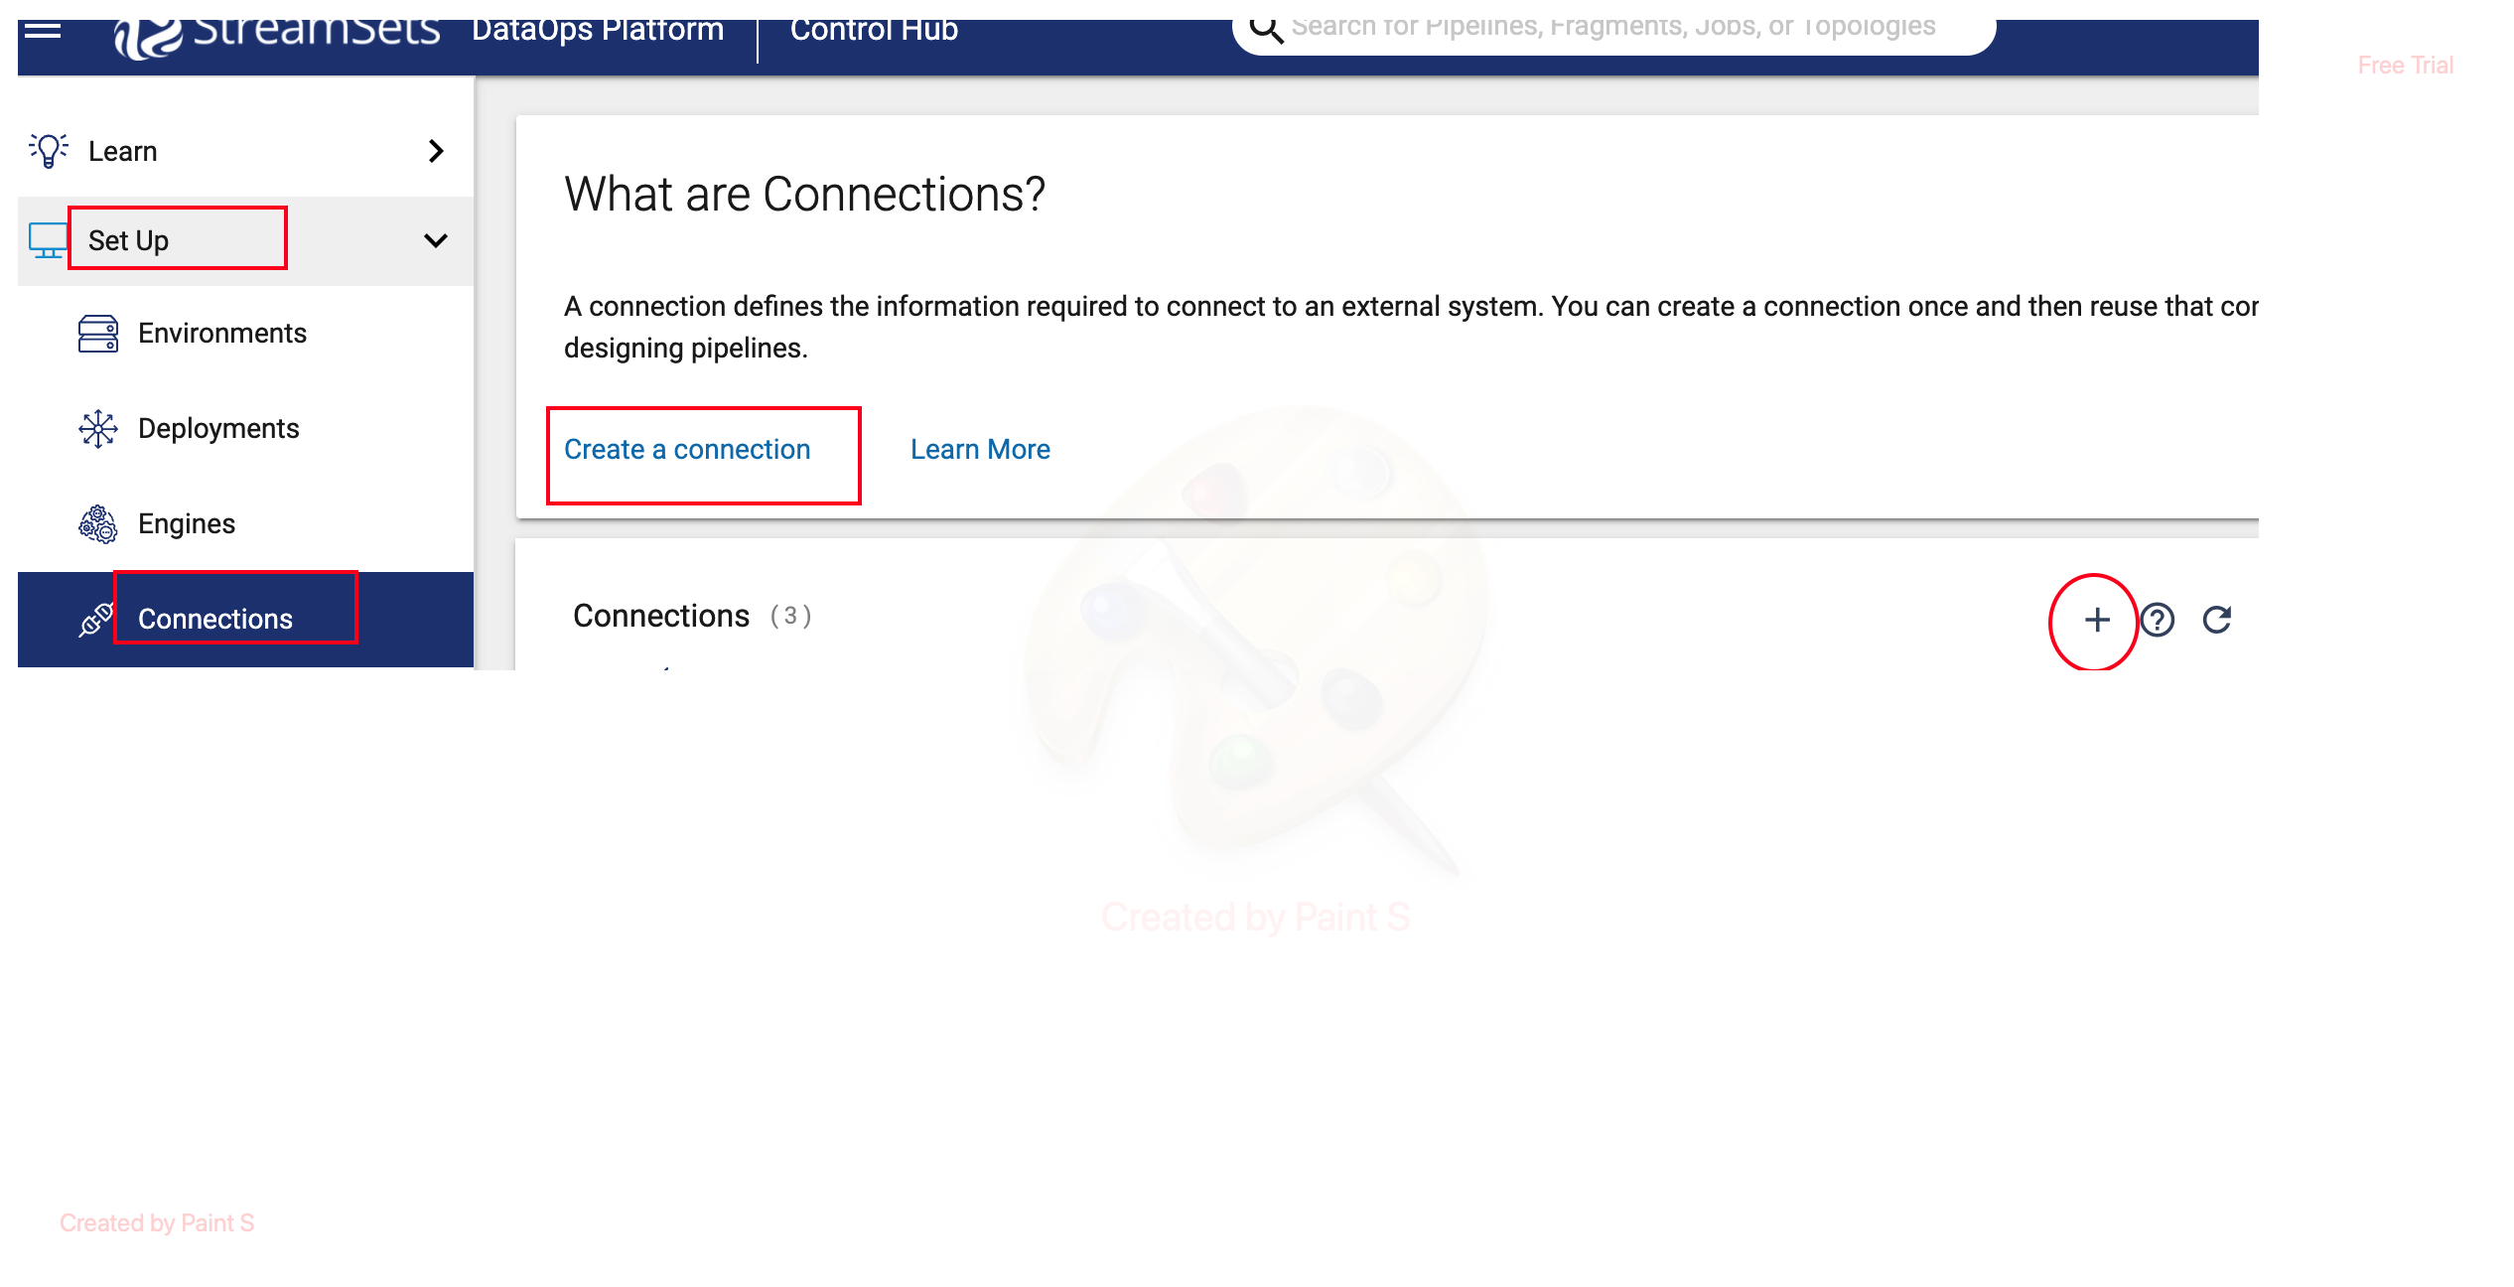

Step 2: Define a **Name** and select appropriate **Data Collector engine** with **Type** as JDBC. Then click **Save&Next**

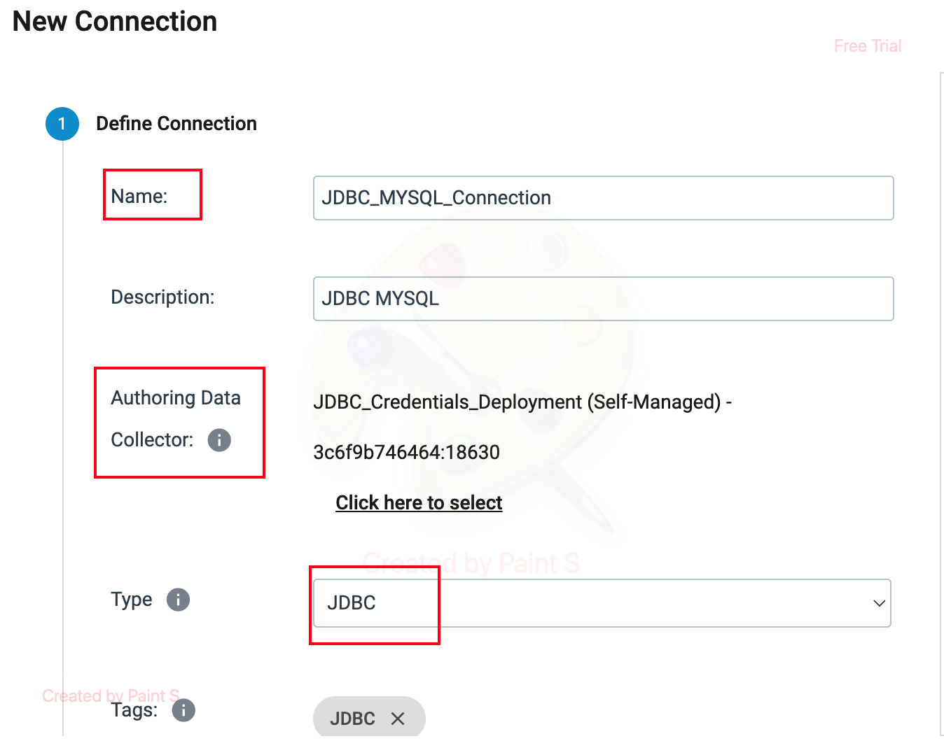

Step 3: To define the **JDBC Connection String.** Click on **JDBC** Tab.

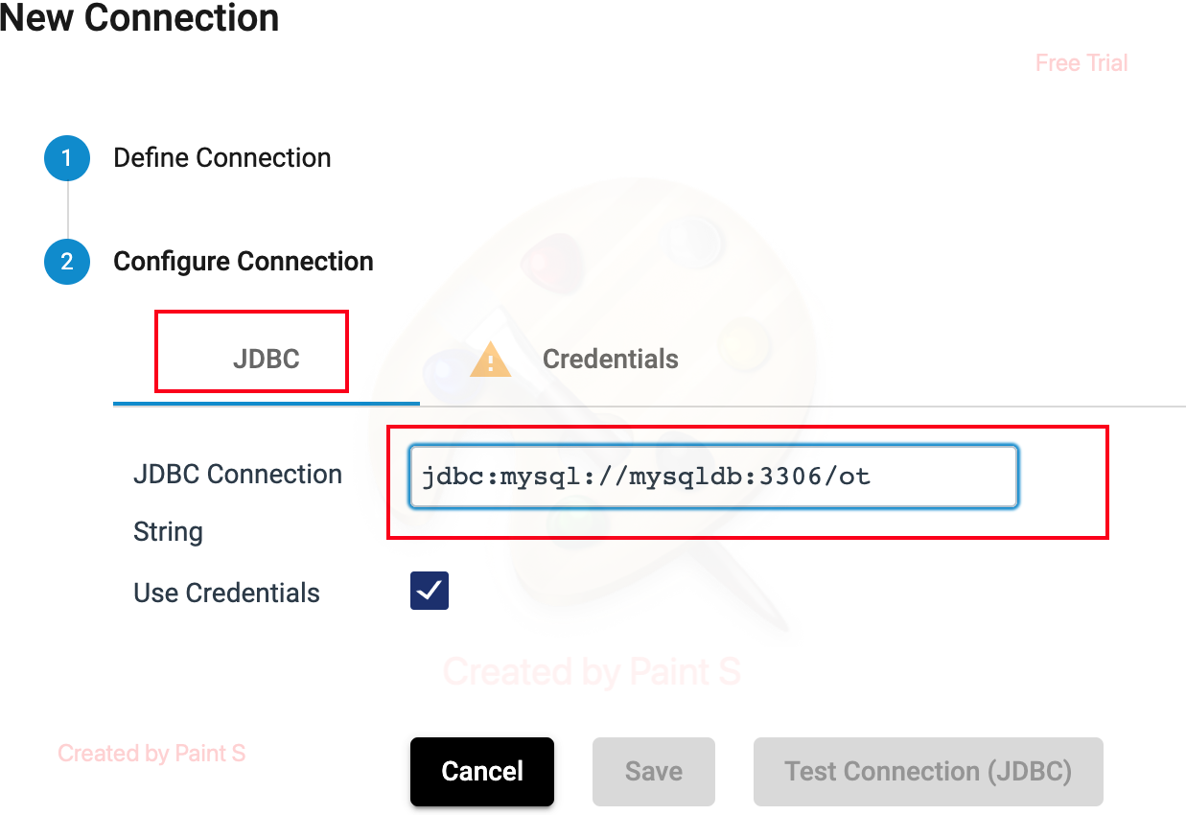

Step 4: Give the Credentials in a **Credentials** Tab and click **Test Connection** button. If connection is successful, then we will get the **green** tick symbol near Configure Connection label. Then click **Save** button to save the connection.

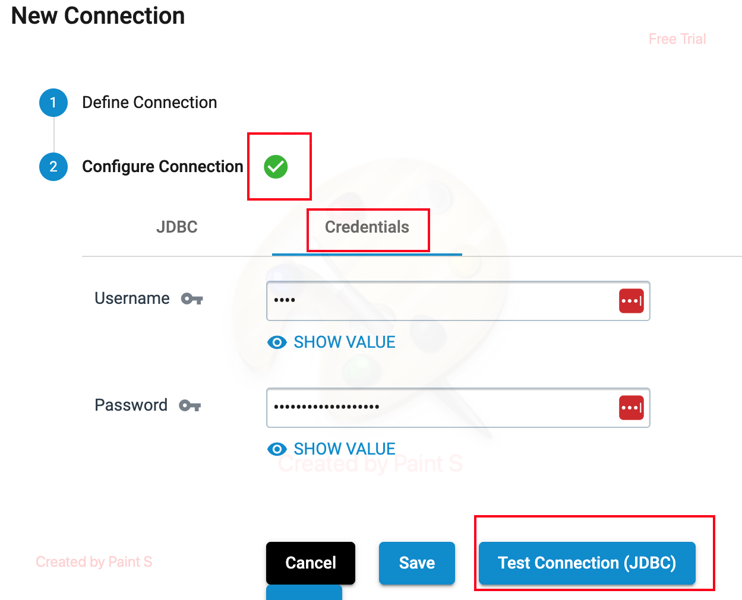

Step 5: To use this above saved or **predefined JDBC connection** in a pipeline. By clicking J**DBC Multitable Consumer**, Select appropriate **connection name** from the dropdown list on a **Connection** label.

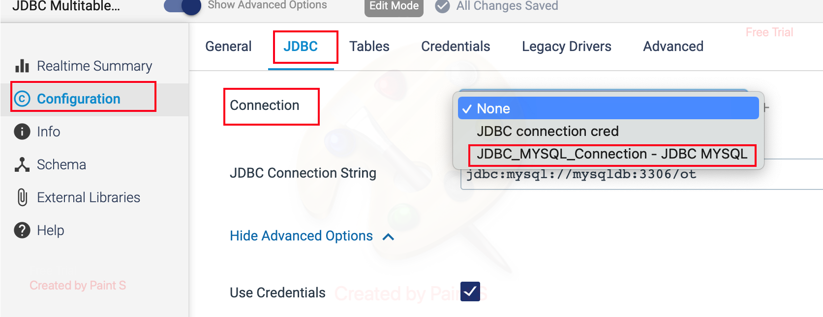

**ORIGIN NAME:** JDBC Query Consumer

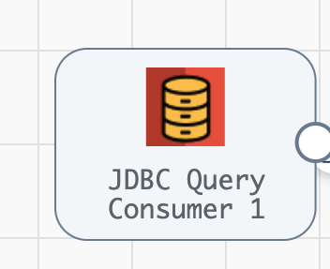

**Engine Type**: Data Collector

**Pipeline Name:** D_JDBC_Origin_AmazonS3_Dest_Pipeline

**Description**: JDBC Query Consumer origin reads data from products table in an ot database using a user-defined SQL query through a JDBC connection.

We are using the following steps to configure the JDBC Query Consumer origin.

Step 1: Click on the JDBC Query Consumer origin, Define the valid **JDBC Connection String** and write a **SQL query** to retrieve the data from the specified source table using **OFFSET** value by specifying the primary key column in an **Offset Column**.

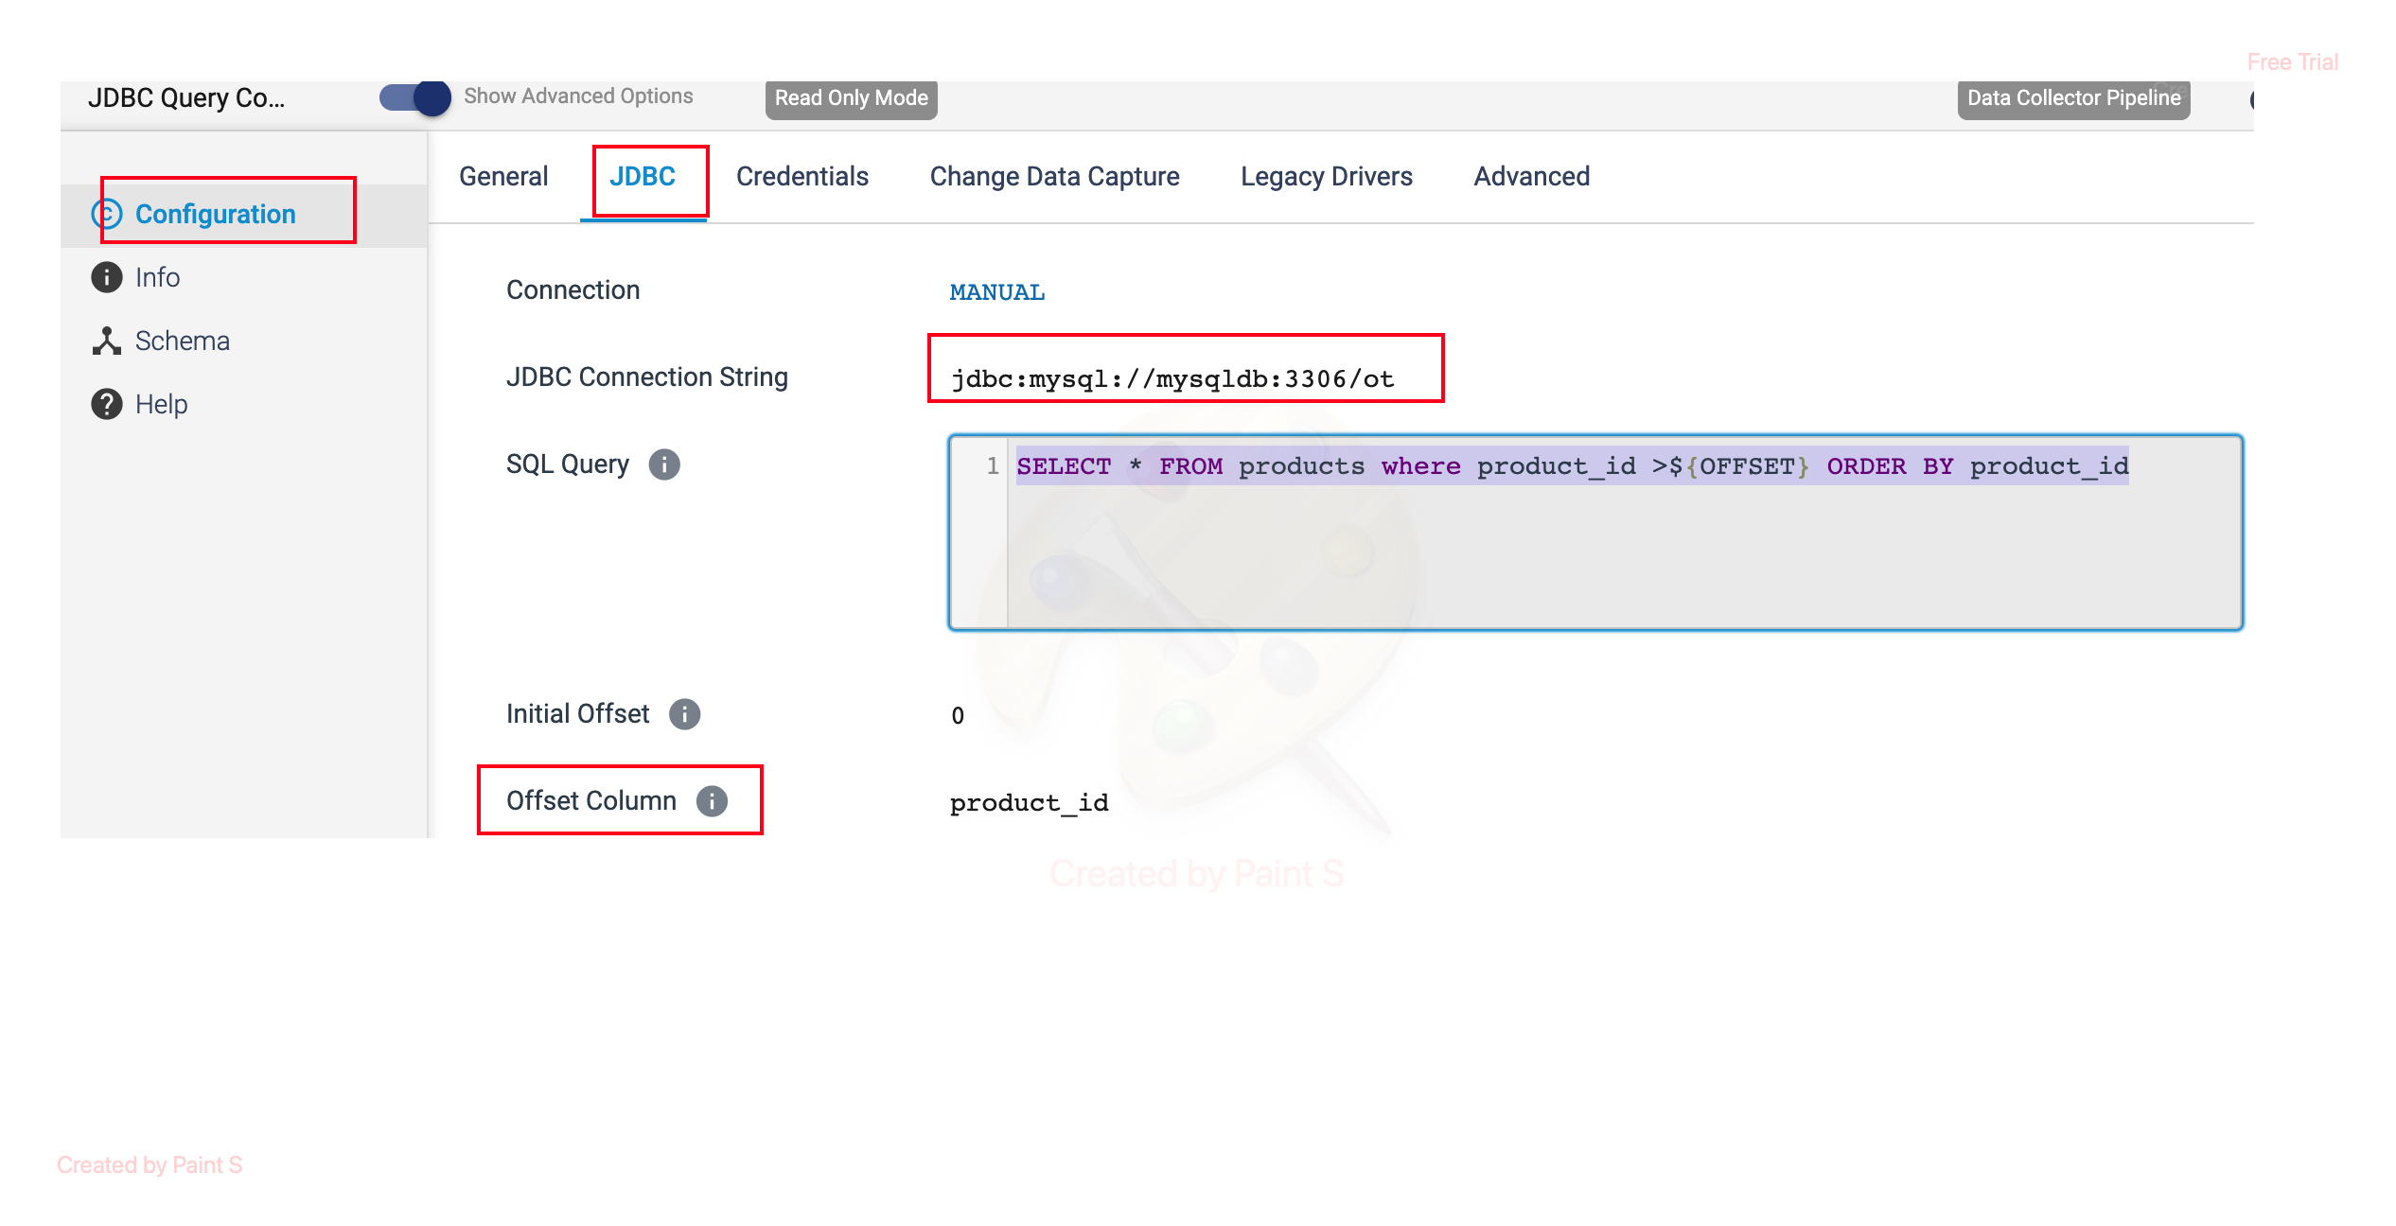

**SQL Query**: SELECT * FROM products where product_id >${OFFSET} ORDER BY product_id

**OFFSET**: It stores the last record value of offset column **product_id** to fetch only new or modified records from products table. It helps in incremental data processing.

**Description**: It retrieves all data from the products table where product_id (primary key column) is greater than the offset value.

**ORDER BY**: It sorts all data with **product_id** in an **ascending order**.

**Offset Column**: Define the primary key column **product_id** which need to store the last record value.

Step 2: Need to give the credentials in the **Credentials** Tab.

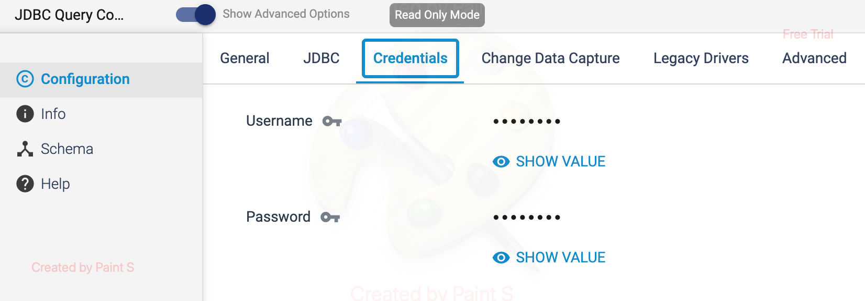

**ORIGIN NAME:** Amazon S3 Origin

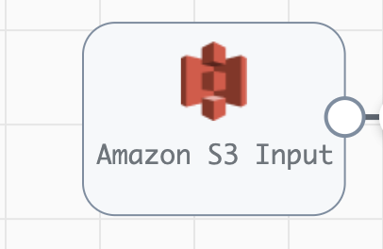

**Engine Type**: Data Collector

**Pipeline Name:** AmazonS3_Origin_Pipeline_Hardcoded

**Description**: S3 origin in StreamSets allows you to extract data from S3 buckets and process it within your data pipelines.

When configuring the **Amazon S3** origin in a pipeline, you need to provide the necessary following AWS credentials (access key and secret key) to authenticate and access your S3 resources.

Step 1: Click the Amazon S3 Origin, then provide the **access key**, **secret key** and **bucket name** in **Amazon S3** Tab. We can also provide the file type in **Prefix Pattern.**

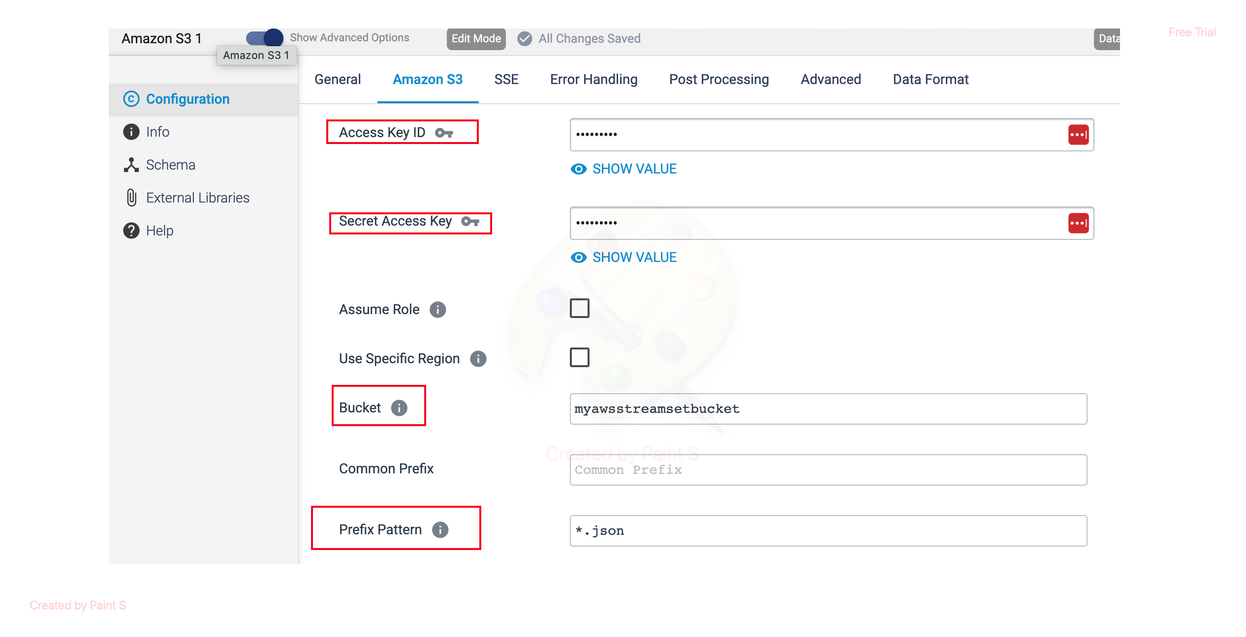

Step 2: To Define the Data Format in **Data Format** Tab.

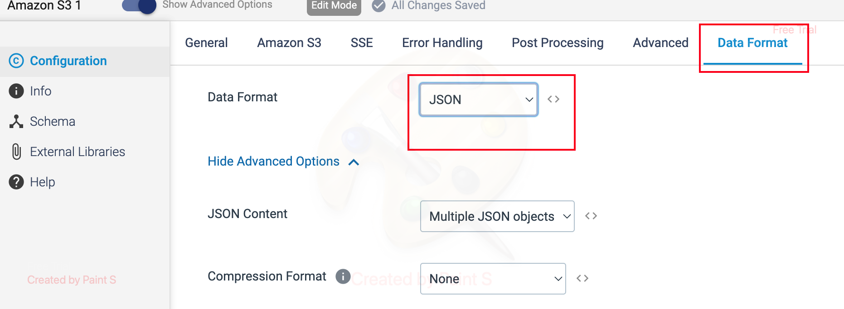

**ORIGIN NAME:** Kafka Multitopic Consumer

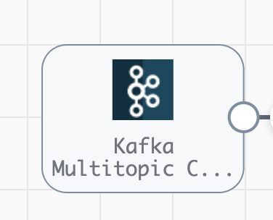

**Engine Type**: Data Collector

**Pipeline Name:** Kafka_API_Usecase_Pipeline

**Description**: The **Kafka Multitopic Consumer** origin reads data from multiple topics in an Apache Kafka cluster.

We need to configure the **Kafka Multitopic Consumer** Origin using following steps.

Step 1: Click **Kafka Multitopic Consumer** Origin, then specify the Kafka **Broker URI**, **Consumer Group** Name and Name of **Topic List** in Connection Tab.

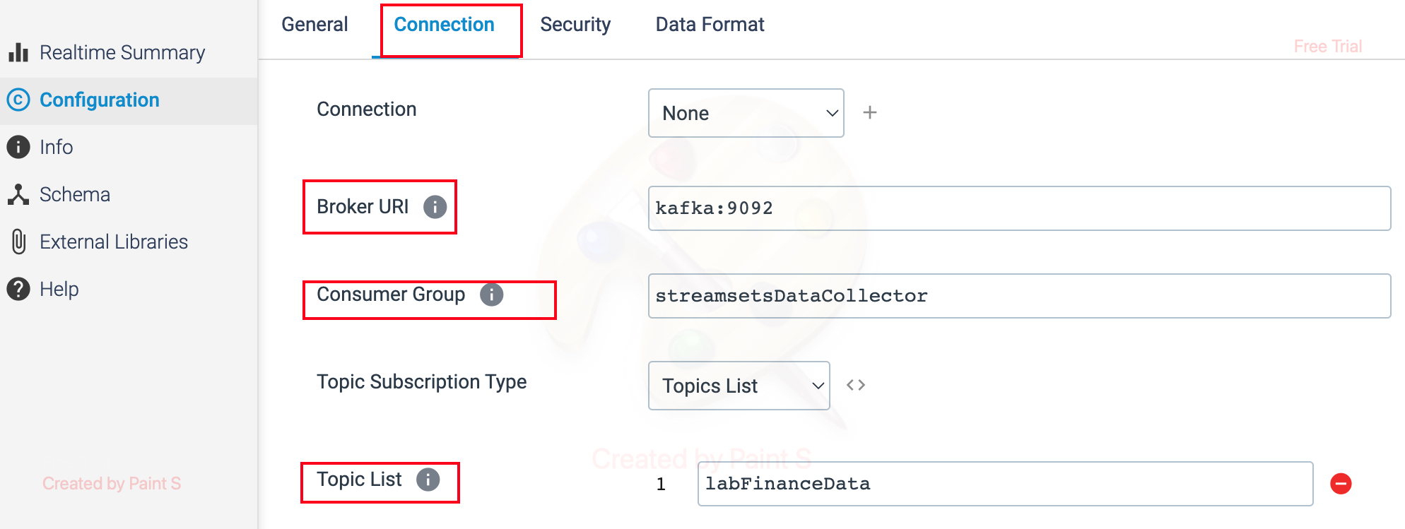

Step 2: To define the Data Format in **Data Format** Tab.

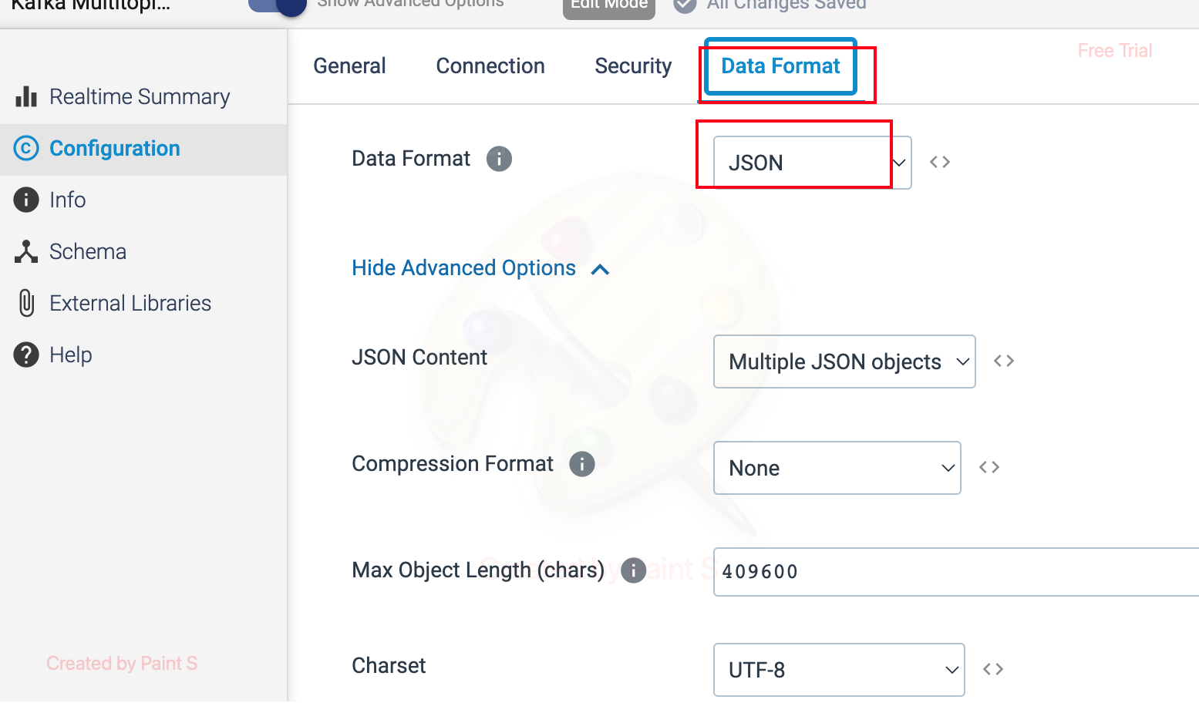

**Another method of configuring Kafka Connection**

Likewise, above JDBC Predefined Connection, we can also create a predefined Kafka Connection in a following same way.

Step 1: To create a predefine Kafka Connection, Go to Setup->Connections->Create a connection or click + symbol.



Step 2: Give the **Name** for Kafka connection and Select the Type as **Kafka.** Also make sure to select the authoring **Data Collector** engine. Then, Click Save&Next

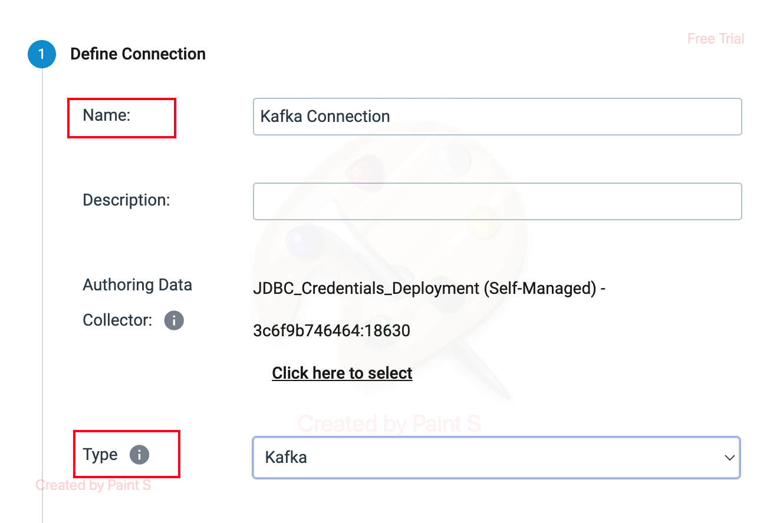

Step 3: Click on the **Kafka** Tab to define the **Broker URI**. Then click the **Test Connection** button. If connection is successful, **green** tick will appear near **Configure Connection** label. Then click **Save** button to save the Kafka Connection.

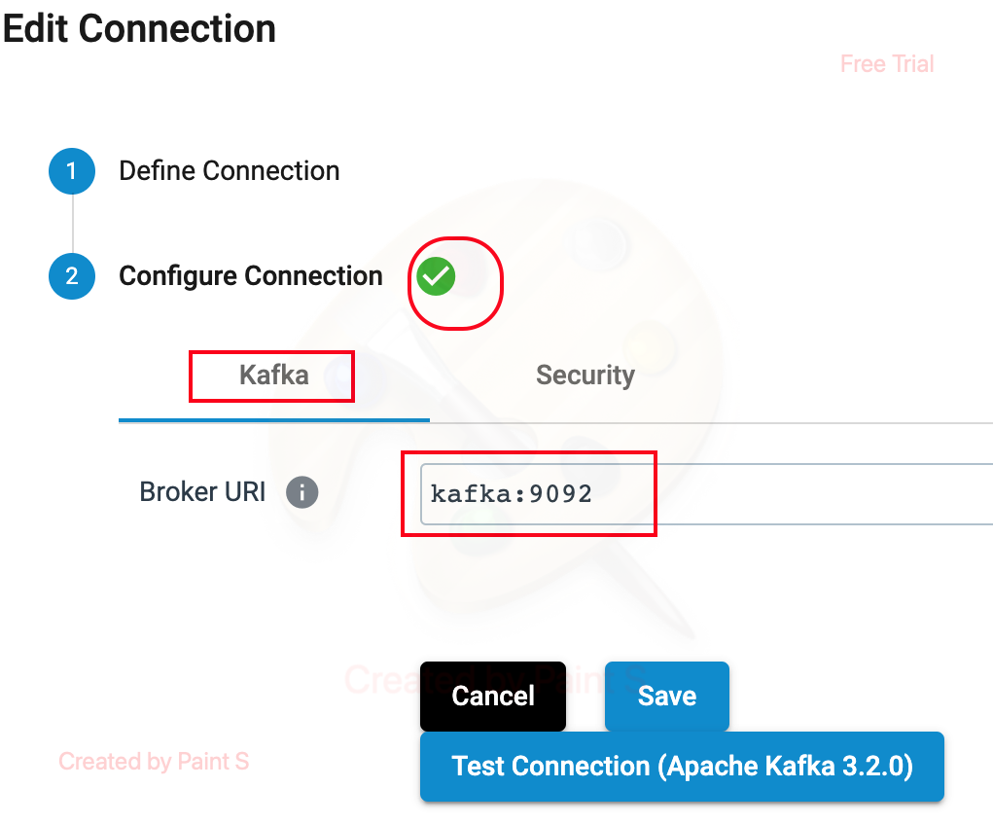

Step 4: To use the configured Kafka Connection in a pipeline, Click the **Kafka Multitopic Consumer** Origin. Select the configured Kafka Connection name as **Kafka Connection** from the dropdown list box in **Connection**.

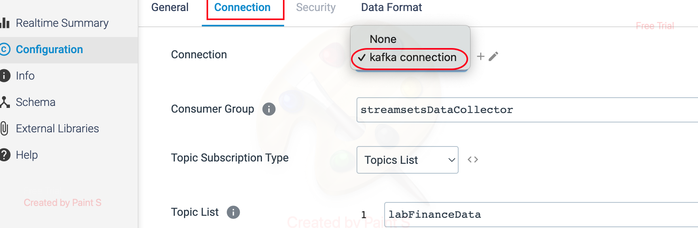

**ORIGIN NAME:** Amazon SQS Consumer

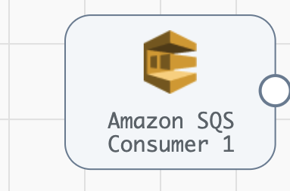

**Engine Type**: Data Collector

**Pipeline Name:** D_AmazonSQS_Origin_JDBC_Dest_Pipeline_CredStr

**Description**: The **Amazon SQS Consumer** in StreamSets Data Collector is used to consume messages from an **Amazon Simple Queue Service** (SQS) queue.

We need to configure the **Amazon SQS Consumer** origin using following steps.

Step 1: Click on the Amazon SQS origin, provide the details such as access key ID, Secret access key and Region, if **Authentication Method** is selected as **AWS Keys** else provide the required credentials based on the respective Authentication Method. Then specify the **queue name** on the **Queue Name Prefixes**.

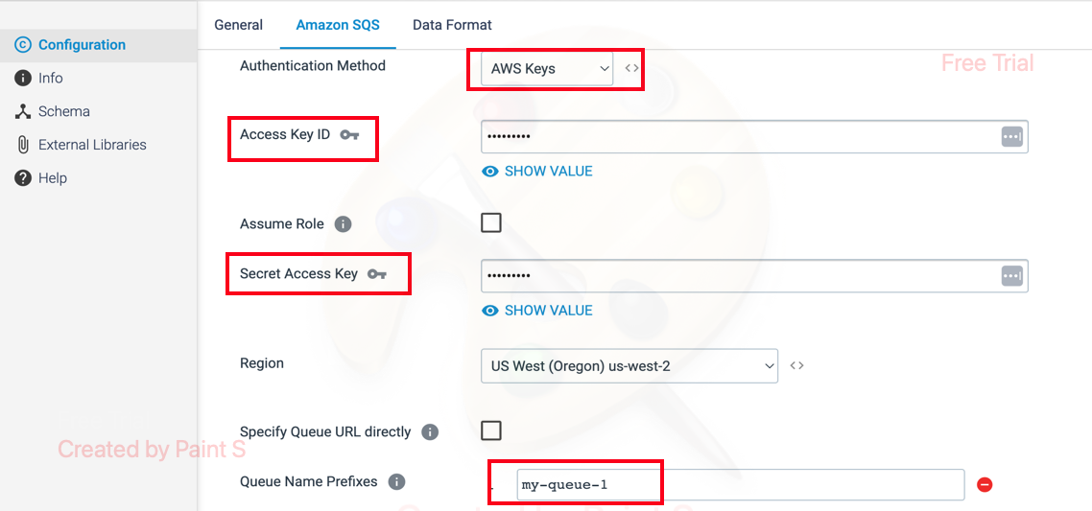

Step 2: To define the Data Format in the Data Format Tab.

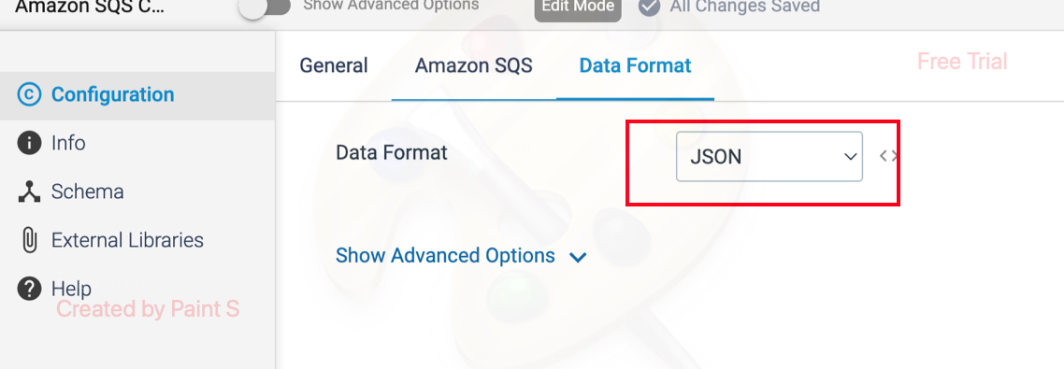

**ORIGIN NAME:** Aurora PostgreSQL CDC Client

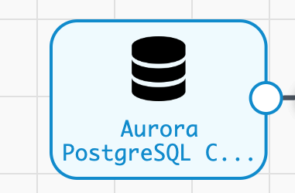

**Engine Type**: Data Collector

**Pipeline Name:** D_Postgrs_Orgn_Azre_LkeGen2_Dest_Pipelne_CredStr

**Description**: The **Aurora PostgreSQL CDC** (Change Data Capture) **Client** in StreamSets Data Collector is used to capture and process changes from an **Aurora PostgreSQL** database. It allows you to track inserts, updates, and deletes happening in the database tables in near real-time.

We need to configure the Aurora PostgreSQL CDC Client in a following way.

Step 1: Click on the **Aurora PostgreSQL CDC Client** origin, specify the **schema name** and **table name**. Then, select the operations to capture the changes in records such as **insert, update and delete**.

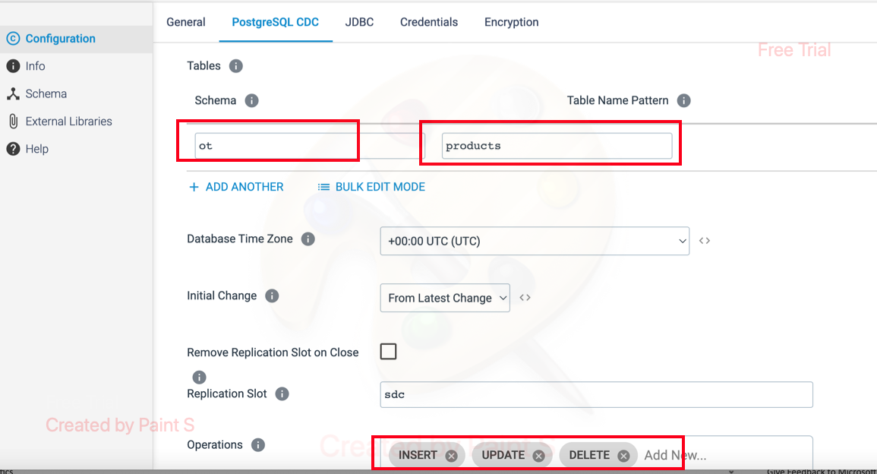

Step 2: Click on the JDBC tab and provide the JDBC Connection String details.

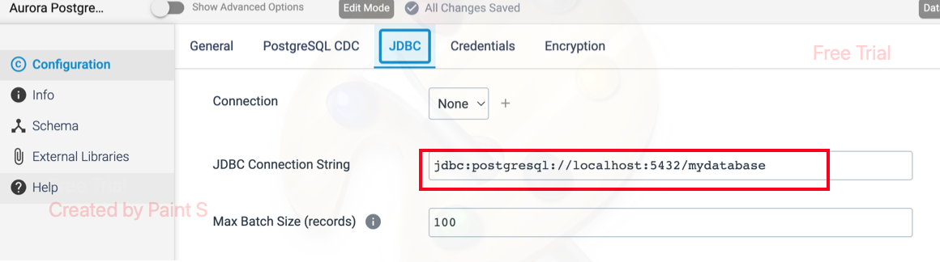

Step 3: Click on the Credentials tab, give the required credentials.

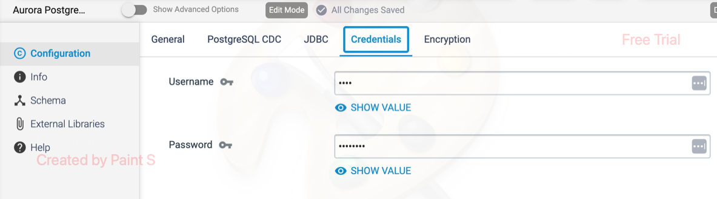

**Another way of creating JDBC Connection:**

We can also use a predefined **JDBC connection** in a pipeline by using following steps.

Step 1: To create a Predefined JDBC Connection. Go to **Setup ->Connections->Create a Connection** or click **+** symbol on right side.



Step 2: Define a **Name** and select appropriate **Data Collector engine** with **Type** as JDBC. Then click **Save&Next**



Step 3: To define the **JDBC Connection String.** Click on **JDBC** Tab.



Step 4: Give the Credentials in a **Credentials** Tab and click **Test Connection** button. If connection is successful, then we will get the **green** tick symbol near Configure Connection label. Then click **Save** button to save the connection.



Step 5: The above predefined JDBC connection can be used in a pipeline. We can select appropriate JDBC connection name for PostgreSQL.



**ORIGIN NAME:**  Azure Blob Storage

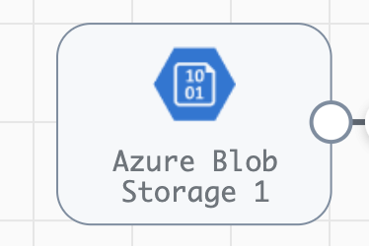

**Engine Type**: Data Collector

**Pipeline Name:** D_Azure_Blob_Orgn_AzureSQL_Dest_Pipeline_Cred

**Description**: The **Azure Blob Storage** origin reads data from Microsoft Azure Blob Storage.

We need to configure the **Azure Blob Storage** origin in a following way.

Step 1: Click on the **Azure Blob Storage** origin, then specify the required details and credentials like below.

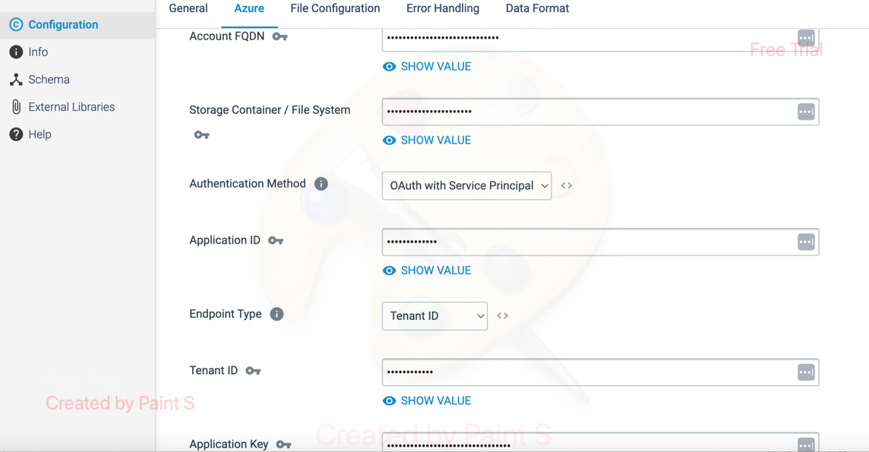

Step 2: Click on the **File Configuration** tab to specify the required file path details.

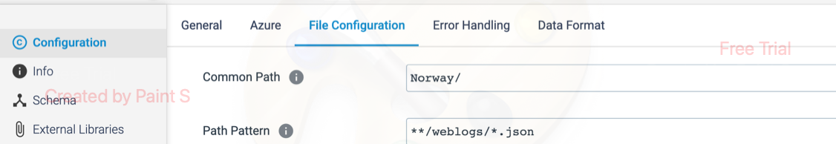

Step 3: Click on the **Data Format** to define the data format for the output.

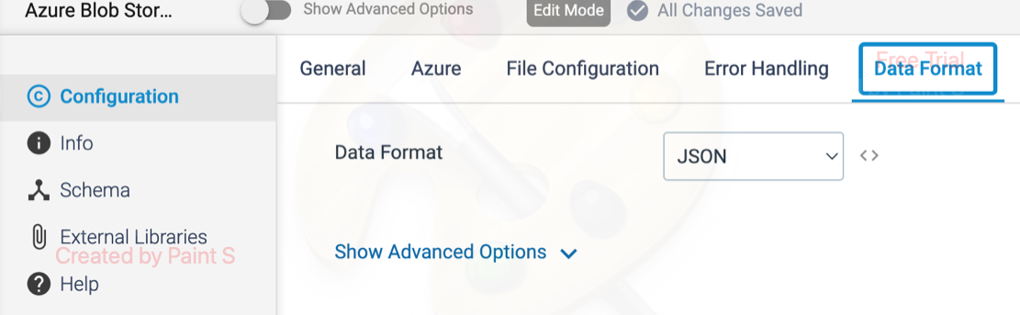

**ORIGIN NAME:** Azure Data Lake Storage Gen2 (Legacy)

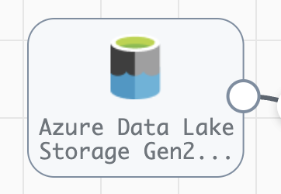

**Engine Type**: Data Collector

**Pipeline Name:** D_azre_DataLakeGen2_orgn_Dest_Pipeline_Cred

**Description**: The **Azure Data Lake Storage Gen2 (Legacy)** origin reads data from Microsoft Azure Data Lake Storage Gen2.

We need to configure the **Azure Data Lake Storage Gen2 (Legacy)** origin in a following way.

Step 1: Click on the **Azure Data Lake Storage Gen2(Legacy)** origin to provide the below required details.

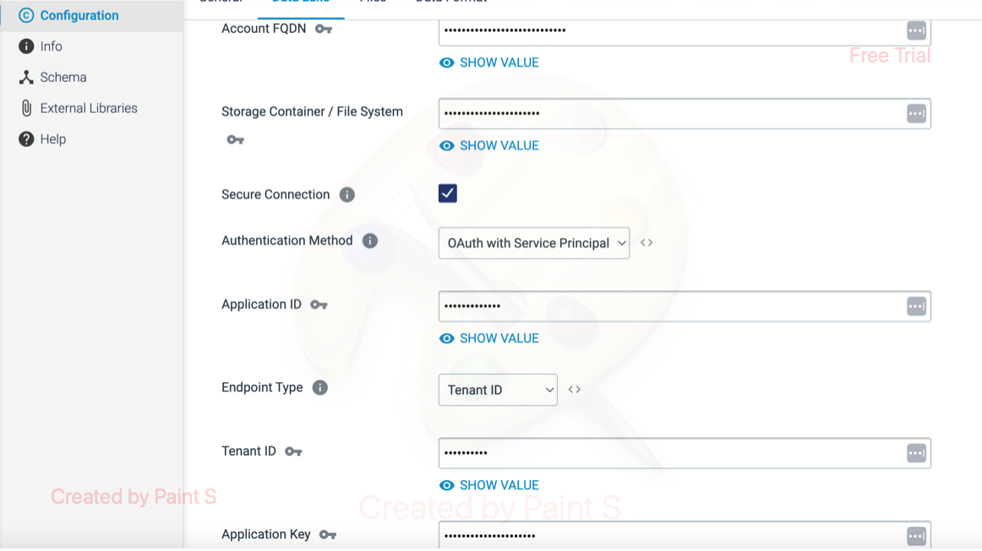

Step 2: Click on the **File Configuration** tab to provide the file path details.

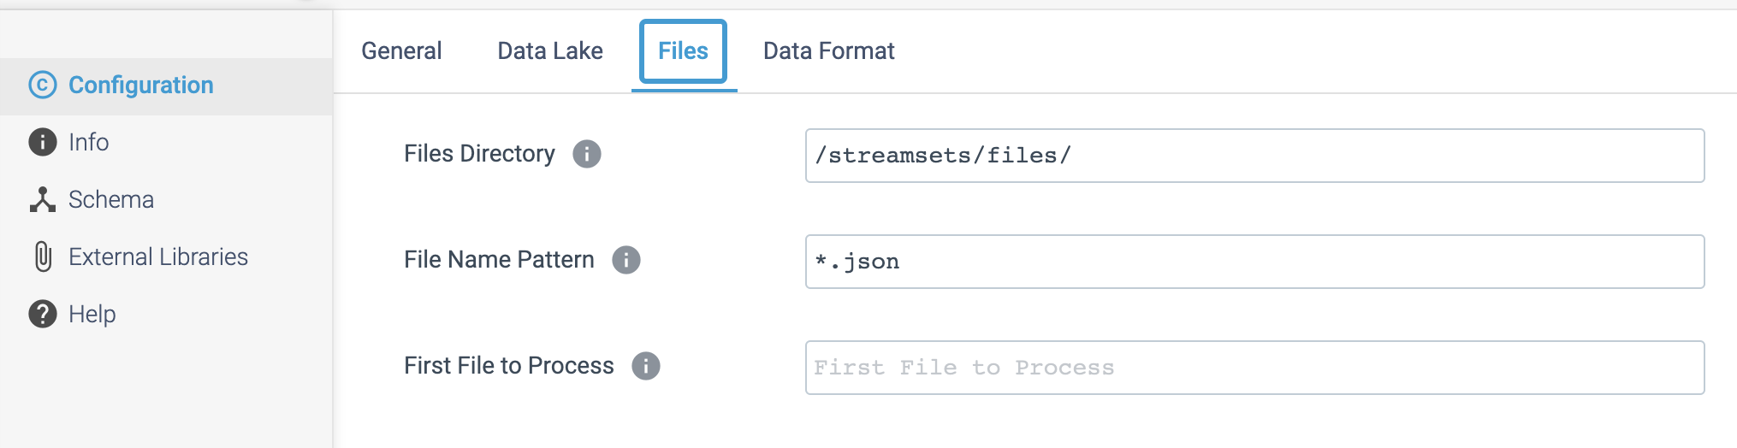

Step 3: To define the Data Format of output, Click **Data Format** tab.

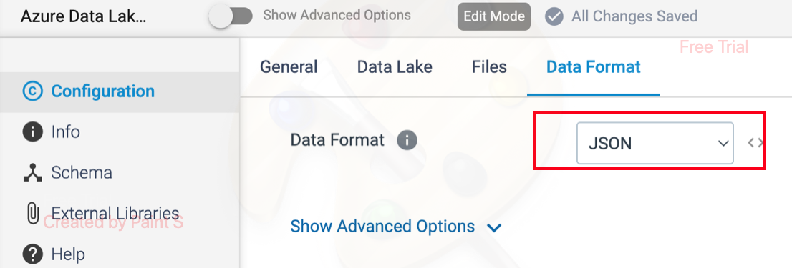

**ORIGIN NAME:** Azure Data Lake Storage Gen2

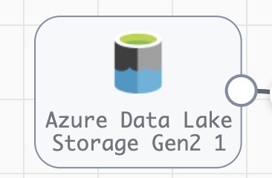

**Engine Type**: Data Collector

**Pipeline Name:** D_azre_DataLake_orgn_Dest_Pipeline_Cred

**Description**: The **Azure Data Lake Storage Gen2** origin reads data from Microsoft Azure Data Lake Storage Gen2.

We need to configure the **Azure Data Lake Storage Gen** origin in a following way.

Step 1: Click on the **Azure Data Lake Storage Gen** origin to provide the below details.

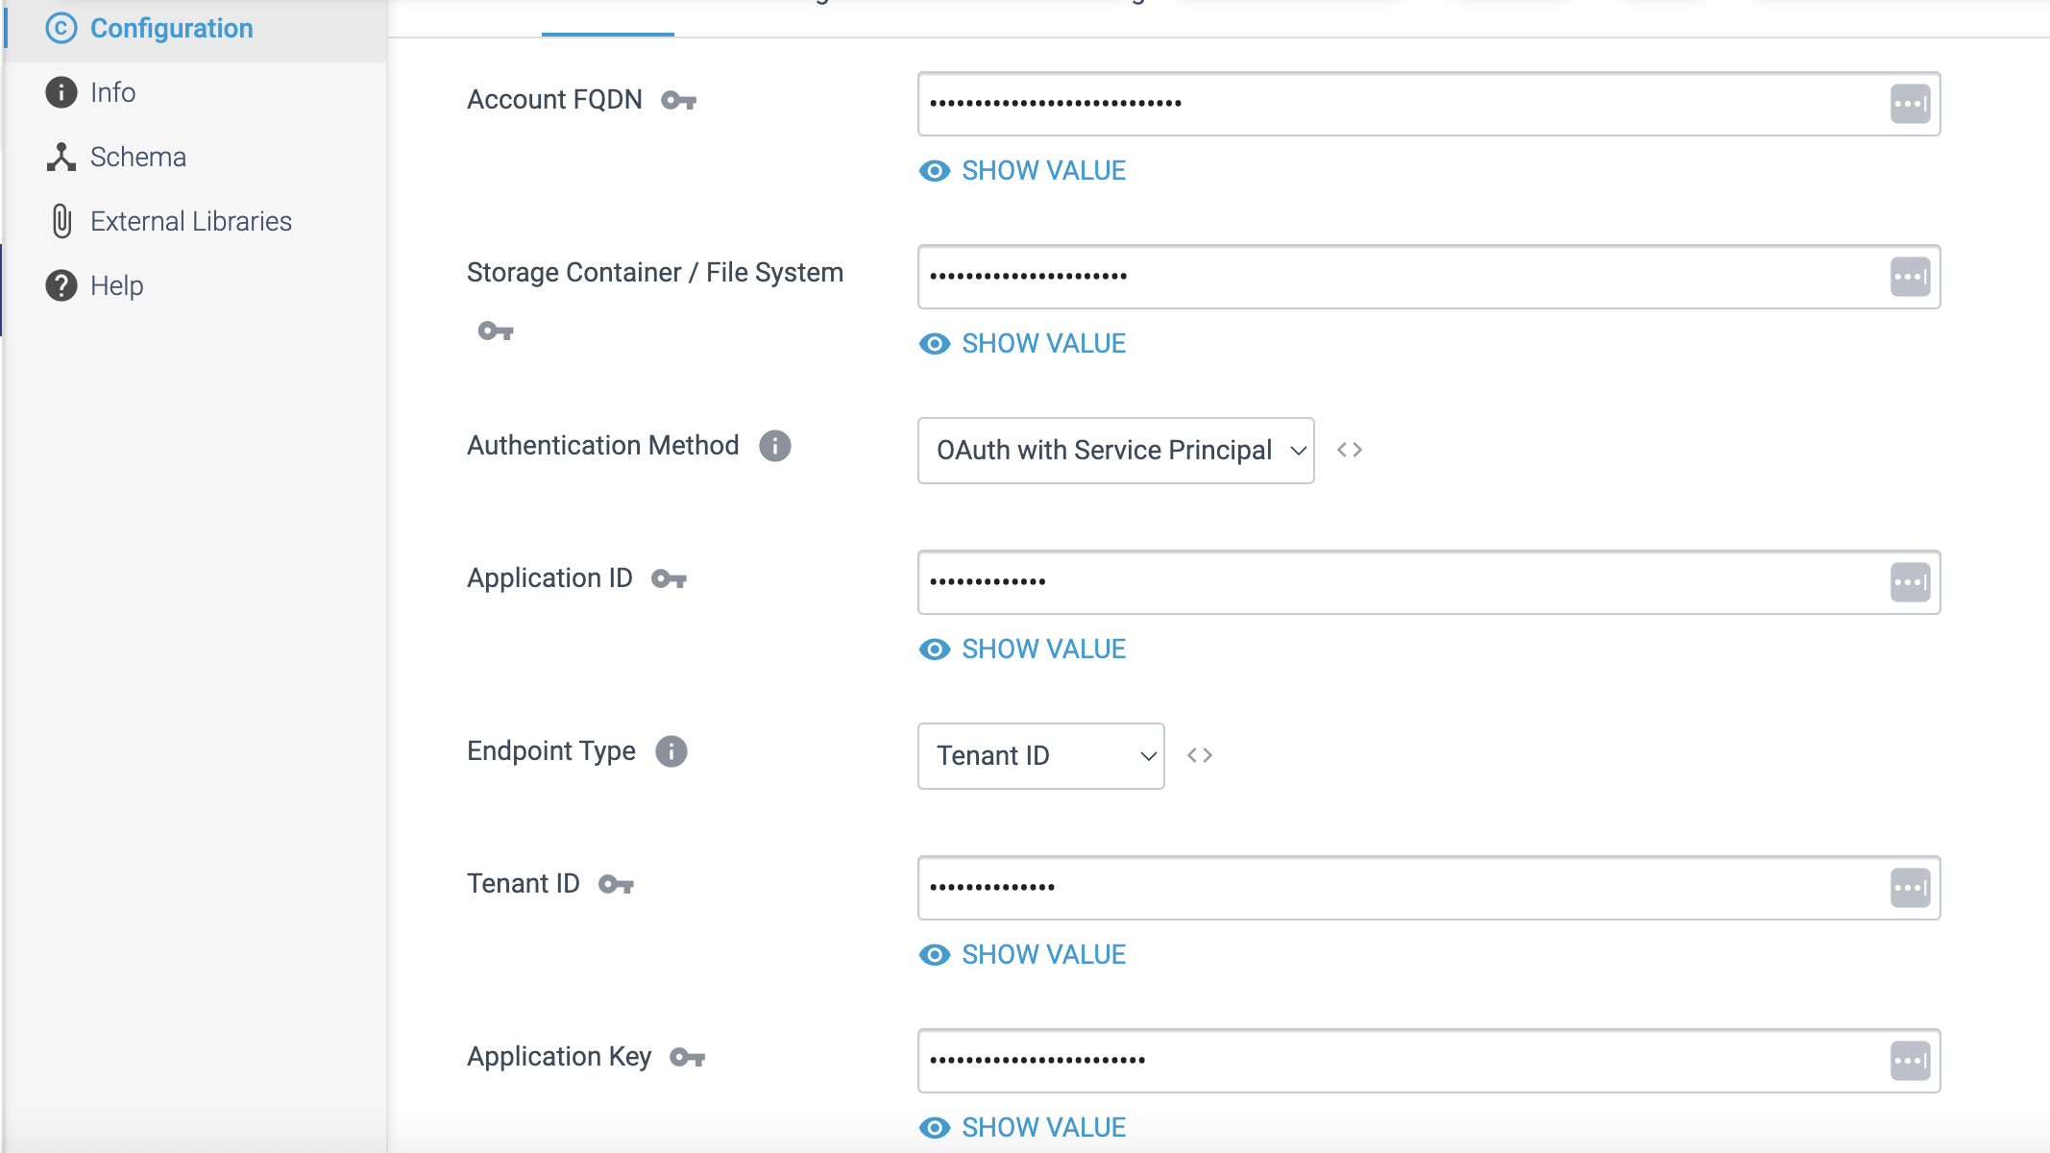

Step 2: To provide the file path details in a **File configuration** tab.

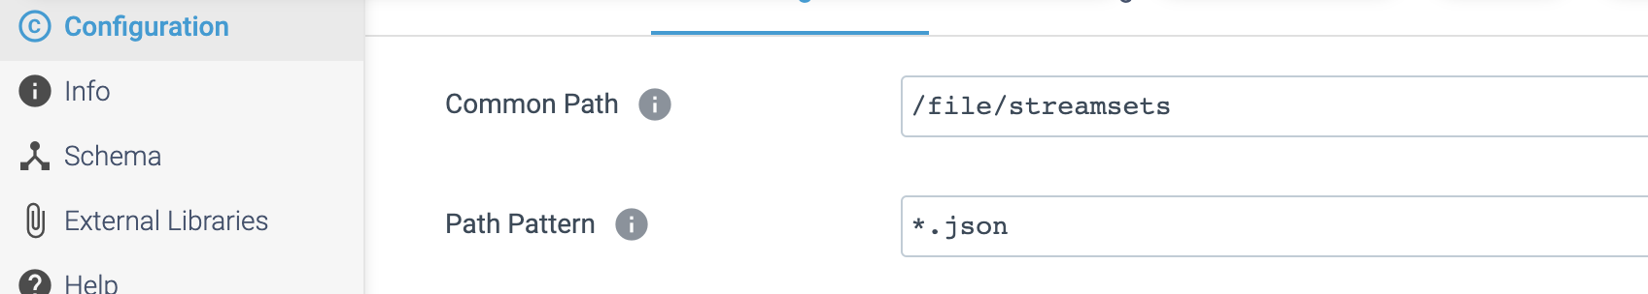

Step 3: To define the output data format in **Data Format** tab.

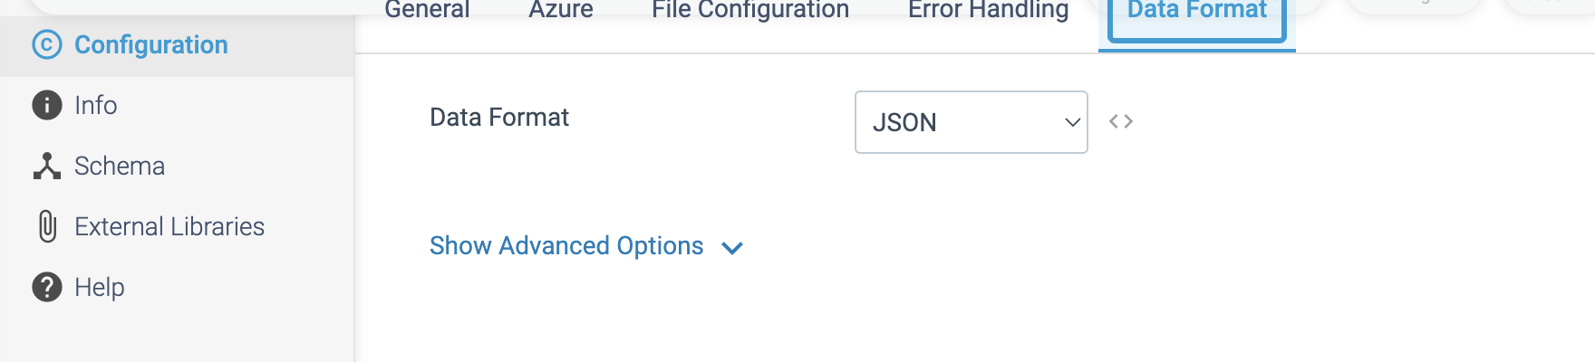

**ORIGIN NAME:** Azure IoT/Event Hub Consumer

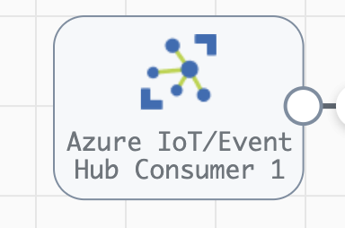

**Engine Type**: Data Collector

**Pipeline Name:** D_azure_IoT_Orgn_Hub_Dest_Pipeline_CredStr

**Description**: The **Azure IoT/Event Hub Consumer** origin reads data from Microsoft Azure Event Hub.

We need to configure the **Azure IoT/Event Hub Consumer** origin in a following way.

Step 1: Click on the **Azure IoT/Event Hub Consumer** origin to provide the below details.

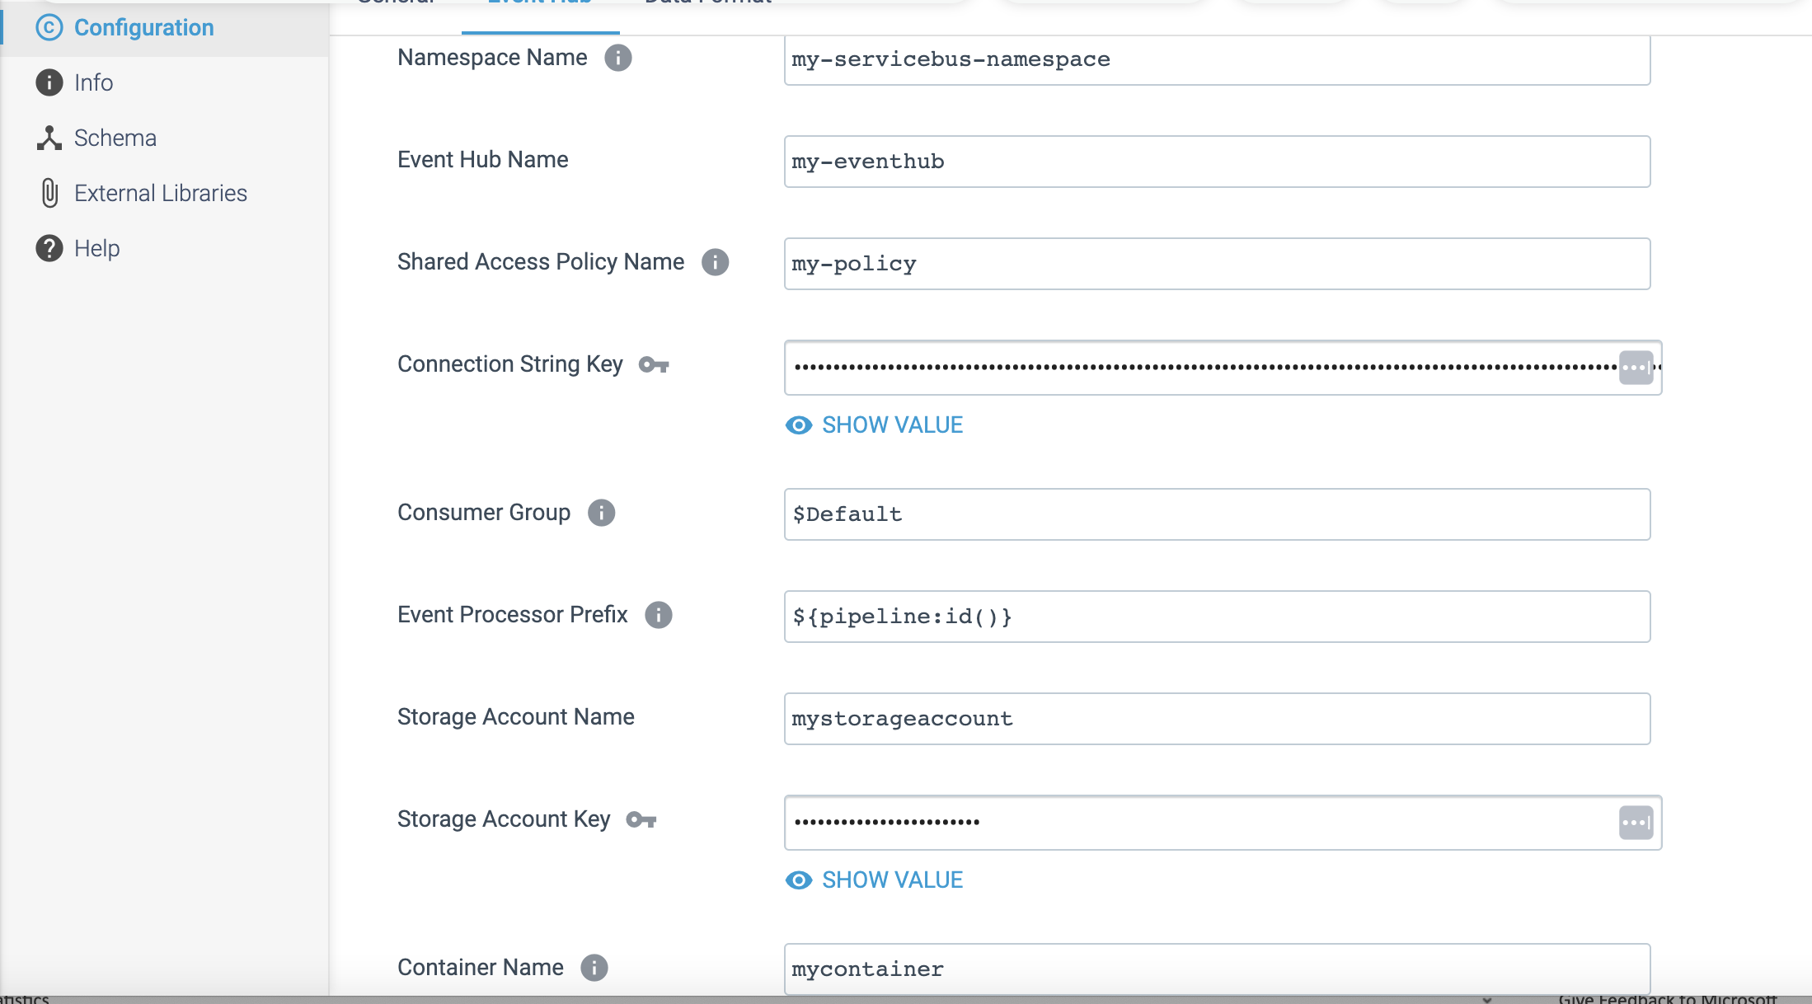

Step 2: To define the data format for output in Data Format tab.

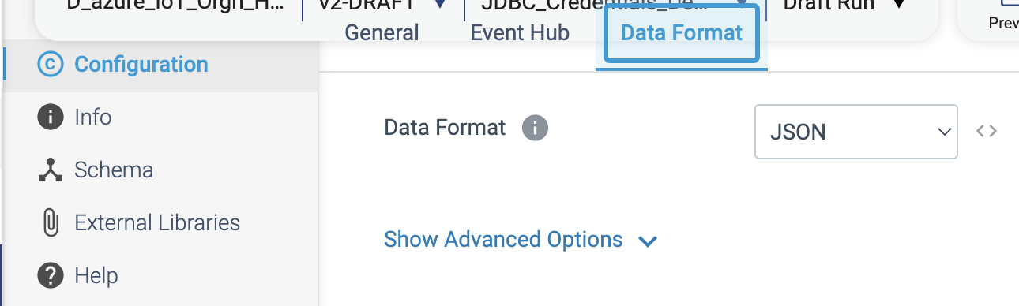

**ORIGIN NAME:** CONNX CDC

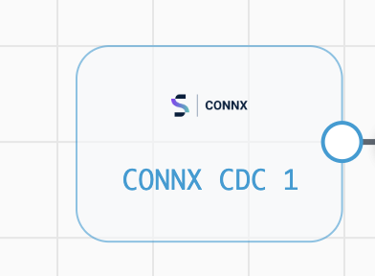

**Engine Type**: Data Collector

**Pipeline Name:** D_CONNX_CDC_orgn_Dest_Pipeline_CredStr

**Description**: **CONNX CDC** (Change Data Capture) allows to capture and replicate data changes in real-time from various database sources.

We need to configure the **CONNX CDC origin** in a following way.

Step 1: Click on the **CONNX CDC** origin, then provide the below details.

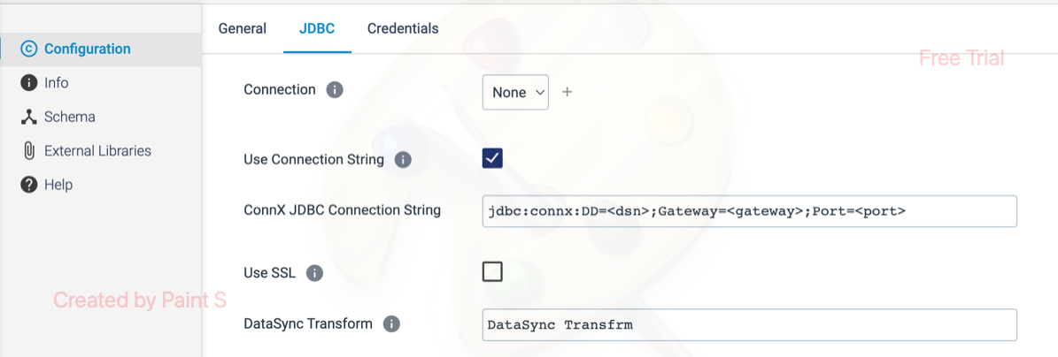

Step 2: Click on the **Credentials** tab to provide the credentials.

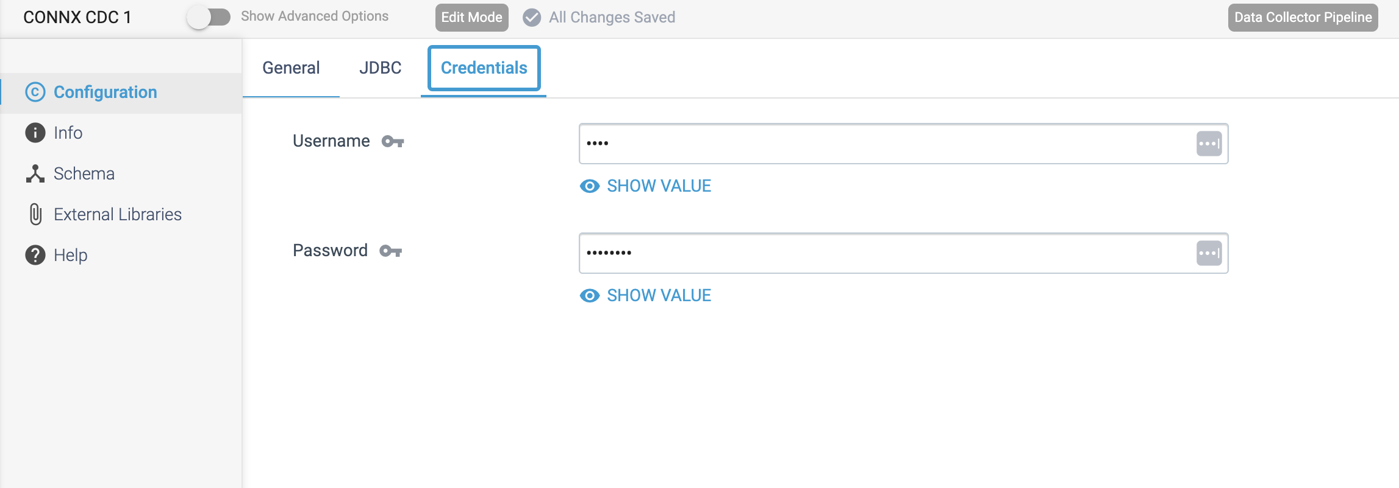

**ORIGIN NAME:** CONNX

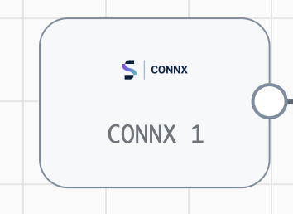

**Engine Type**: Data Collector

**Pipeline Name:** D_CONNX_orgn_Dest_Pipeline_CredStr

**Description**: The **CONNX** origin uses a SQL query to read mainframe data from a CONNX server.

We need to configure the **CONNX** origin in a following way.

Step 1: Click on the **CONNX** origin, then provide the JDBC Connection String for ConnX and SQL Query to retrieve the records based on OFFSET Column.

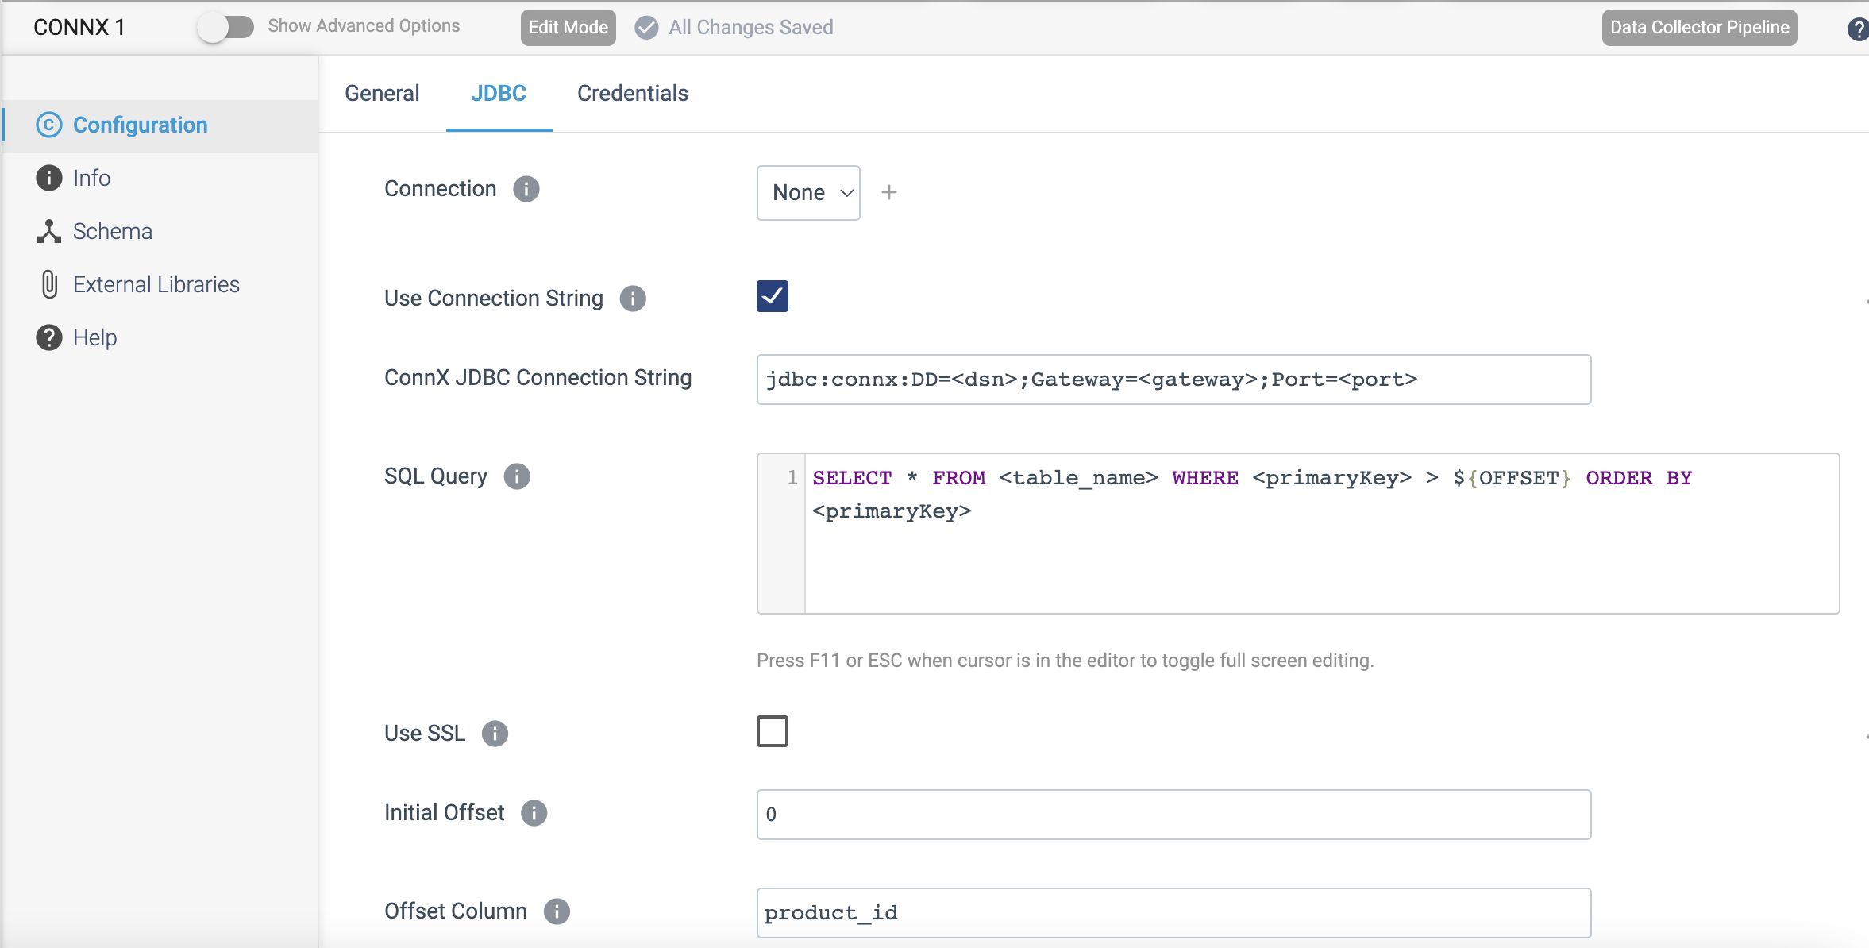

Step 2: Click on the **Credentials** tab to provide the credentials.

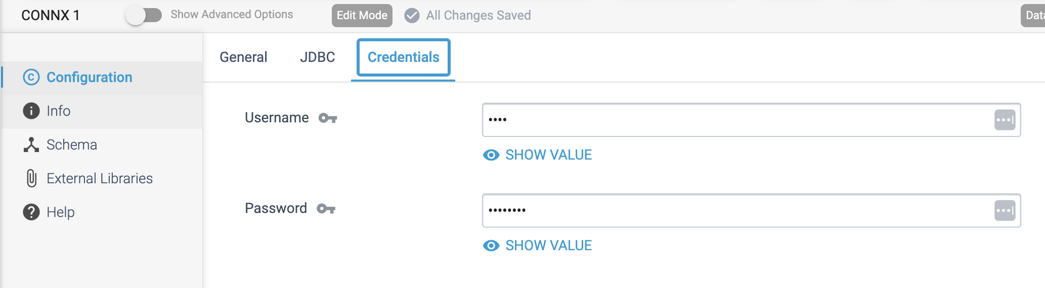

**ORIGIN NAME:** Elasticsearch

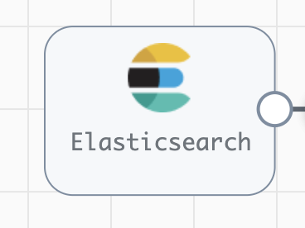

**Engine Type**: Data Collector

**Pipeline Name:** D_Elasticsrch_orgn_Dest_Pipeline_Cred_URL

**Description**: The **Elasticsearch** origin is a multithreaded origin that reads data from an Elasticsearch cluster, including Elastic Cloud clusters (formerly Found clusters) and Amazon Elasticsearch Service clusters.

We need to configure the **Elasticsearch** origin in a following way.

Step 1: Click on the **Elasticsearch** origin, then provide the below necessary details. If it needs a query search, then write the specific query on **Query** box.

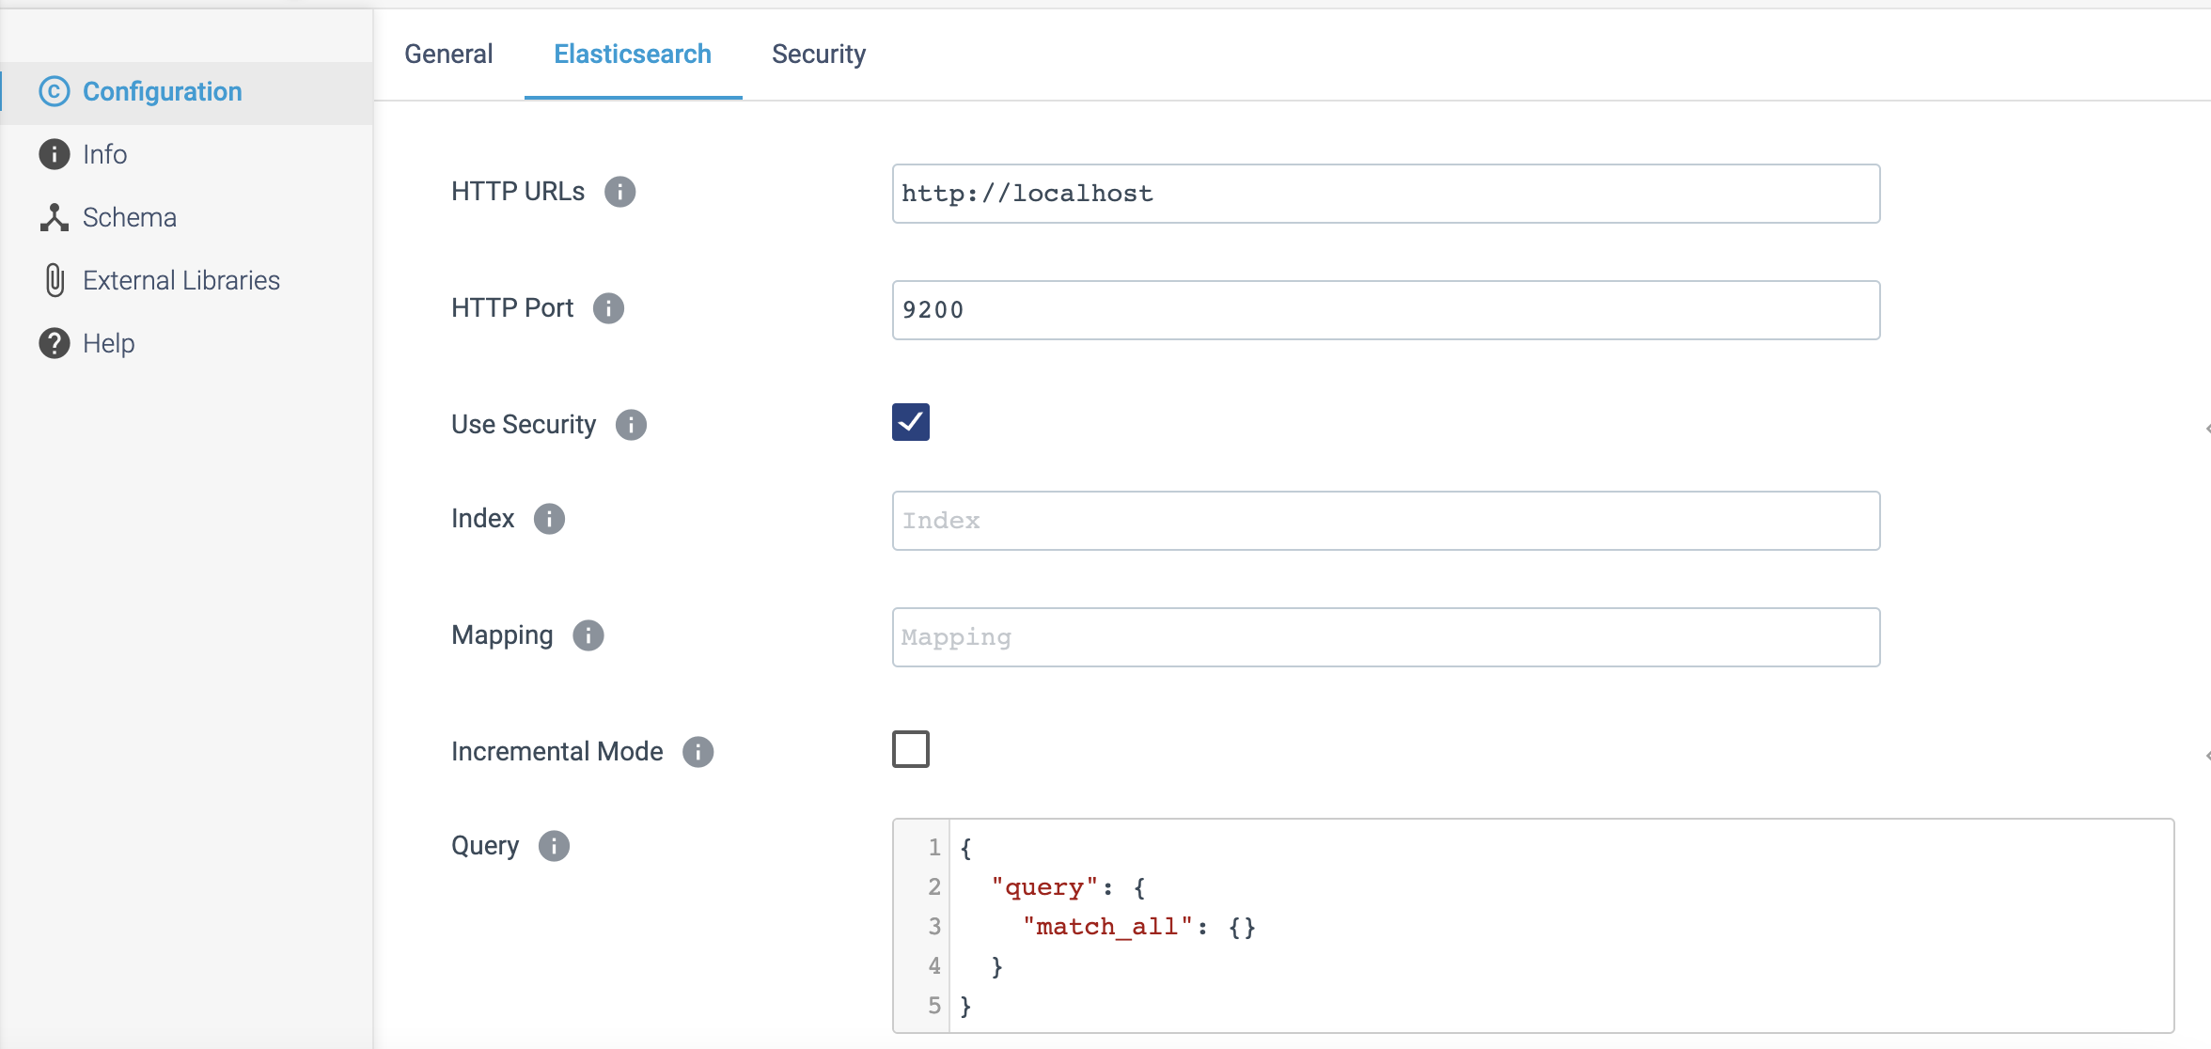

Step 2: Click on the Security tab to specify the credentials.

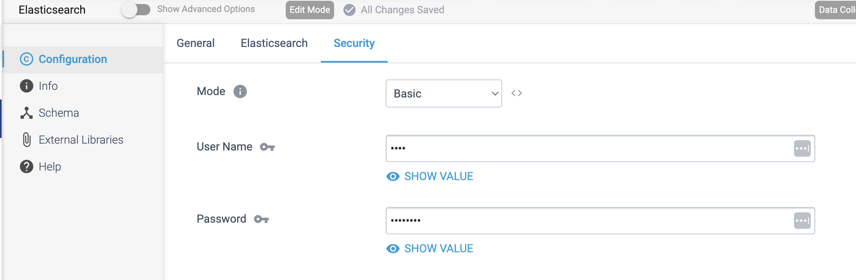

**ORIGIN NAME:** FTP/FTPS/SFTP Client

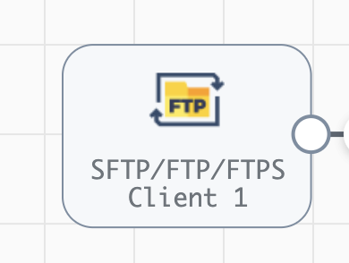

**Engine Type**: Data Collector

**Pipeline Name:** D_SFTP_orgn_Http_Dest_Pipeline_Cred_URL

**Description**: The **SFTP/FTP/FTPS Client** origin reads files from a server using the Secure File Transfer Protocol (SFTP), File Transfer Protocol (FTP), or FTP Secure (FTPS) protocol.

We need to configure the **SFTP/FTP/FTPS Client** origin in a following way.

Step 1: Click on the **SFTP/FTP/FTPS Client** origin, then provide the below necessary details as follows.

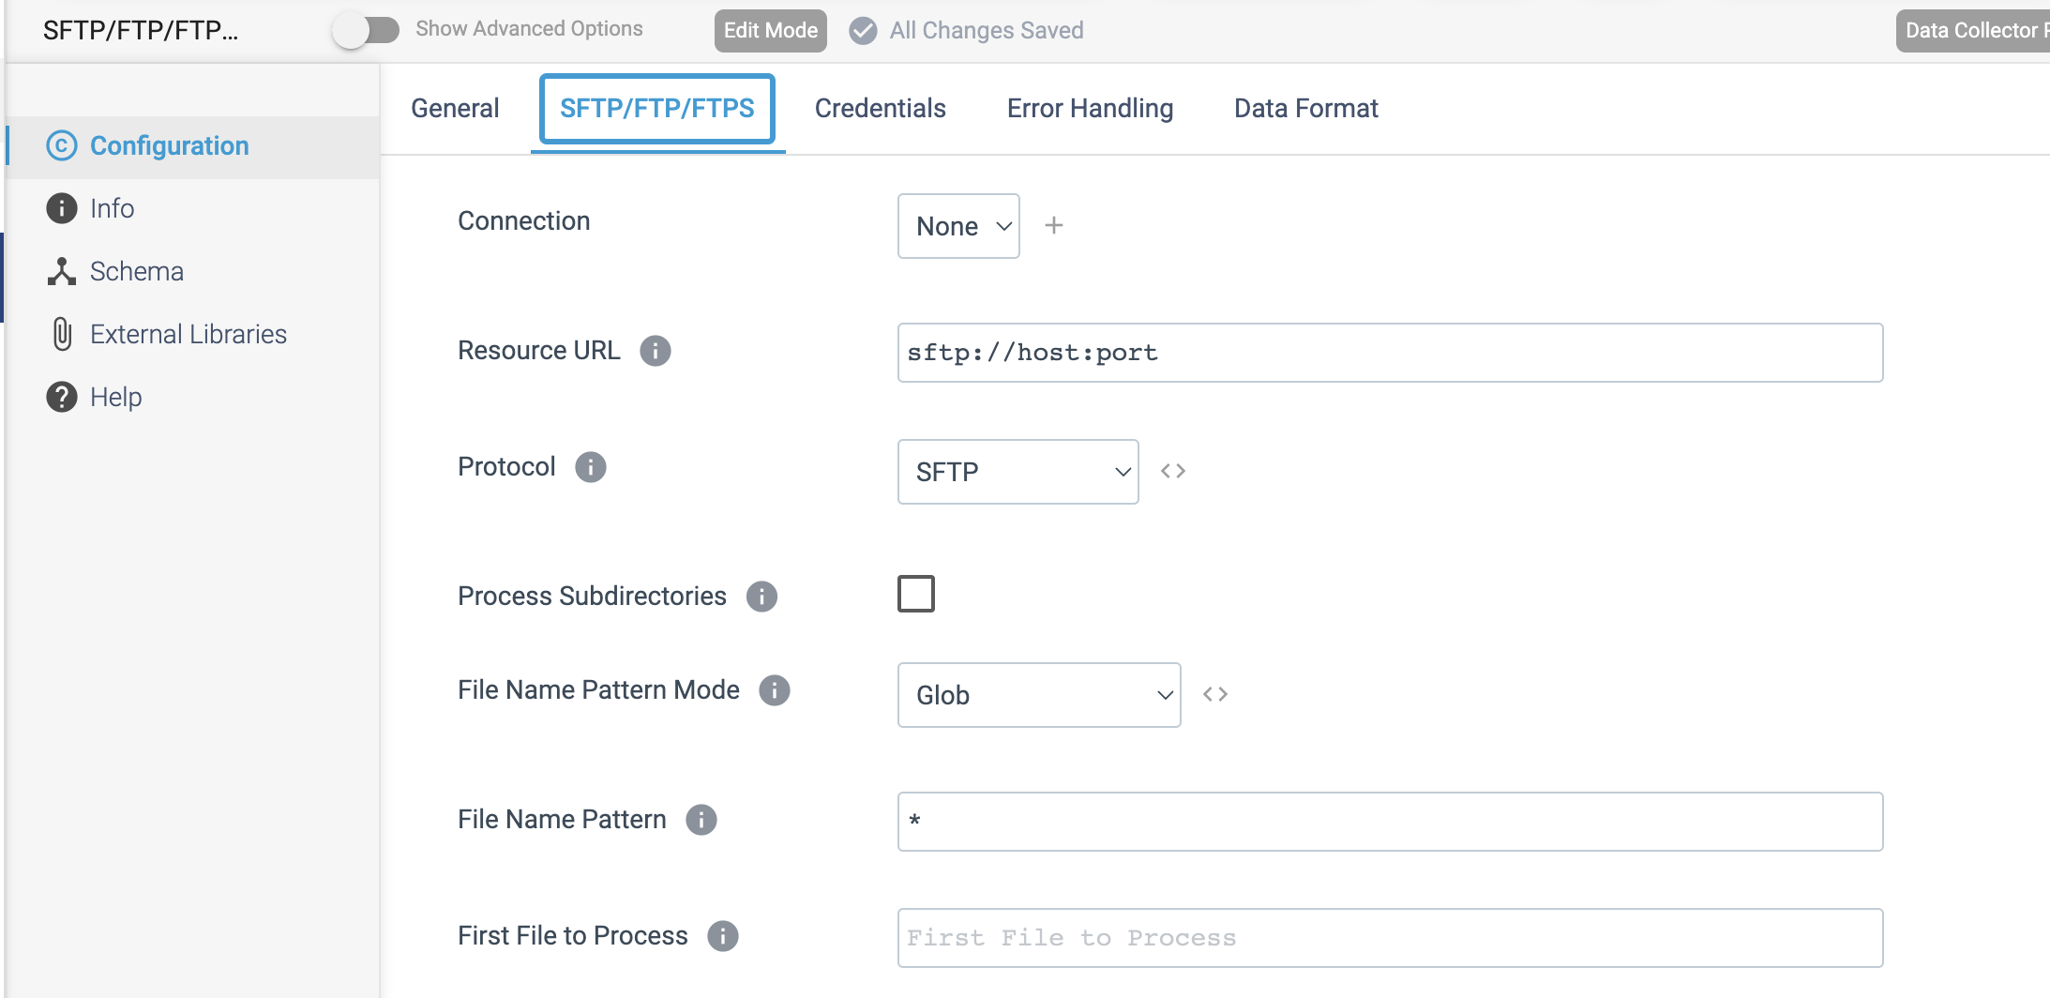

Step 2: Click on the **Credentials** tab to provide the necessary credentials.

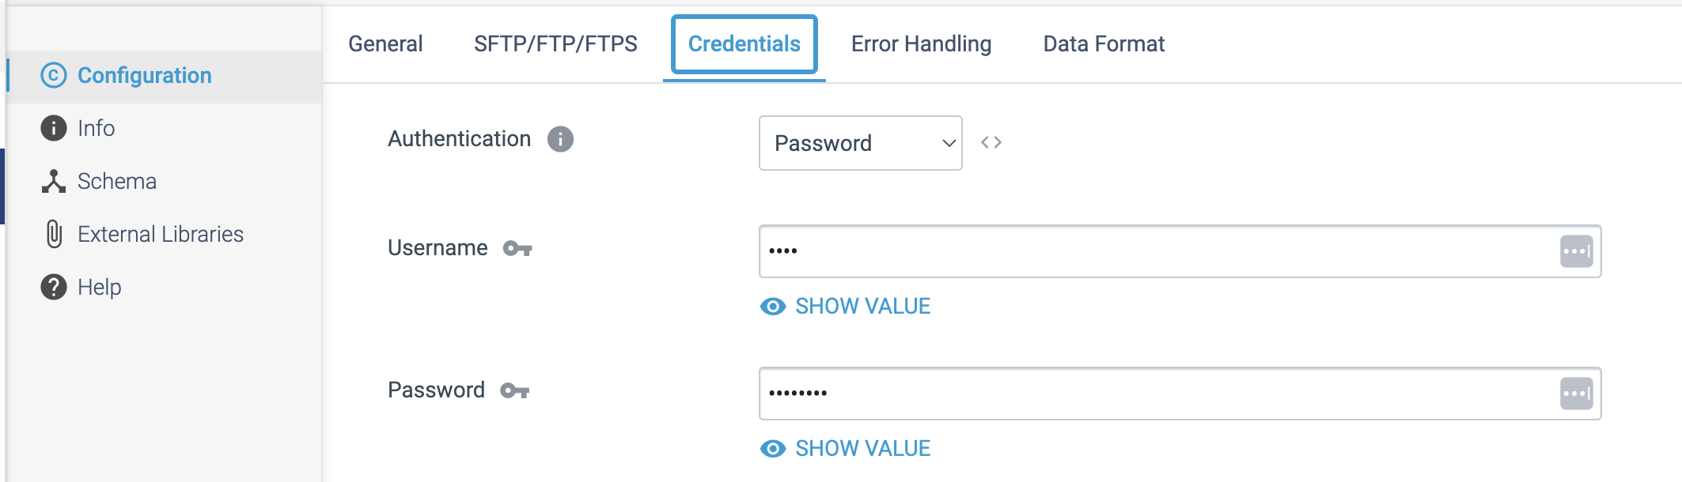

Step 3: Click on the Data Format tab to define the output format.

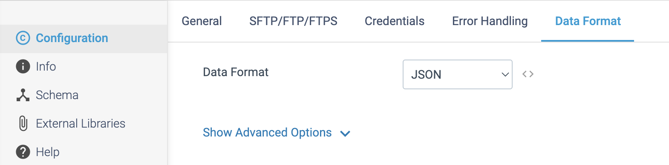

**ORIGIN NAME:** Google Big Query

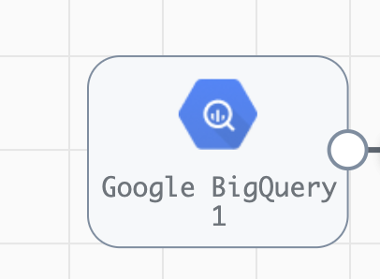

**Engine Type**: Data Collector

**Pipeline Name:** D_Ggle_qry_Orgn_Splnk_Dest_Pipeline_Cred

**Description**: The **Google BigQuery** origin executes a query job and reads the result from Google BigQuery.

We need to configure the **Google BigQuery** origin in a following way.

Step 1: Click on the **Google BigQuery** origin, then provide the below query details.

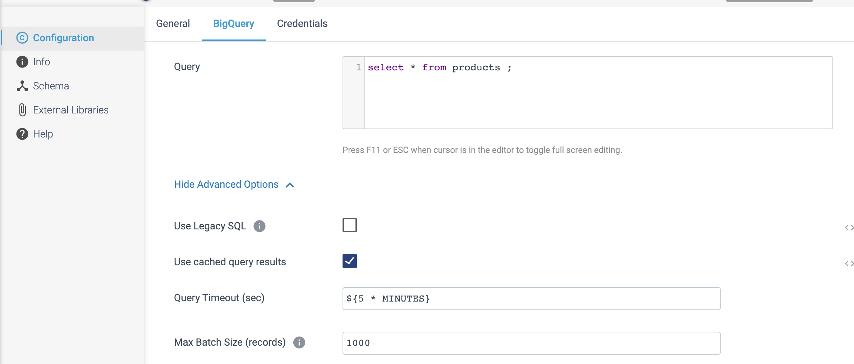

Step 2: Click on the credentials tab to provide the below details.

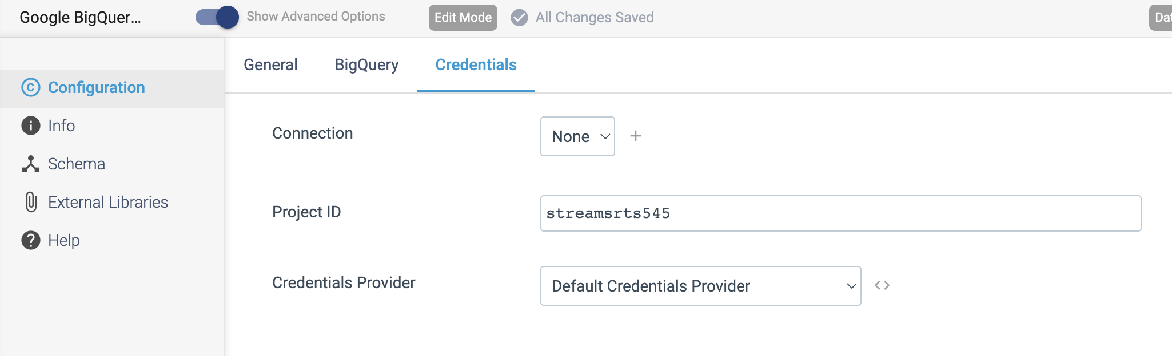

**ORIGIN NAME:** Google Cloud Storage

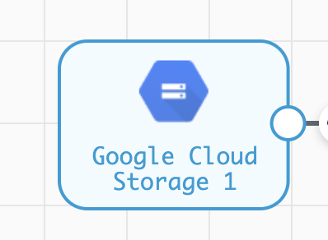

**Engine Type**: Data Collector

**Pipeline Name:** D_Ggle_strge_orgn_bigtble_Dest_Pipeline_Cred

**Description**: The **Google BigQuery** origin executes a query job and reads the result from Google BigQuery.

Step 1: Click on the **GCS** tab to define the bucket, prefix pattern, and optional common prefix. These properties determine the objects that the origin processes.

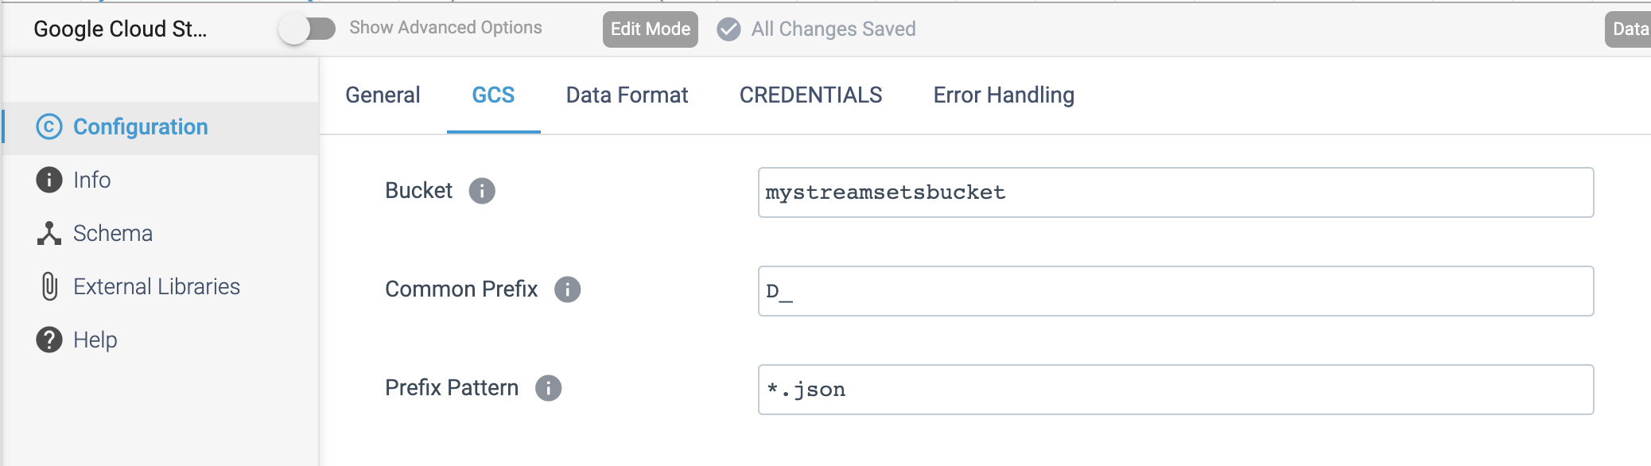

Step 2: Click on the **Data Format** tab to specify the output format.

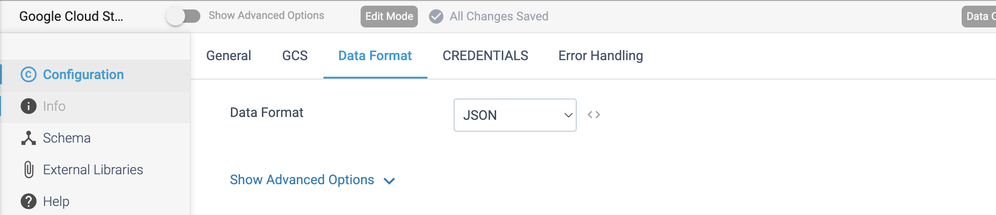

Step 3: Click on the **Credentials** tab to define the project ID and credentials to use when connecting to Google Cloud Storage.

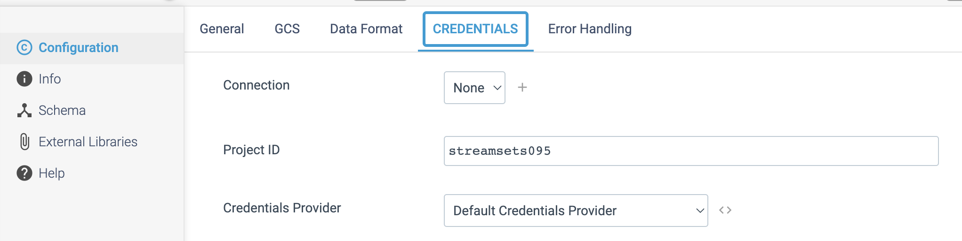

**ORIGIN NAME:** Google Pub/Sub Subscriber

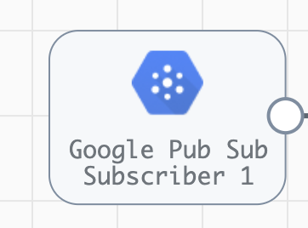

**Engine Type**: Data Collector

**Pipeline Name:** D_Ggle_Subscr_orgn_Pblshr_Dest_Pipeline_Cred

**Description**: The **Google Pub/Sub Subscriber** origin consumes messages from a Google Pub/Sub subscription.

We need to configure the **Google Pub/Sub Subscriber** origin in a following way.

Step 1: Click on the **Google Pub/Sub Subscriber** origin to define the Google Pub/Sub subscription ID to receive messages from.

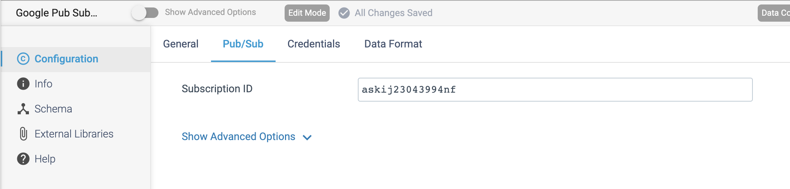

Step 2: Click on the **Credentials** tab to provide the necessary credentials.

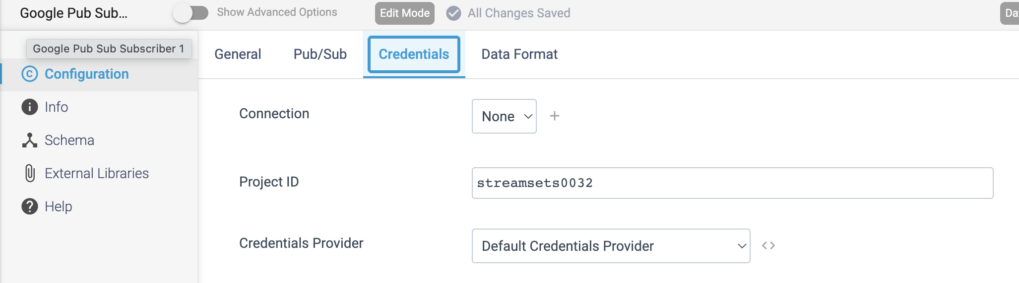

Step 3: Click on the **Data Format** tab to specify the output format.

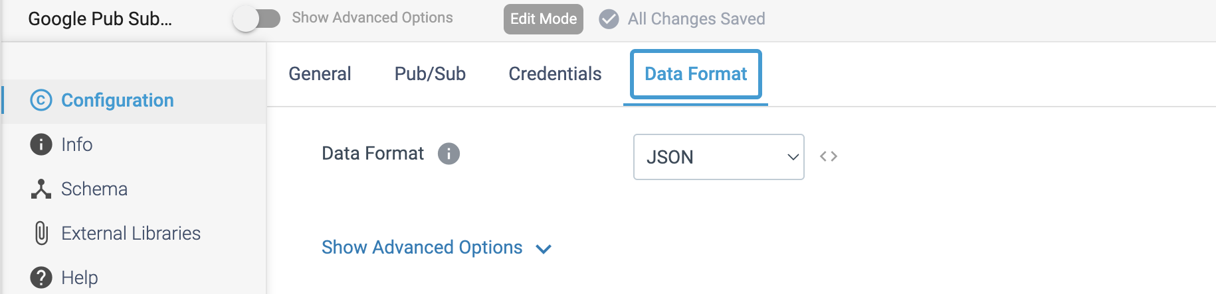

**ORIGIN NAME:** HTTP Client

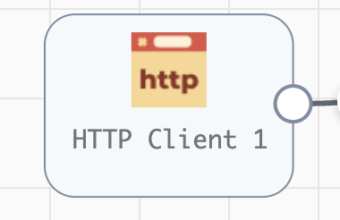

**Engine Type**: Data Collector

**Pipeline Name:** D_SFTP_orgn_Dest_Pipeline_Cred_URL

**Description**: The **HTTP Client** origin reads data from an HTTP resource URL.

We need to configure the **HTTP Client** origin in a following way.

Step 1: Click on the **HTTP Client** origin to specify the resource URL, optional headers, and the method to use. For some methods, you can specify the request body and default content type.

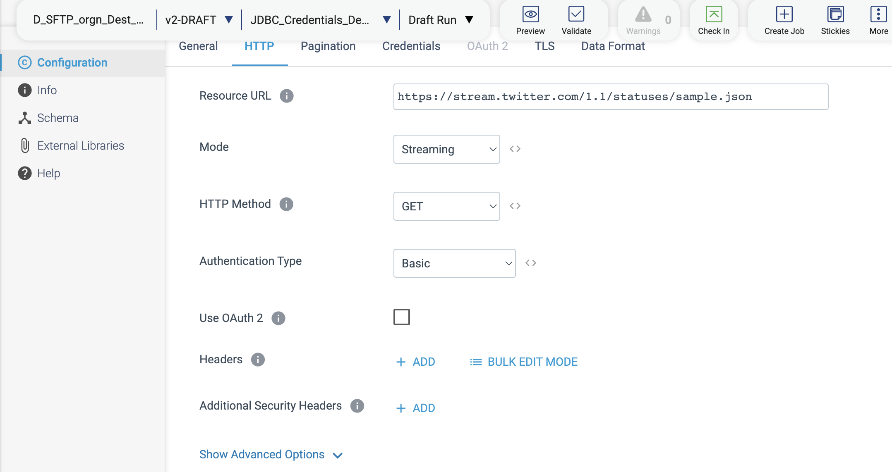

Step 2: Click on the **Credentials** tab to provide the necessary credentials based on the specified **Authentication type** in Step 1.

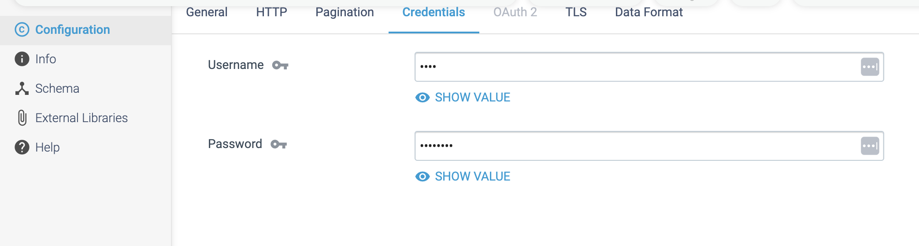

Step 3: Click on the Data Format tab to specify the output format.

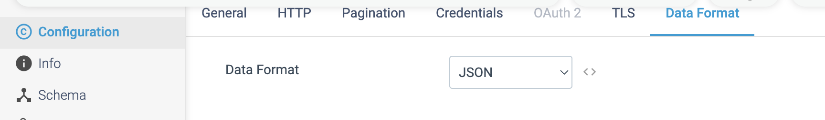

**ORIGIN NAME:** JMS Consumer

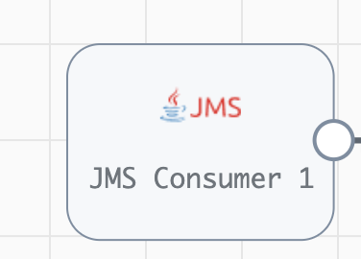

**Engine Type**: Data Collector

**Pipeline Name:** D_JMS_Orgn_Dest_Pipeline_CredURL

**Description**: The **JMS Consumer** origin reads data from a Java Messaging Service (JMS).

We need to configure the **JMS Consumer** origin in a following way.

Step 1: Click on the **JMS Consumer** origin to configure how the origin connects to the JMS server and the JMS destination name. We can optionally specify the JMS destination type, JMS credentials, and remove control characters.

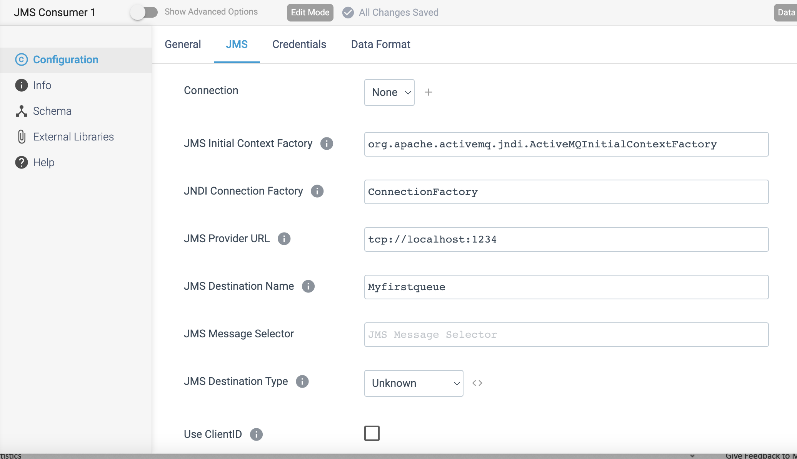

Step 2: Click on the **Credentials** tab to provide the necessary credentials.

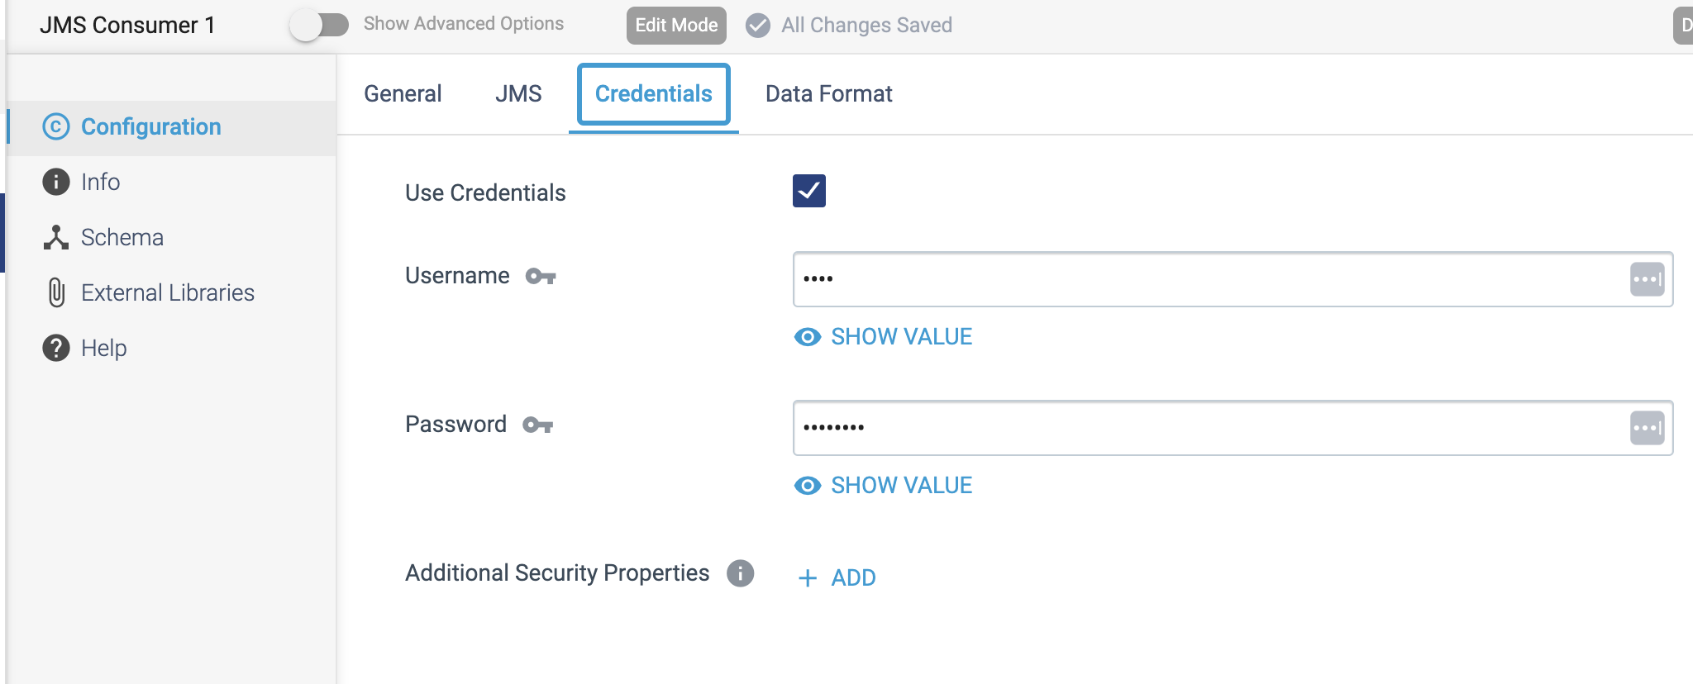

Step 3: Click on the **Data Format** to specify the output format.

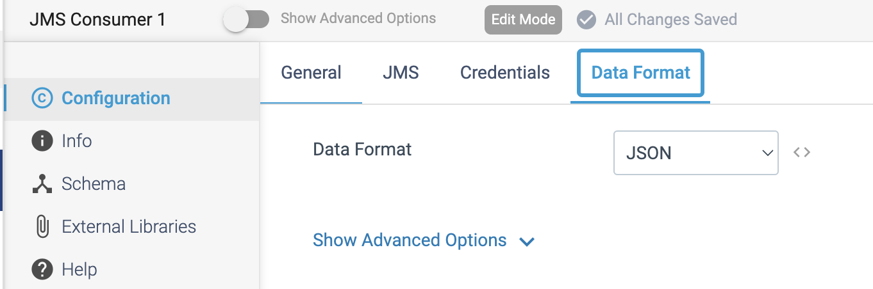

**ORIGIN NAME:** Kinesis Consumer

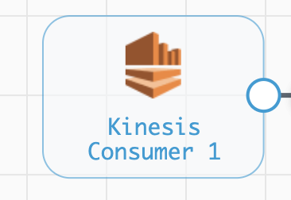

**Engine Type**: Data Collector

**Pipeline Name:** D_Kinesis_Orgn_Dest_Pipeline_Cred

**Description**: The **Kinesis Consumer** origin reads data from Amazon Kinesis Streams.

We need to configure the **Kinesis Consumer** origin in a following way.

Step 1: Click on the **Kinesis Consumer** origin to specify the Amazon Web Services connection information for our Kinesis cluster and the data format of source data. We can also configure additional Kinesis configuration properties that we require.

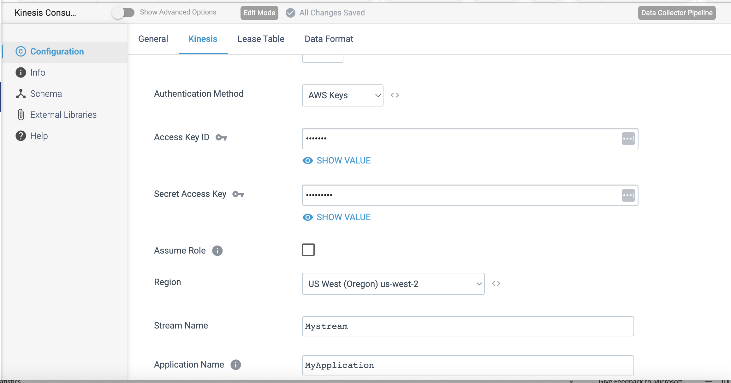

Step 2: Click on the **Data Format** tab to specify the output format.

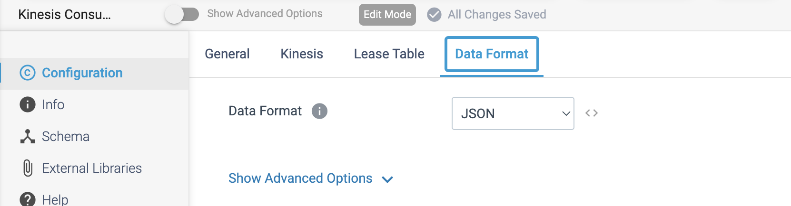

**ORIGIN NAME:** MongoDB Atlas

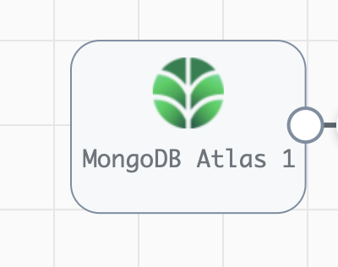

**Engine Type**: Data Collector

**Pipeline Name:** D_MongoAtlas_orgn_cssndra_Dest_pipeline_CredStr

**Description**: The **MongoDB Atlas** origin reads data from MongoDB Atlas or MongoDB Enterprise Server.

We need to configure the **MongoDB Atlas** origin in a following way.

Step 1: Click on the **MongoDB Atlas** origin to define connection information, such as the connection string. We can specify SSL/TLS properties for an SSL/TLS-enabled MongoDB cluster.

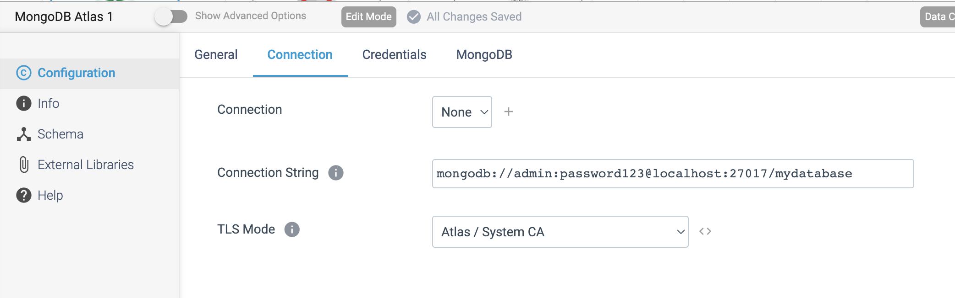

Step 2: On the **Credentials** tab, based on the authentication used by MongoDB, configure the MongoDB Atlas origin to use no authentication, username/password authentication, or LDAP authentication. By default, no authentication is used.

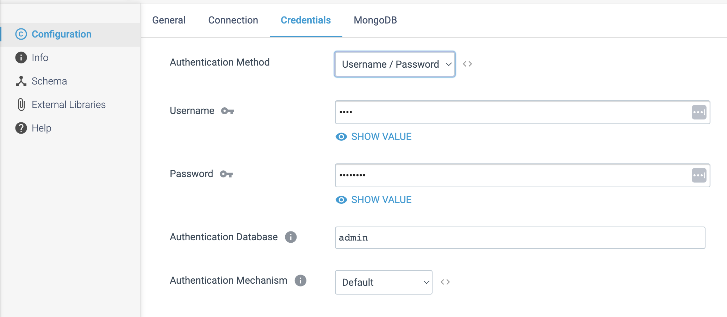

Step 3: Click on the **MongoDB** tab to give the Database details.

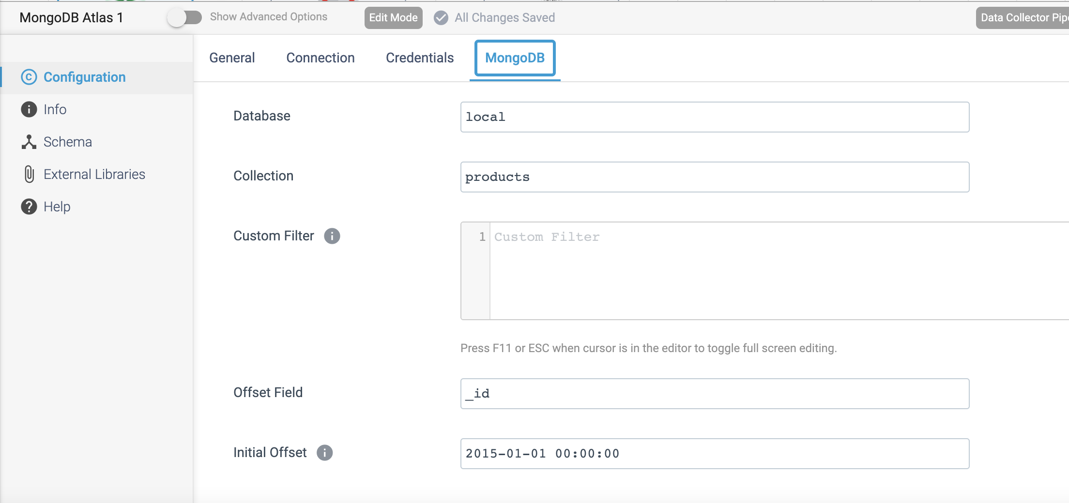

**ORIGIN NAME:** MongoDB Oplog

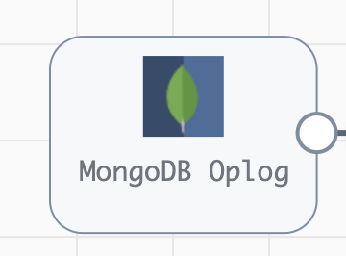

**Engine Type**: Data Collector

**Pipeline Name:** D_Mongolog_orgn_Atlas_Dest_pipeline_CredStr

**Description**: The **MongoDB Oplog** origin reads entries from MongoDB Oplog.

We need to configure the **MongoDB Oplog** origin in a following way.

Step 1: Click on the **MongoDB Oplog** origin to provide the below necessary details.

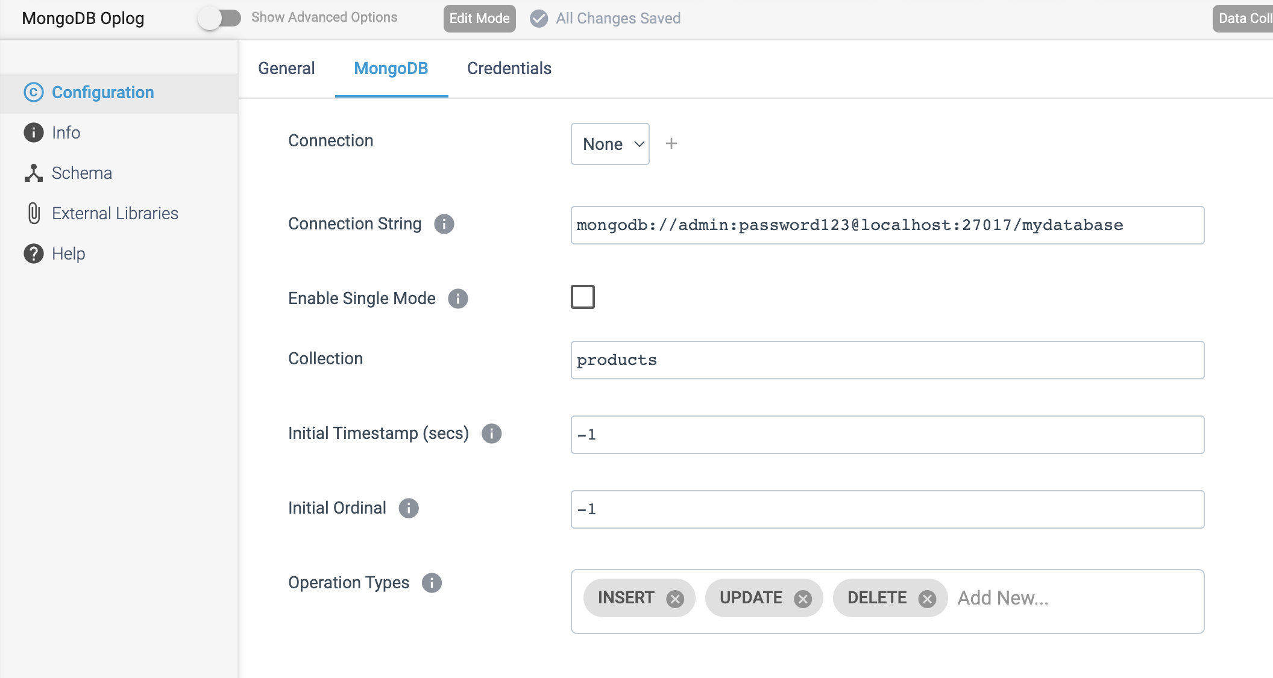

Step 2: Click on the **Credentials** tab to give the credentials.

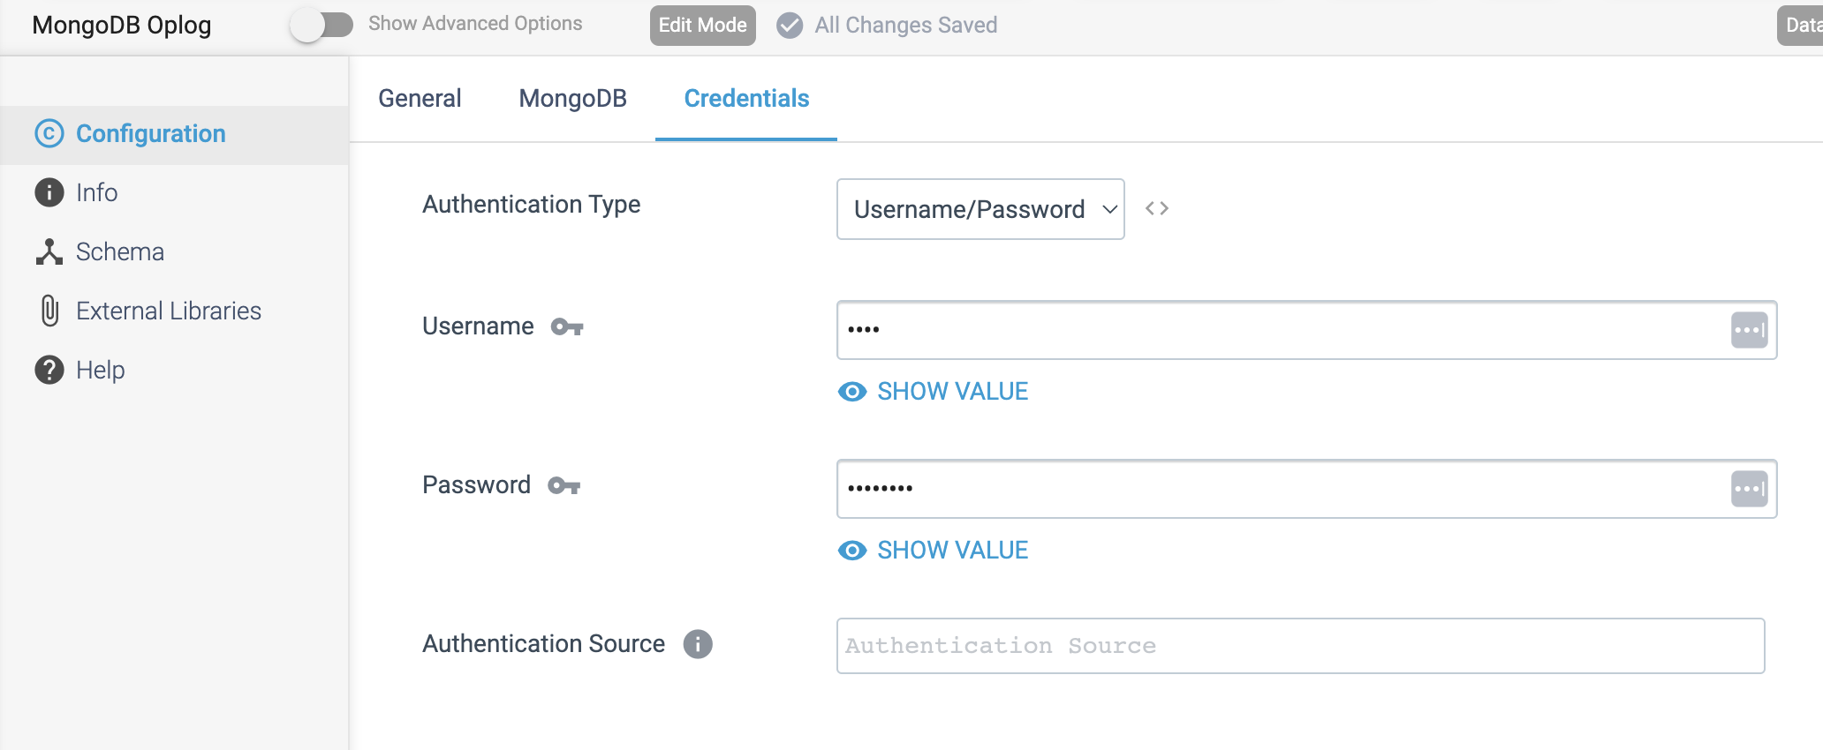

**ORIGIN NAME:** MongoDB

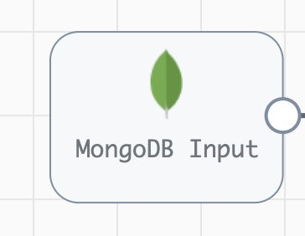

**Engine Type**: Data Collector

**Pipeline Name:** D_MongoDB_Orgn_Dest_Pipeline_Cred

**Description**: The **MongoDB** origin reads from MongoDB and generates a record for every MongoDB document.

We need to configure the **MongoDB** origin in a following way.

Step 1: Click on the **MongoDB** origin to provide the below necessary details.

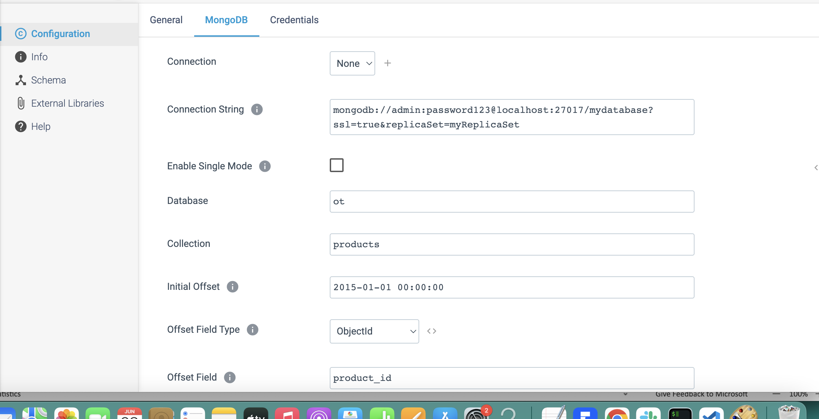

Step 2: Click on the **Credentials** tab to give the credentials based on the **Authentication Type.**

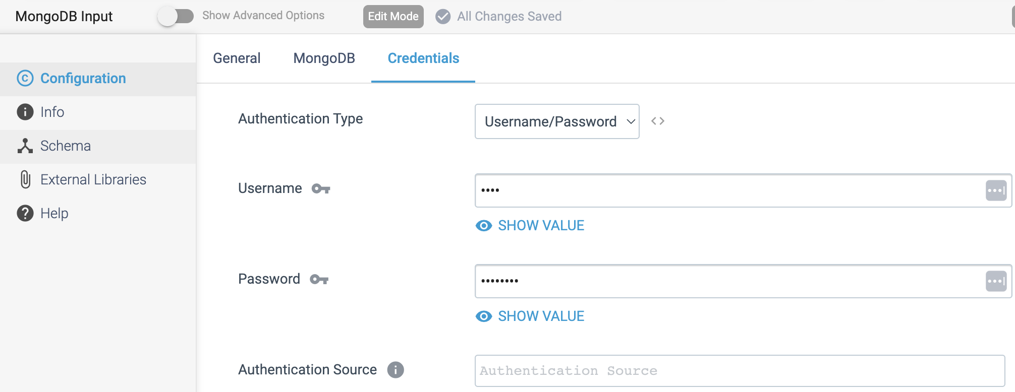

**ORIGIN NAME:** MQTT Subscriber

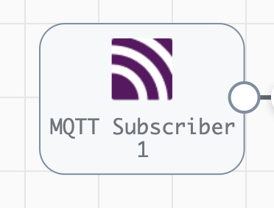

**Engine Type**: Data Collector

**Pipeline Name:** D_MQTT_Subs_Orgn_Pub_Dest_Pipeline_CredURL

**Description**: The **MQTT Subscriber** origin subscribes to topics on an MQTT broker to read messages from the broker.

We need to configure the **MQTT Subscriber** origin in a following way.

Step1: Click on the **MQTT Subscriber** origin to specify the information needed to connect to the MQTT broker.

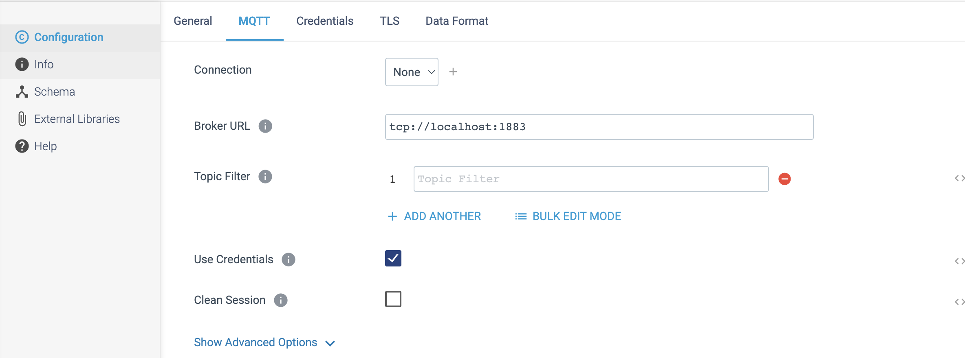

Step 2: Click on the **Credentials** tab to define connection credentials when the MQTT broker requires a **username** and **password**.

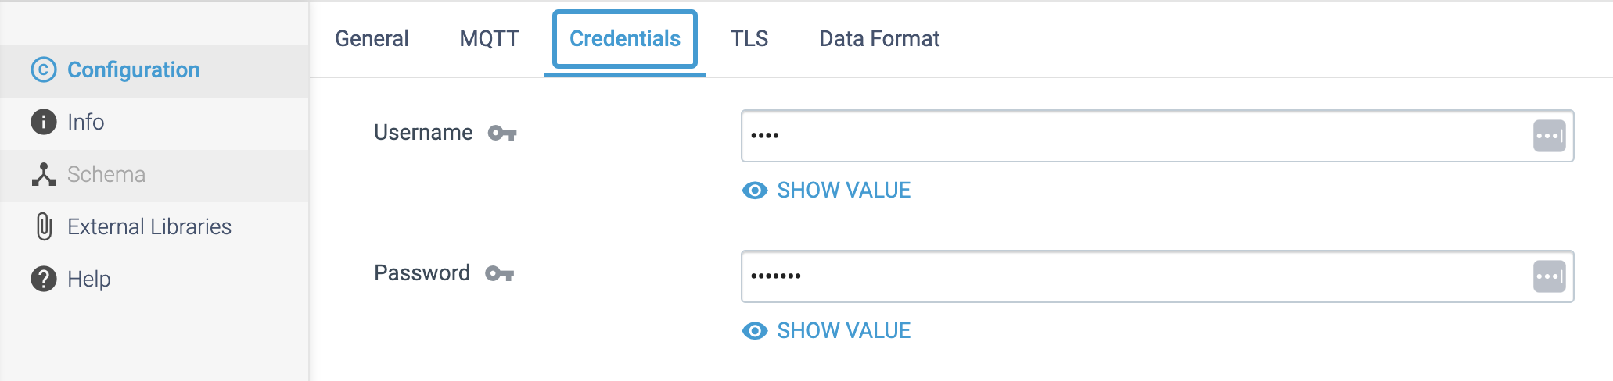

Step 3: Click on the **Data Format** tab to specify the output format.

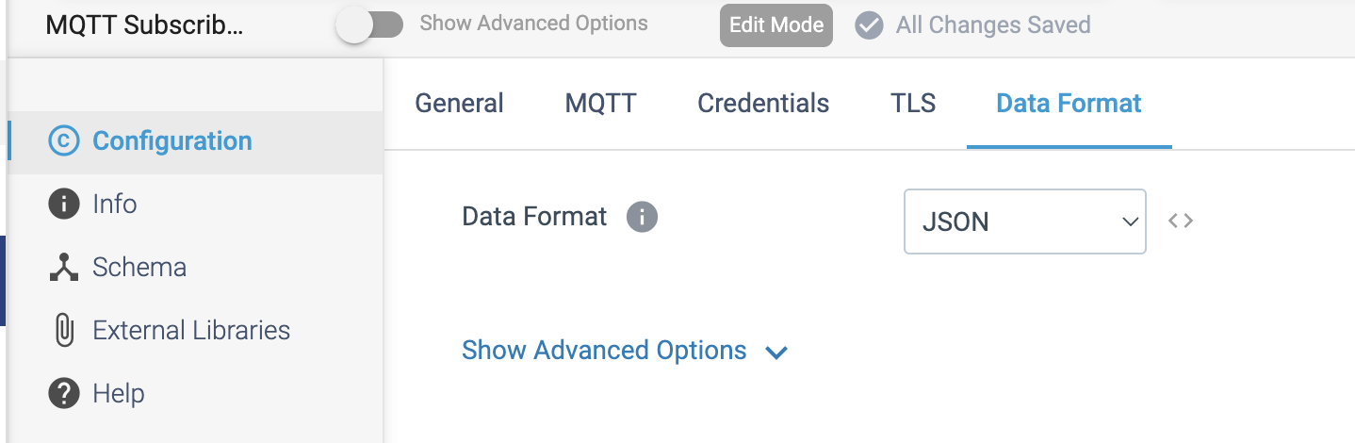

**ORIGIN NAME:** MYSQL Binary Log

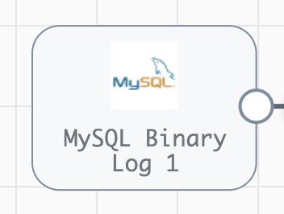

**Engine Type**: Data Collector

**Pipeline Name:** D_MYSQLlog_orgn_Ggle_Strge_Dest_Pipeline_CredStr

**Description**: The **MySQL Binary Log** origin processes change data capture (CDC) information provided by MySQL server in binary logs.

We need to configure the **MYSQL Binary Log** origin in a following way.

Step 1: Click on the **MYSQL Binary Log** origin, configure the database server from which to read the log files. We can specify an **offset** to determine where the origin starts reading data.

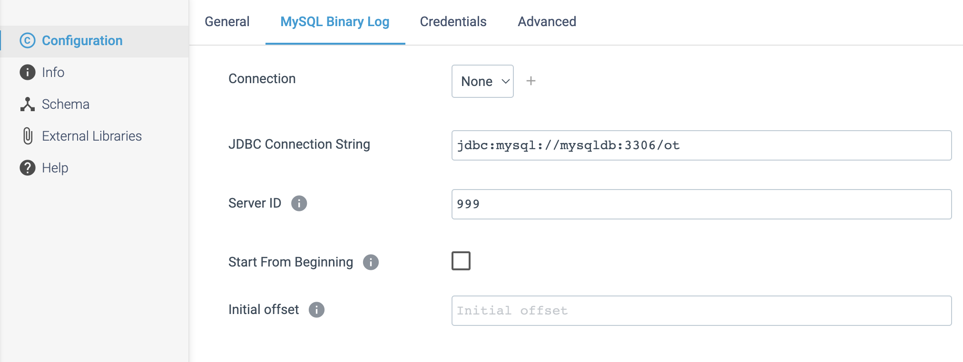

Step 2: Click on the **Credentials** tab, specify the credentials to use to connect to the MYSQL Server.

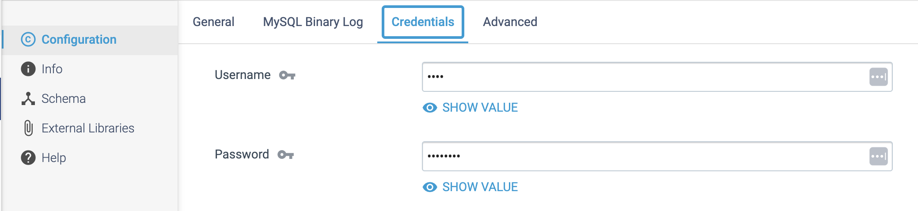

**ORIGIN NAME:** OPC UA Client

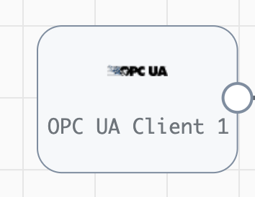

**Engine Type**: Data Collector

**Pipeline Name:** D_OPC_Client_orgn_Couchbse_Dest_Pipeline_URL_URI

**Description**: The **OPC UA Client** origin processes data from an OPC UA server. The **OPC UA Client** origin can poll the server at regular intervals, returning the latest data from all specified nodes. Or it can subscribe to specific nodes and receive messages from the server each time a change related to a specified node occurs.

We need to configure the **OPC UA Client** origin in a following way.

Step 1: Click on the **OPC UA Client** origin to specify the connection information and optional security information **username** and **password** checkbox.

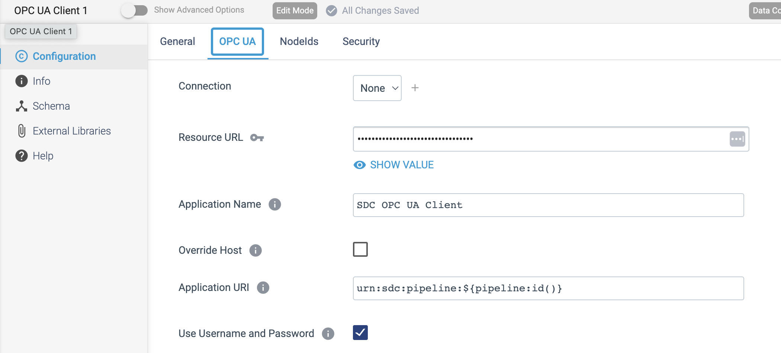

Step 2: Click on the **NodeIds** tab to specify the **NodeIds** for the nodes that want to use.

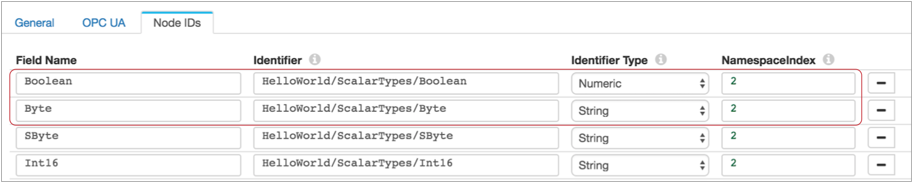

Step 3: To authenticate with a **username** and **password**, select the Use **Username** and **Password** check box on the **OPC UA** tab and then enter the **username** and **password** on the **Security** tab.

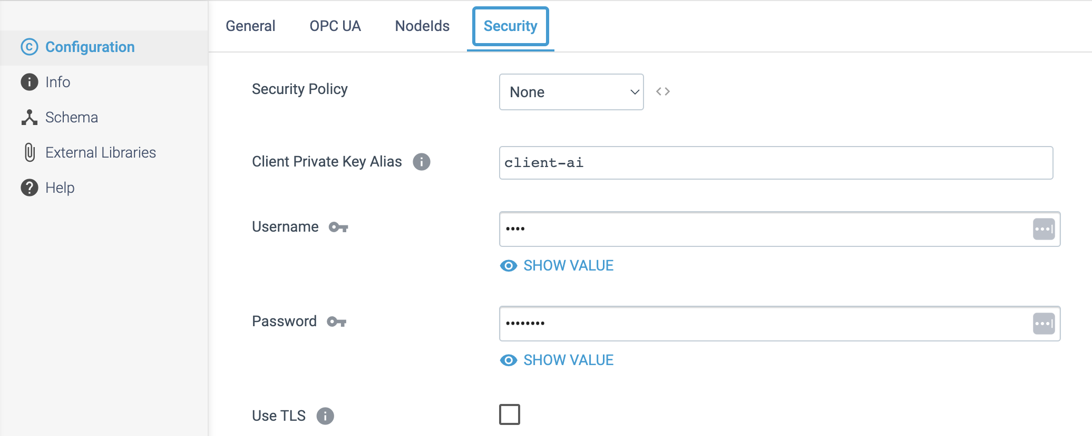

**ORIGIN NAME:** Oracle Bulkload

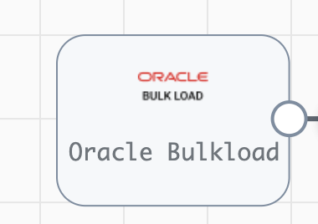

**Engine Type**: Data Collector

**Pipeline Name:** D_OracleBulk_orgn_CRM_Dest_Pipeline_CredStr

**Description**: The Oracle Bulkload origin reads all available data from multiple Oracle tables, then stops the pipeline.

We need to configure the **Oracle Bulkload** origin in a following way.

Step 1: Click on the **Oracle Bulkload** origin to specify the connection information and the tables to read.

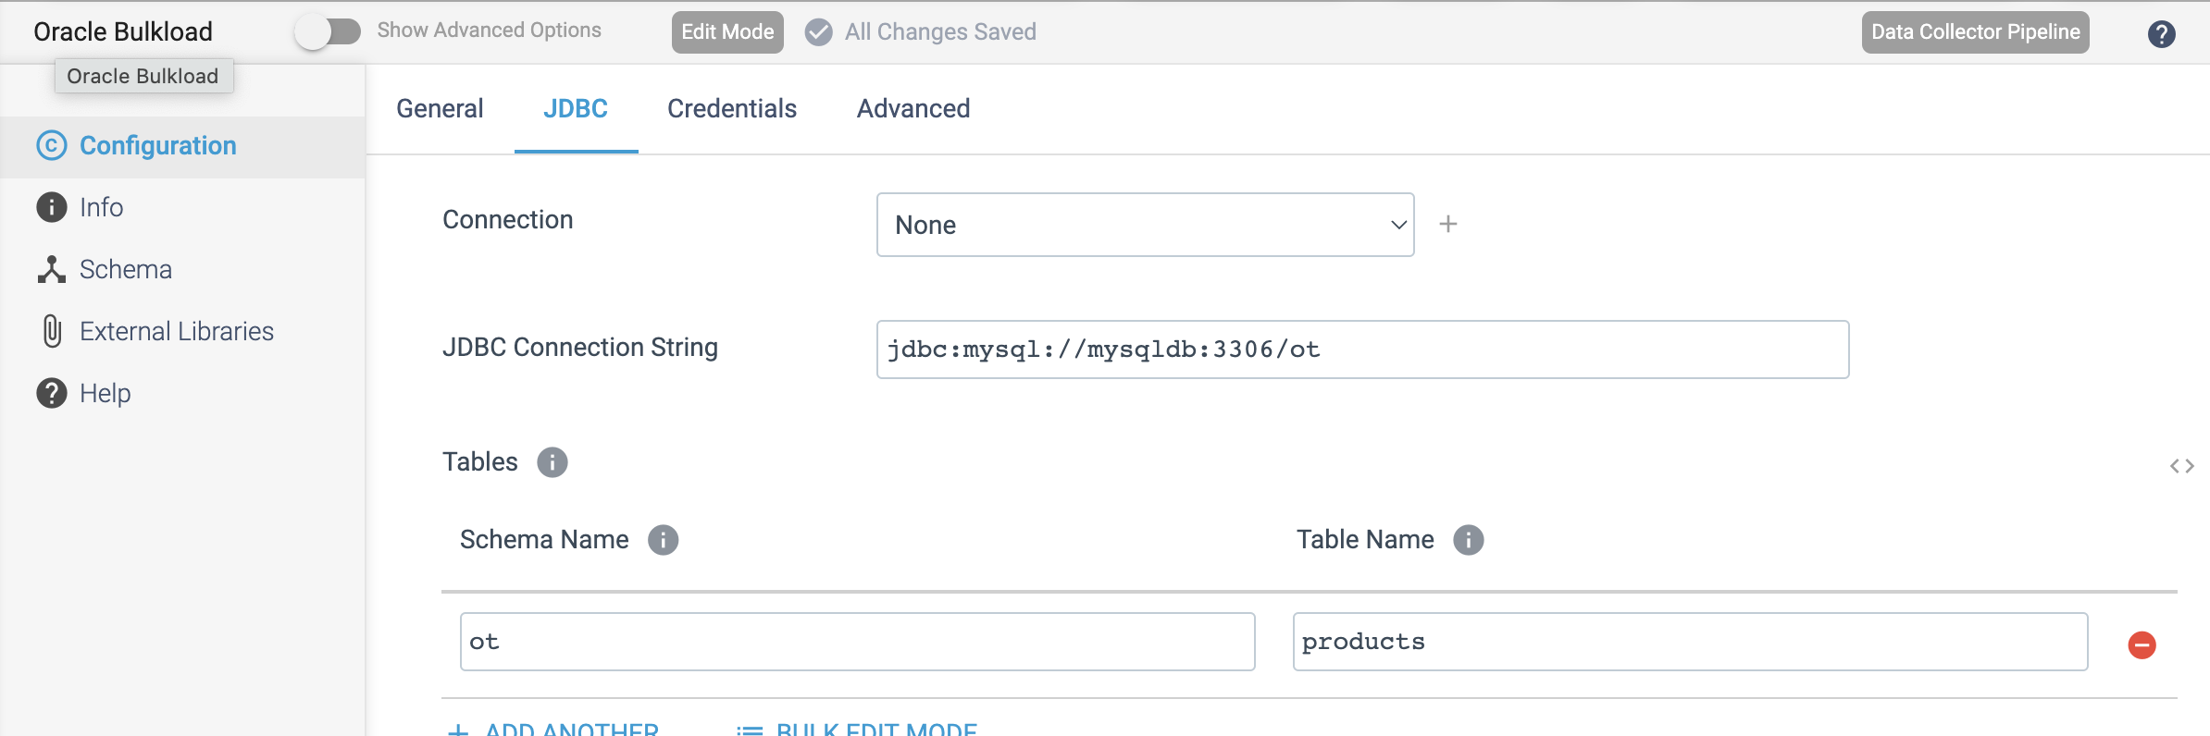

Step 2: Click on the **Credentials** tab to specify the JDBC credentials.

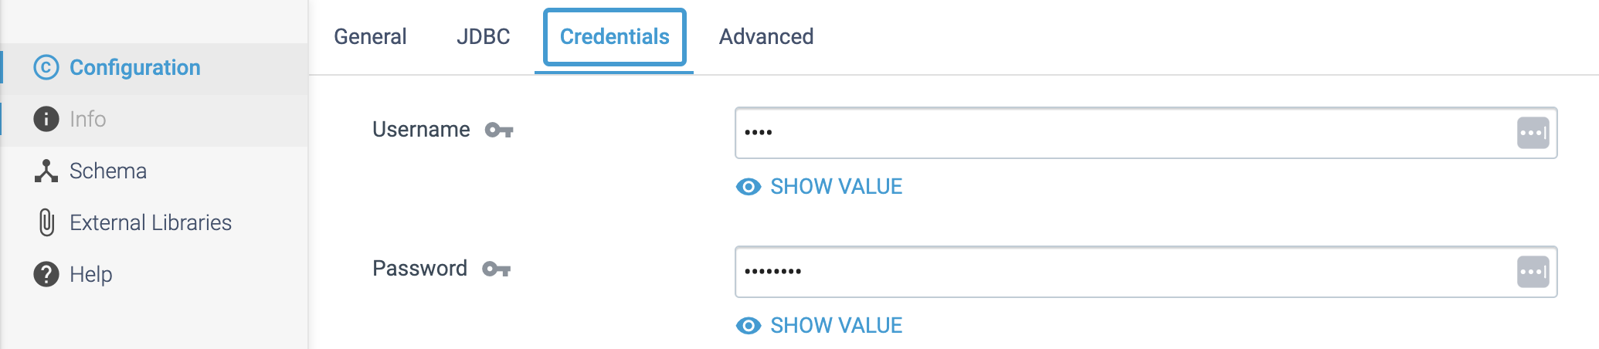

Step 3: On the **Advanced** tab, optionally configure the following properties.

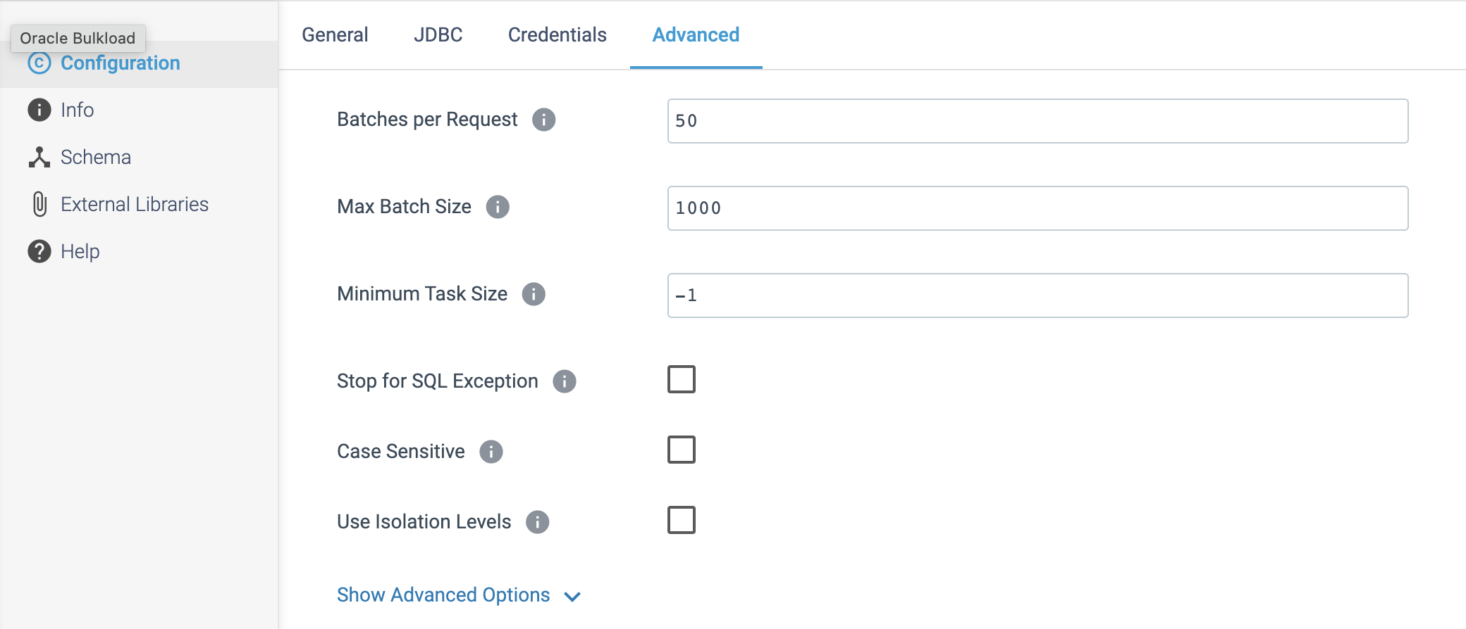

**ORIGIN NAME:** Oracle CDC Client

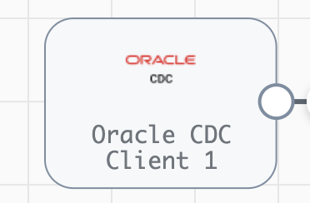

**Engine Type**: Data Collector

**Pipeline Name:** D_Oracle_snowflake_Pipeline_CredStr

**Description**: The **Oracle CDC Client** origin processes change data capture (CDC) information provided by Oracle LogMiner redo logs.

We need to configure the **Oracle CDC Client** origin in a following way.

Step 1: Click on the **Oracle CDC Client** origin to configure change data capture details, such as the **schema** and **tables** to read from, how to read the **initial change**, the **dictionary source** location, and the **operations** to include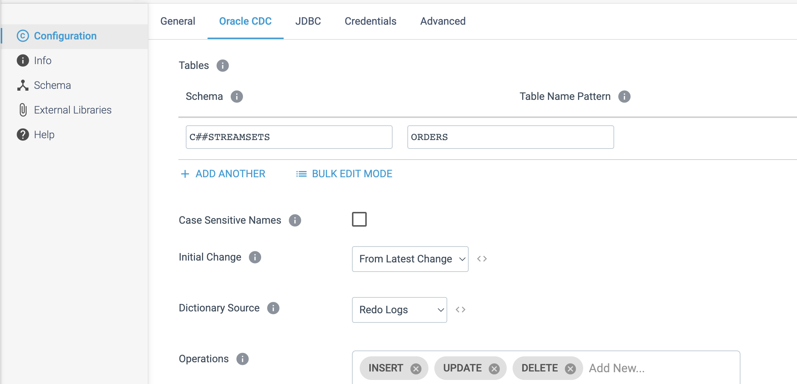

Step 2: We can also specify the **transaction** window and **LogMiner session** windows in **Oracle CDC** tab.

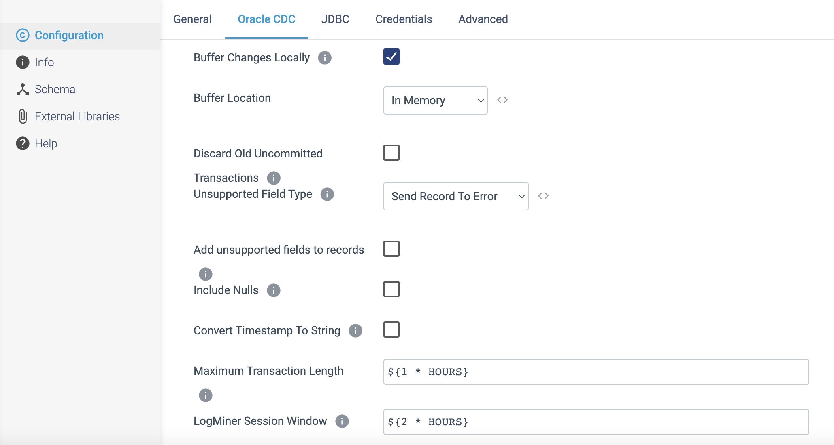

Step 3: On the **JDBC** tab, Specify the connection information.

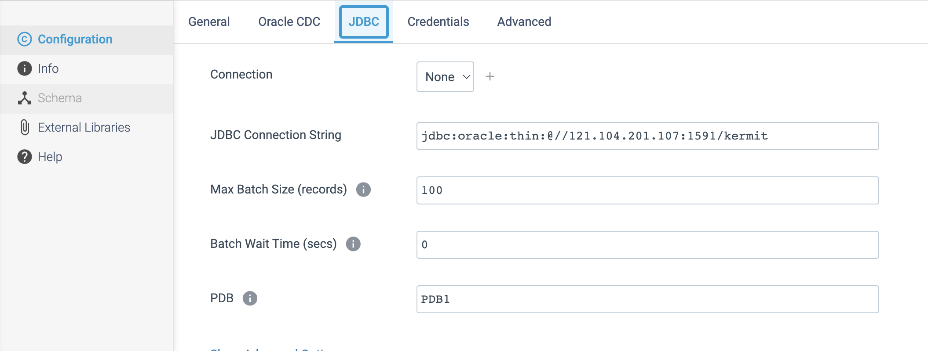

Step 4: On the **credentials** tab, specify the JDBC Credentials such as **username** and **password**.

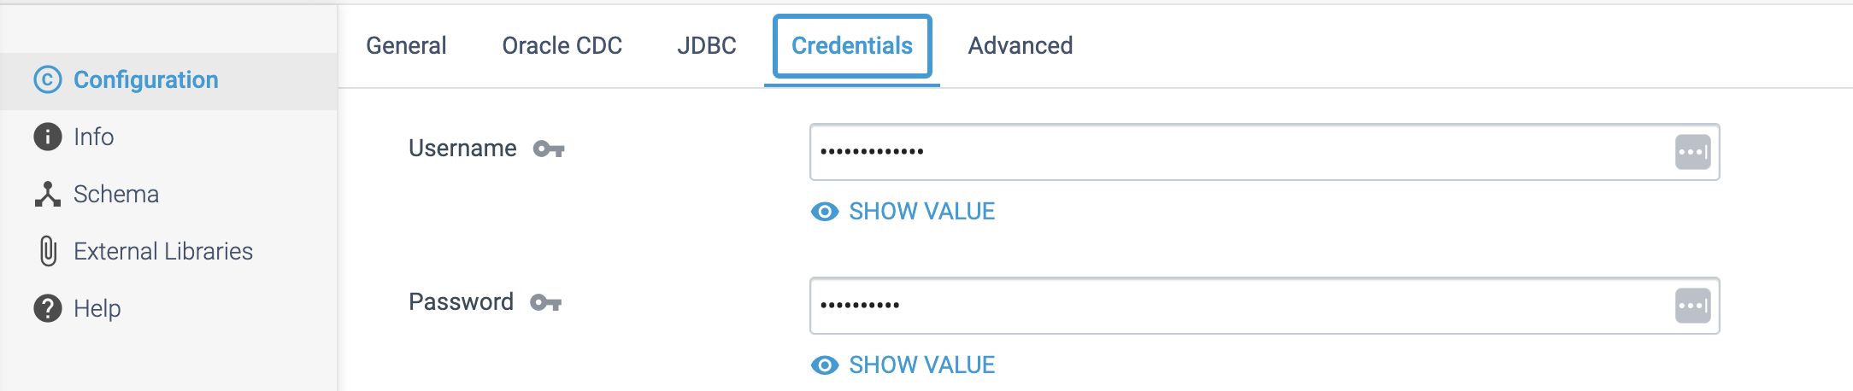

Step 5: On the **Advanced** tab, optionally configure advanced properties.  
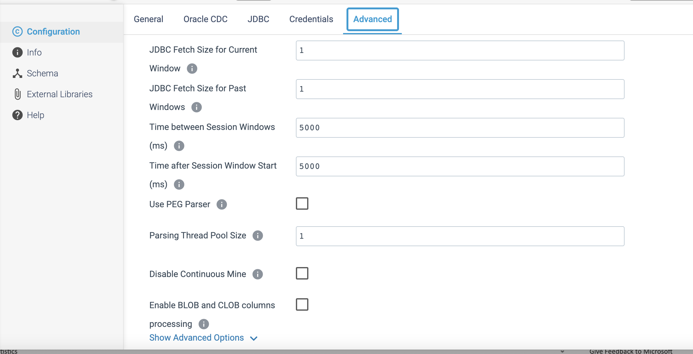

**ORIGIN NAME:** Oracle CDC

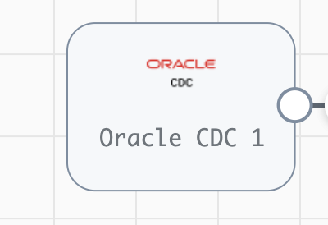

**Engine Type**: Data Collector

**Pipeline Name:** D_Oracle_snwflke_fileloadr_Pipeline_CredStr

**Description**: The **Oracle CDC** origin processes change data capture (CDC) information stored in redo logs and accessed using Oracle LogMiner.

We need to configure the **Oracle CDC** origin in a following way.

Step 1: Click on the **Oracle CDC** origin to specify change data capture details, such as the **schemas** and **tables** to read from, how to read the initial change, and the operations to include. You specify an initial change or time to start processing, transaction details, and uncommitted transaction handling.

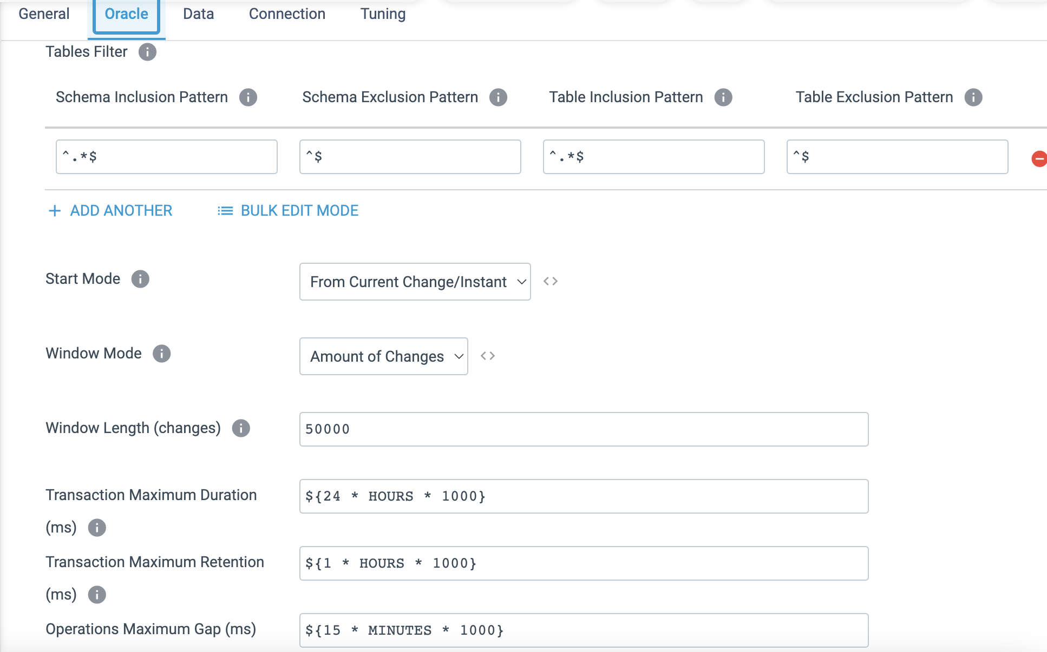

Step 2: On the **Data** tab, set the **Record Format** property to **Basic**.

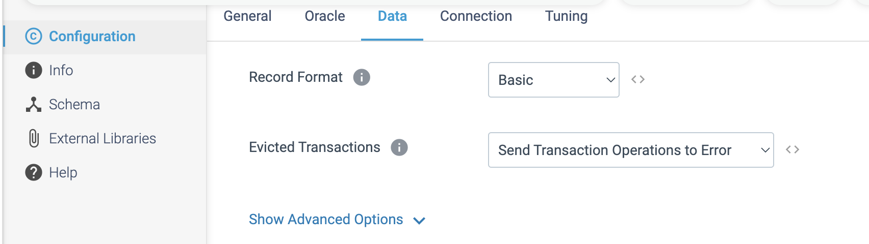

Step 3: Click on the **Connection** tab to specify JDBC connection information and user credentials.

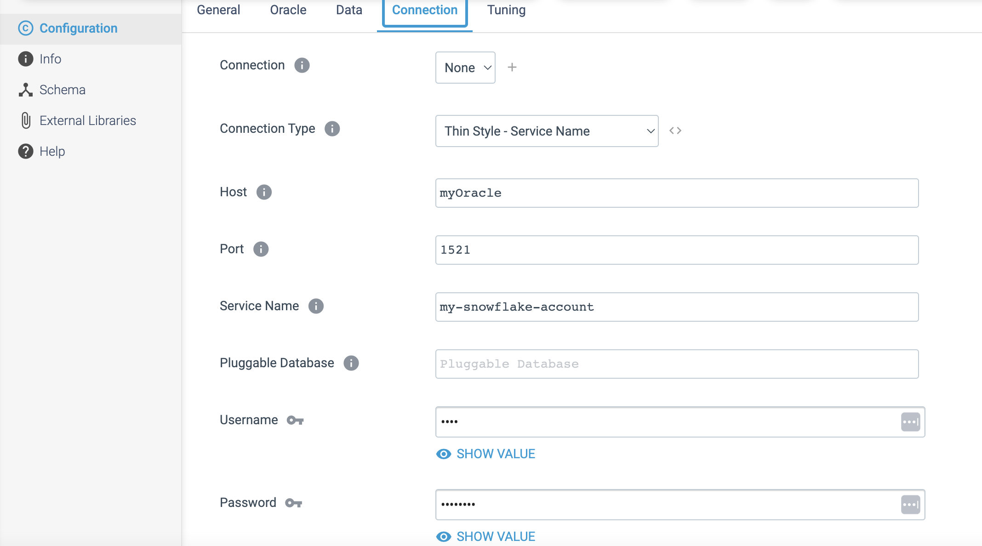

Step 4: Optionally, on the **Tuning** tab, configure below properties to tune the performance of the origin.

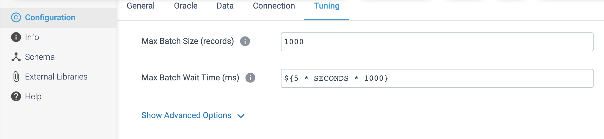

**ORIGIN NAME:** RabbitMQ Consumer

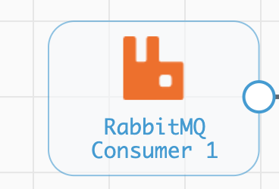

**Engine Type**: Data Collector

**Pipeline Name:** D_RabbitMQ_Orgn_Dest_Pipeline_Cred

**Description**: **RabbitMQ Consumer** reads AMQP messages from a single RabbitMQ queue.

We need to configure the **RabbitMQ Consumer** origin in a following way.

Step 1: Click on the **RabbitMQ Consumer** origin to specify the Connection information needed to connect. Enable **Use Credentials** checkbox, if it needs.

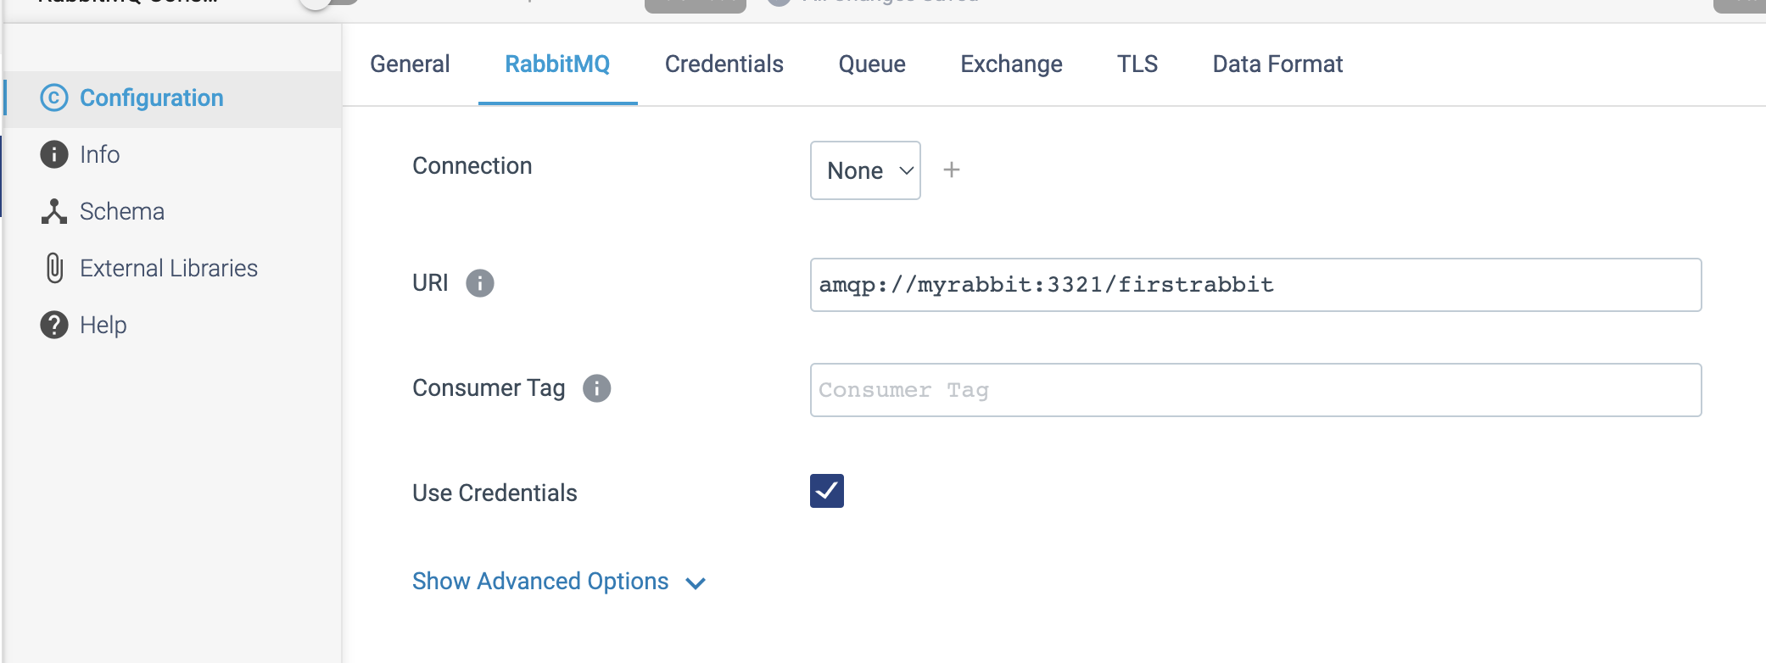

Step 2: Click on the **Credentials** tab to specify the connection information.

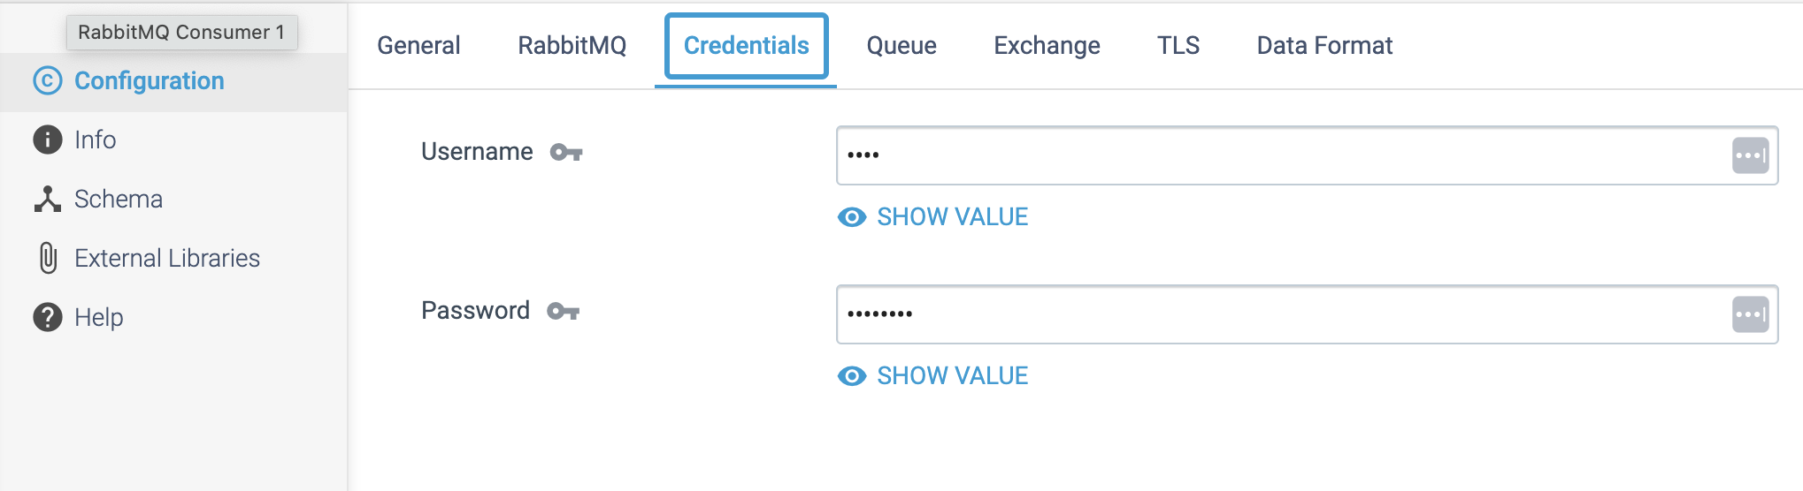

Step 3: Click on the **Queue** tab to define the queue name and other properties. If a queue of the specified name does not exist, **RabbitMQ** creates the queue based on the properties that you defined.

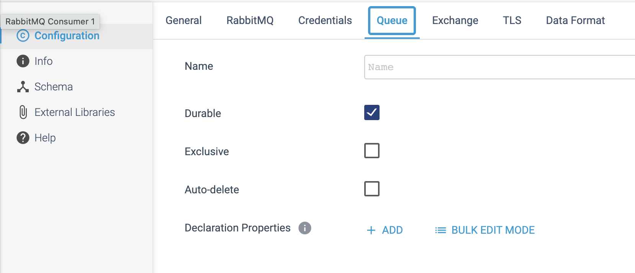

Step 4: On the **Exchange** tab, optionally configure the following binding properties for the bindings that you want to use. When no bindings are configured, the default exchange is used.

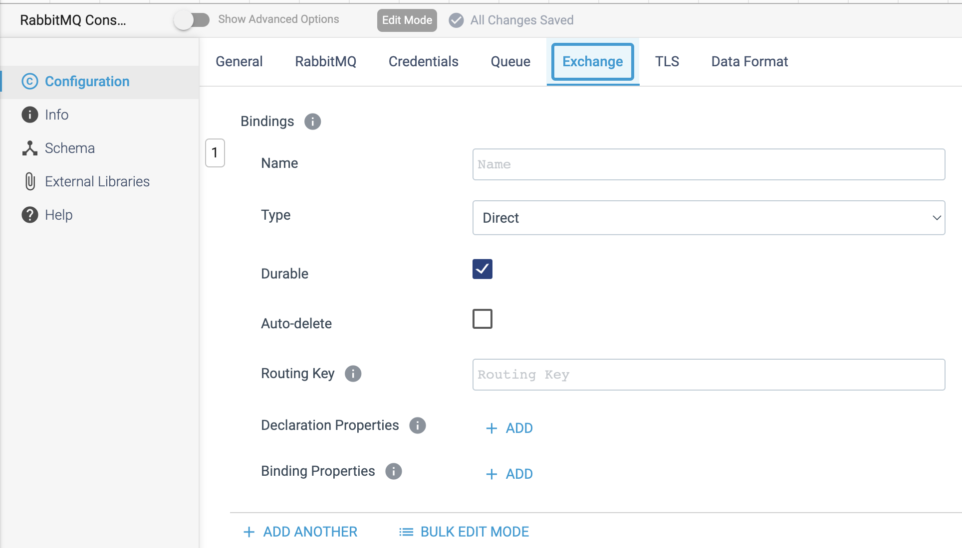

Step 5: The RabbitMQ Consumer origin processes data differently based on the given data format.

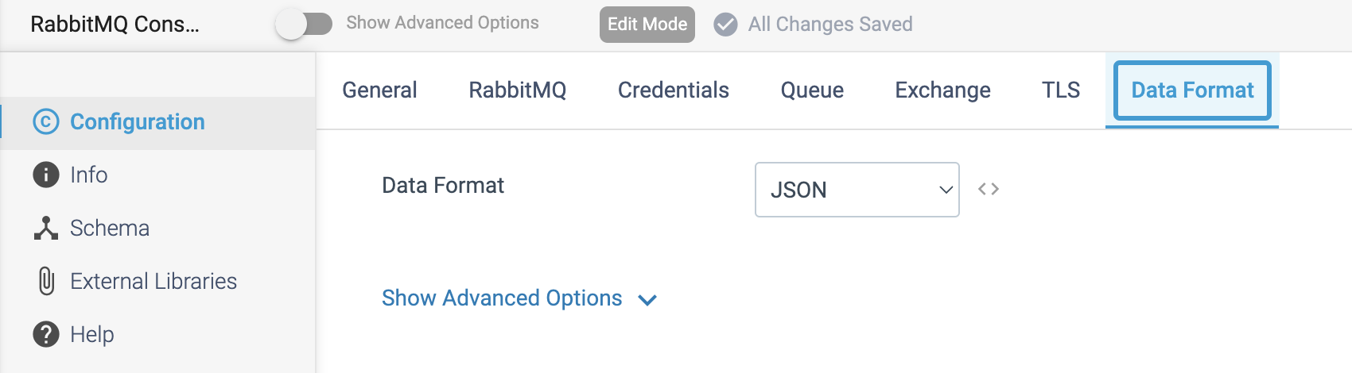

**ORIGIN NAME:** Redis Consumer

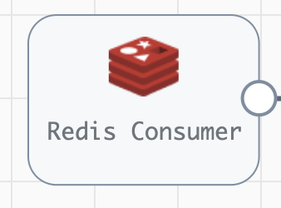

**Engine Type**: Data Collector

**Pipeline Name:** D_Redis_orgn_Dest_Pipeline_URI

**Description**: The **Redis Consumer** origin reads messages from Redis.

We need to configure the **Redis Consumer** origin in a following way.

Step 1: Click on the **Redis Consumer** origin to define the Redis URI and the channels to read from.

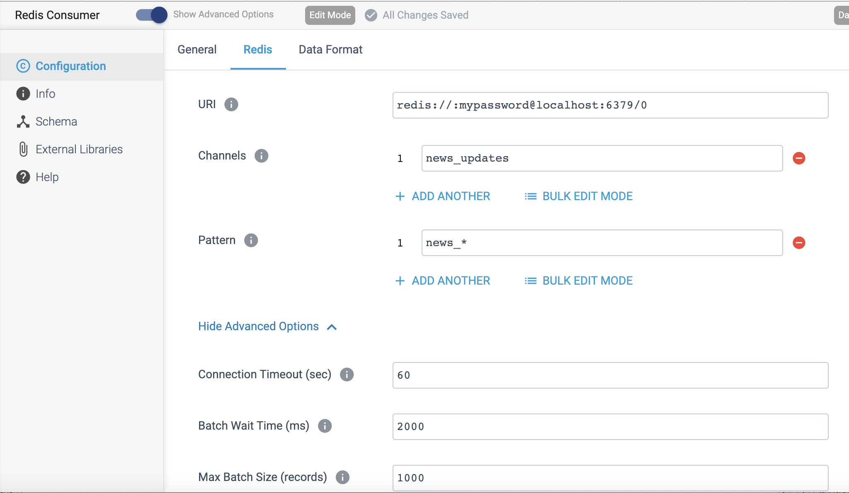

Step 2: The **Redis Consumer** processes data differently based on the given below data format.

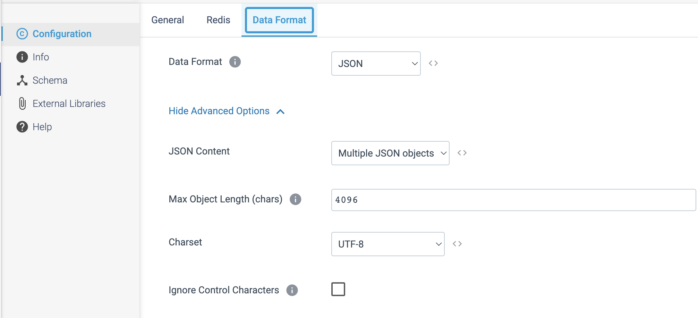

**ORIGIN NAME:** Salesforce

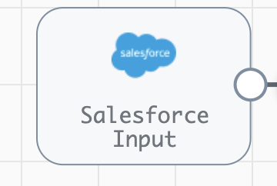

**Engine Type**: Data Collector

**Pipeline Name:** D_Salesfrce_orgn_Dest_Pipeline_Cred

**Description**: The **Salesforce** origin reads data from Salesforce with the SOAP or Bulk API.

We need to configure the **Salesforce** origin in a following way.

Step 1: Click on the **Salesforce** origin to specify the authentication to use.

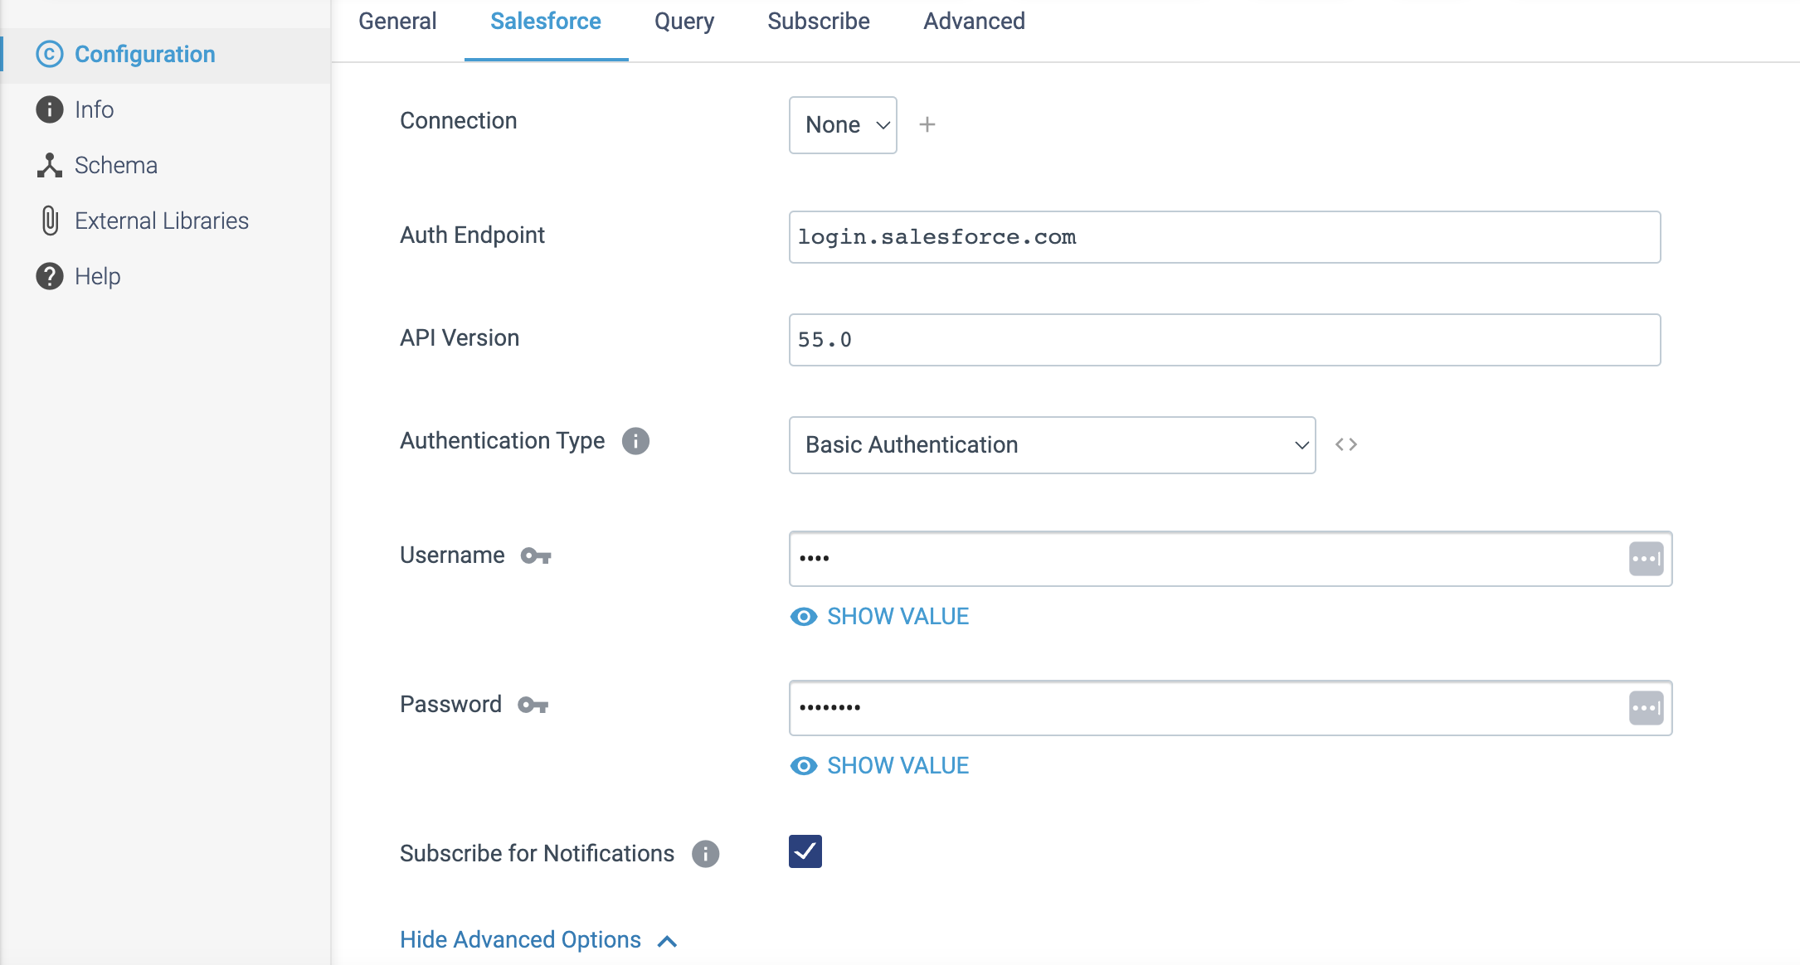

Step 2: Click on the **Query** tab to use the **SOAP or Bulk API** to query existing Salesforce data. When querying existing data, we need to define the below **SOQL query** and related properties to determine the data returned from Salesforce.

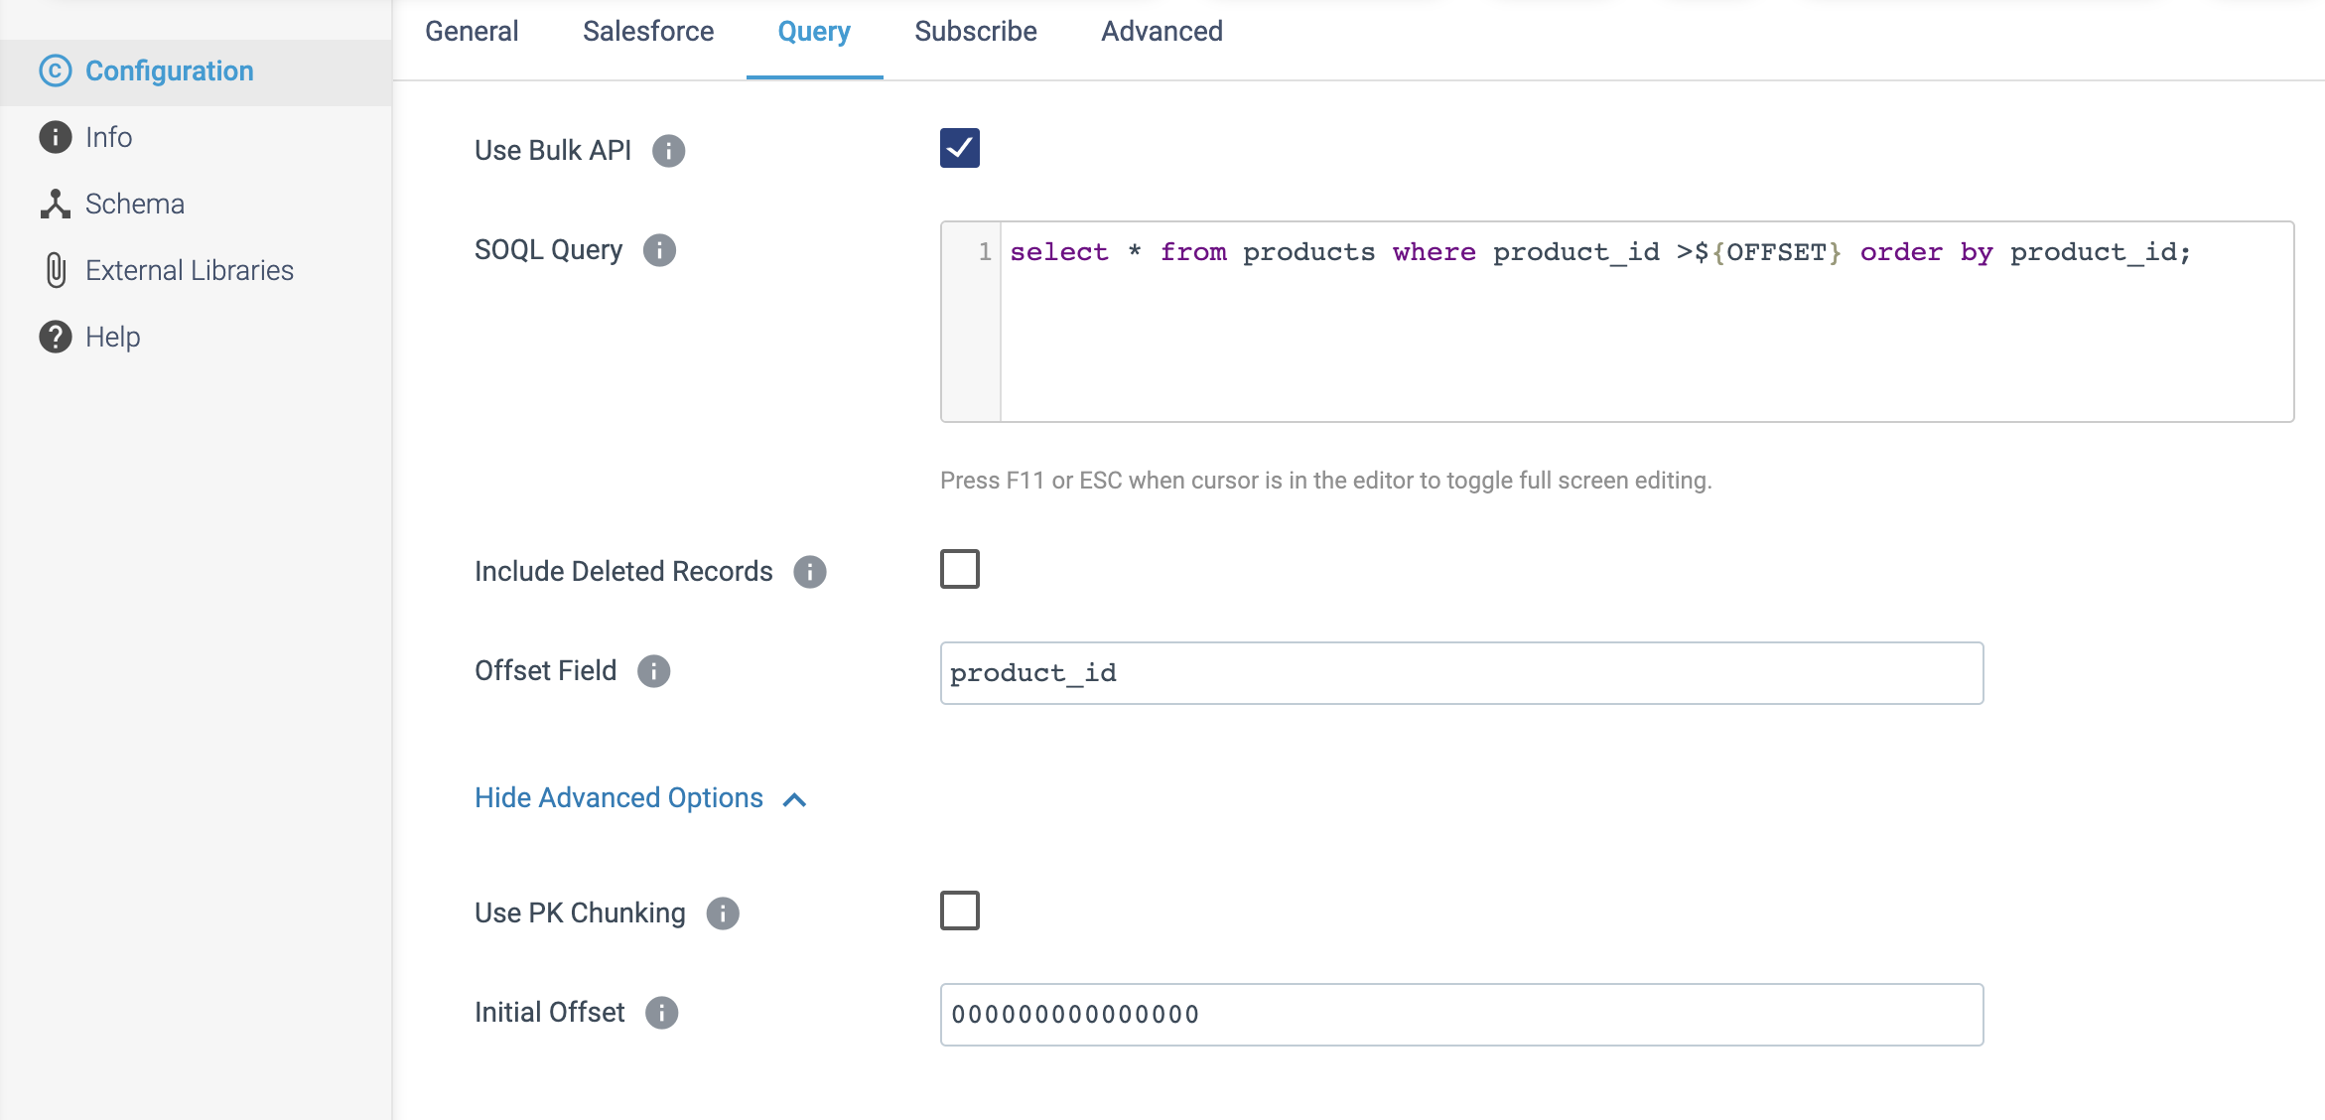

Step 3: Click on the **Subscribe** tab to specify the name of the **PushTopic** to subscribe the notifications.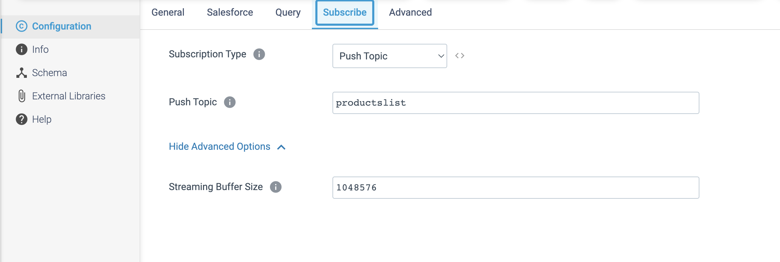

Step 4: On the **Advanced** tab, configure the following properties:

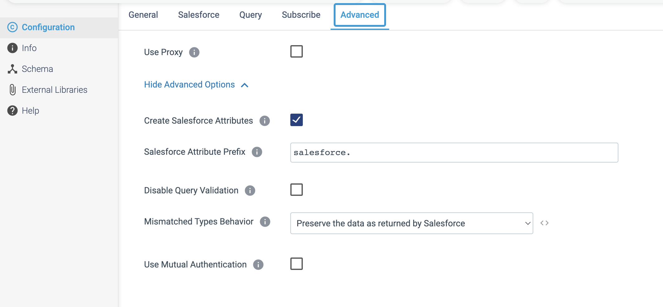

**ORIGIN NAME:** Salesforce Bulk API 2.0

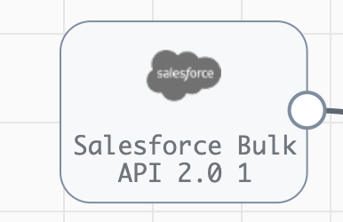

**Engine Type**: Data Collector

**Pipeline Name:** D_Salesfrcebulk_orgn_Dest_Pipeline_Cred

**Description**: The **Salesforce Bulk API 2.0** origin reads existing data from Salesforce using Salesforce Bulk API 2.0. and to read from Salesforce with the SOAP or Bulk API, or to subscribe to notifications.

We need to configure the **Salesforce Bulk API 2.0.** origin in a following way.

Step 1: Click on the **Salesforce Bulk API 2.0.** origin to specify the authentication to use.

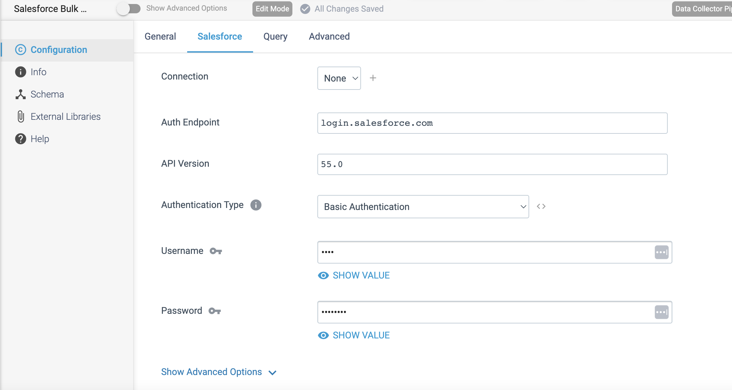

Step 2: Click on the **Query** tab to define the **SOQL query** and related properties to determine the data returned from Salesforce.

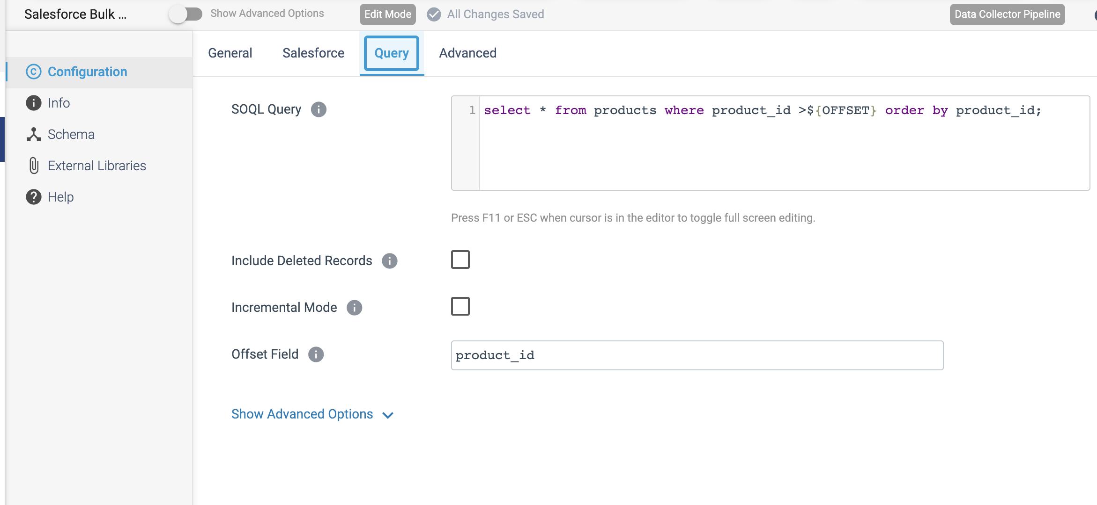

Step 3: On the **Advanced** tab, enable **Use Proxy** checkbox, if Salesforce want to connect via proxy server.

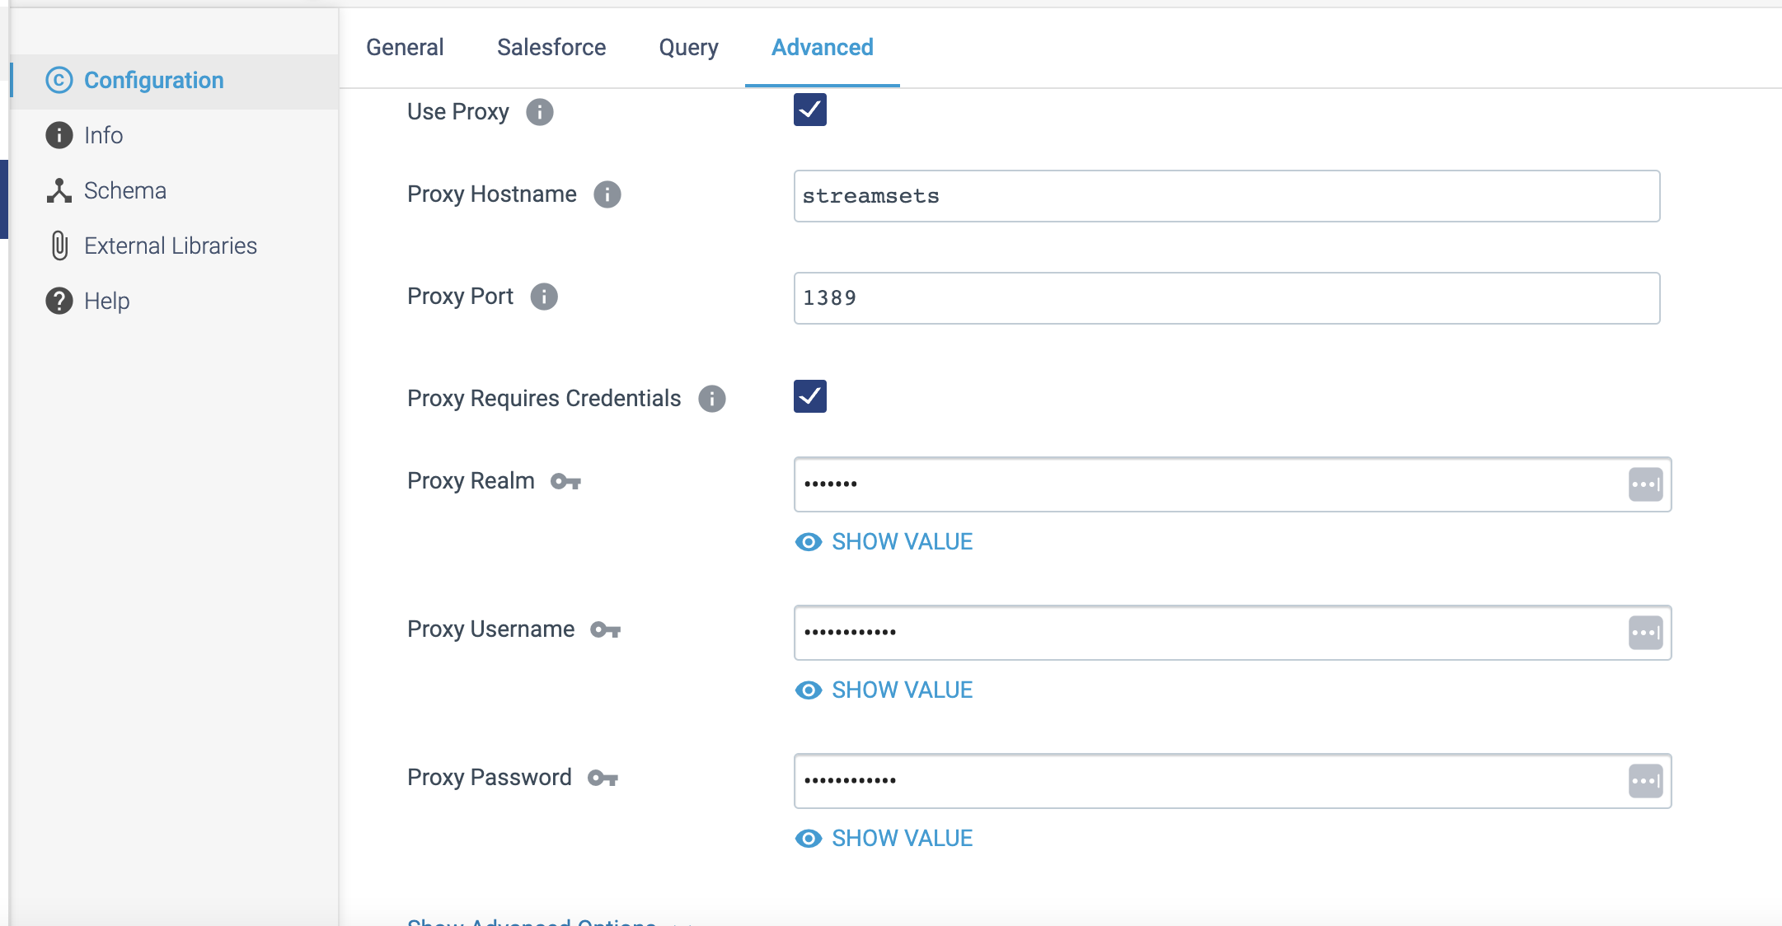

**ORIGIN NAME:** SAP HANA Query Consumer

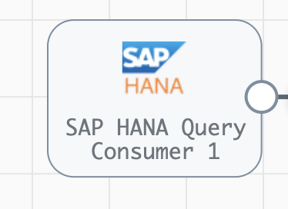

**Engine Type**: Data Collector

**Pipeline Name:** D_SAP_Cons_orgn_Snglestre_Dest_Pipeline_CredStr

**Description:** The **SAP HANA Query Consumer** origin reads from an SAP HANA database using the specified SQL query.

We need to configure the **SAP HANA Query Consumer** origin in a following way.

Step 1: Click on the **SAP HANA Query Consumer** origin to specify **connection** informationand configure the query mode, **SQL query** and related information to define the data returned by the database. We can call stored procedures from the SQL query if necessary.

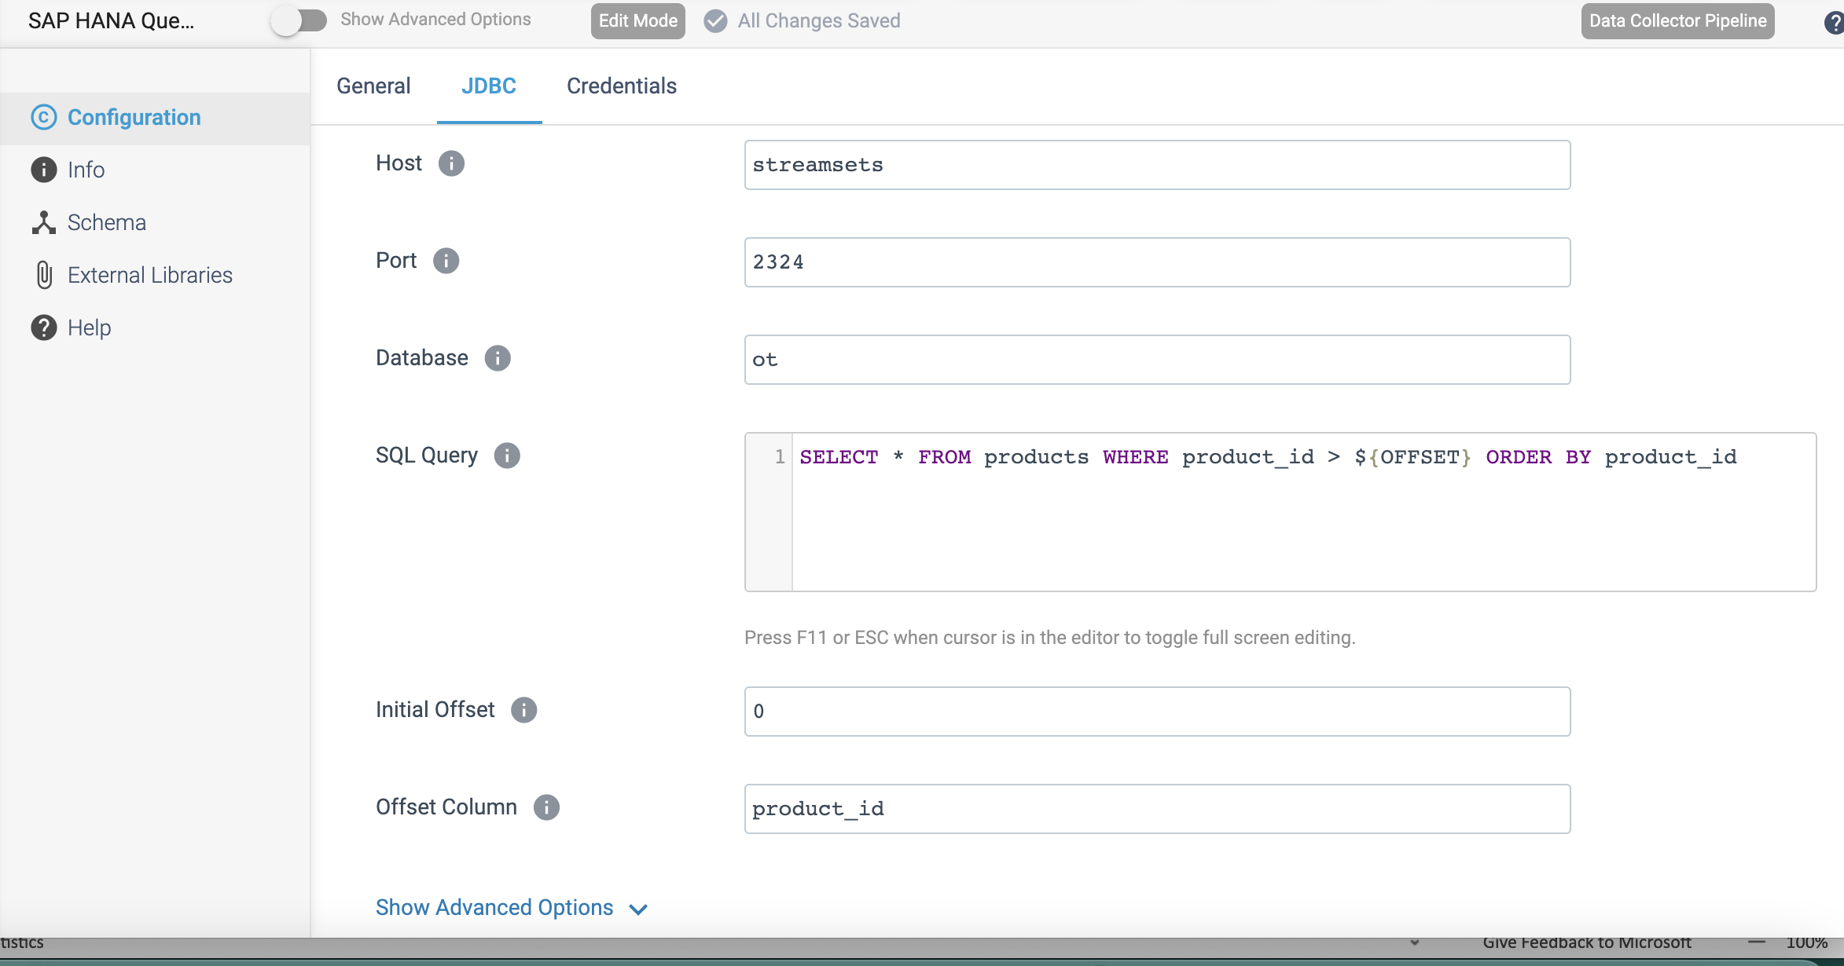

Step 2: Click on the **Credentials** tab to define the required Credentials.

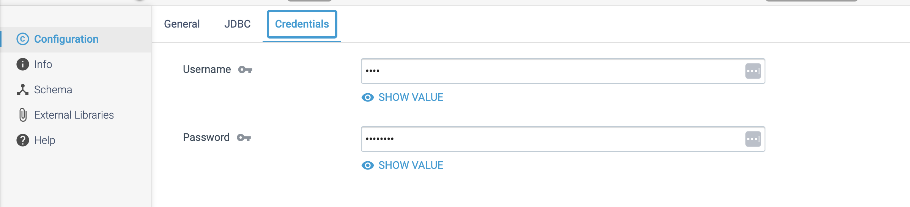

**ORIGIN NAME:** SQL Server 2019 BDC Multitable Consumer

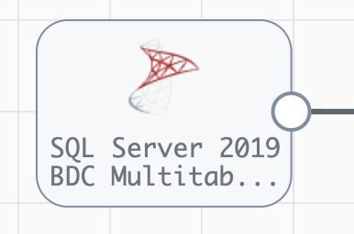

**Engine Type**: Data Collector

**Pipeline Name:** D_Sqlsrvr_Cons_orgn_Snglestre_Dest_Pipeline_CredStr

**Description:** The **SQL Server 2019 BDC Multitable Consumer** origin reads data from Microsoft SQL Server 2019 Big Data Cluster (BDC) through a JDBC connection.

We need to configure **SQL Server 2019 BDC Multitable Consumer** origin in a following way.

Step 1: Click on the **SQL Server 2019 BDC Multitable Consumer** origin to specify connection information and optional custom JDBC configuration properties to determine how the origin connects to SQL Server 2019 BDC.

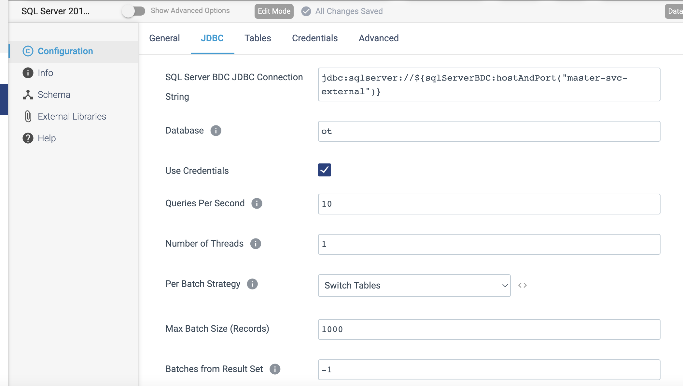

Step 2: Click on the **Tables** tab to specify a database and then define groups of tables to read from that database.

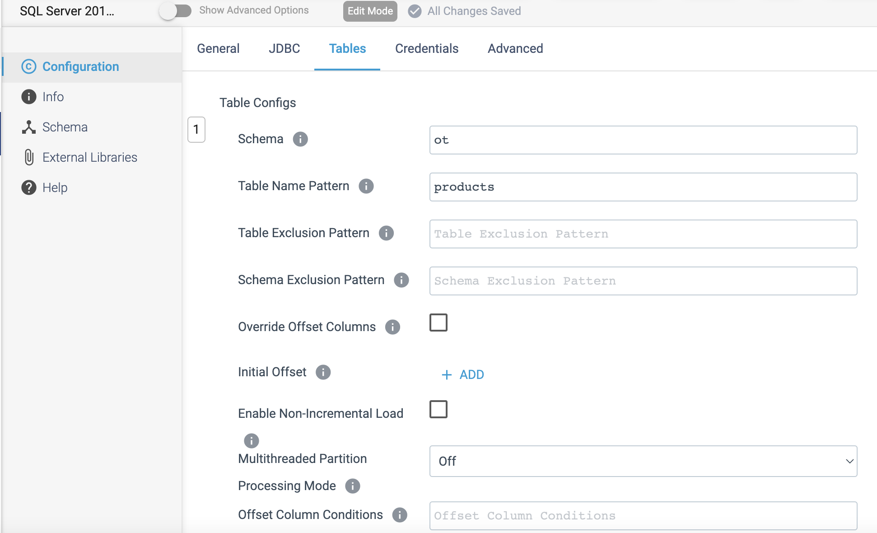

Step 3: Click on the **Credentials** tab to define the credentials.

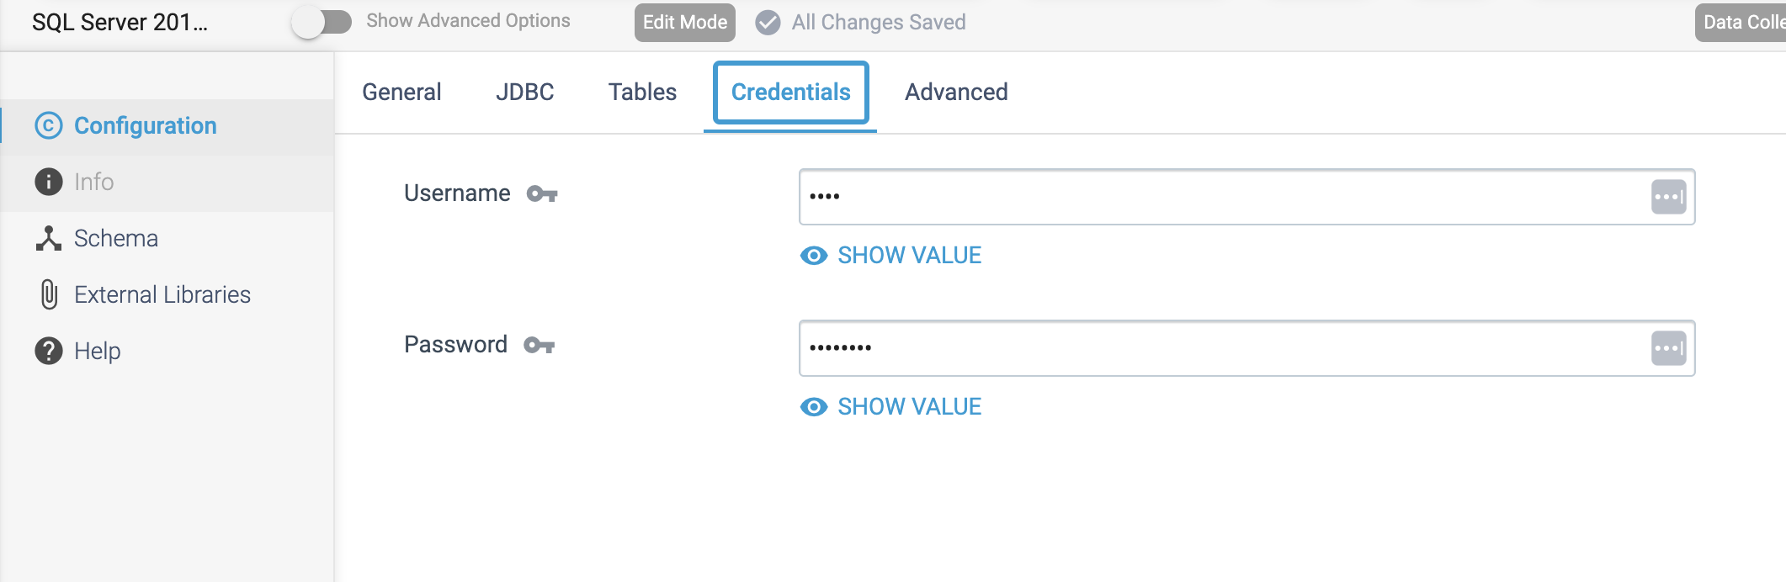

Step 4: On the **Advanced** tab, optionally configure advanced properties.  
The defaults for these properties should work in most cases.

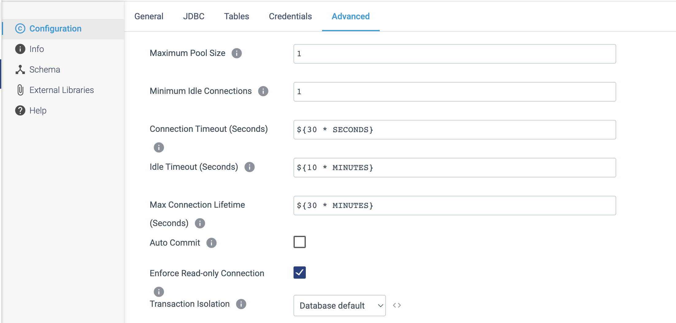

**ORIGIN NAME:** SQL Server CDC Client

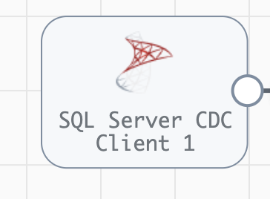

**Engine Type**: Data Collector

**Pipeline Name:** D_Sqlsrvr_CDC_orgn_Snglestre_Dest_Pipeline_CredStr

**Description:** The **SQL Server CDC Client** origin processes data in Microsoft SQL Server change data capture (CDC) tables. The origin fetches changes in time windows and uses multiple threads to enable parallel processing of data.

We need to configure the **SQL Server CDC Client** origin in a following way.

Step 1: Click on the **SQL Server CDC Client** origin to specify connection information, a query interval, number of retries, and any custom JDBC configuration properties that we need.

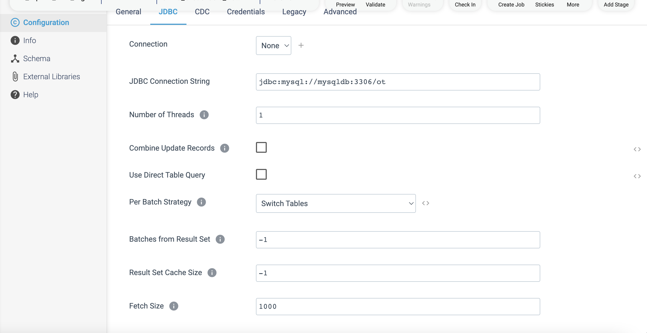

Step 2: Click on CDC tab to specify the SQL Server **capture instance names** - the origin processes the related CDC tables. We can define groups of tables in the same database and any initial offsets to use. When we omit initial offsets, the origin processes all available data in the CDC tables.

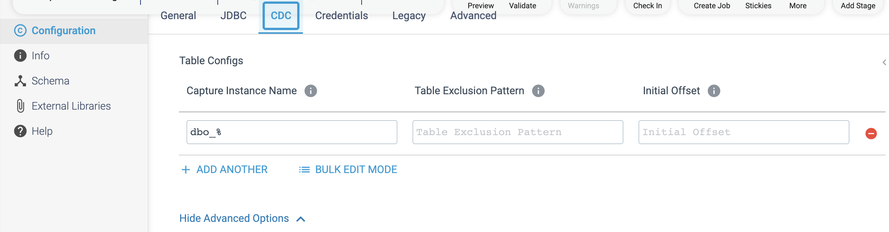

Step 3: Click on the **Credentials** tab to define the credentials.

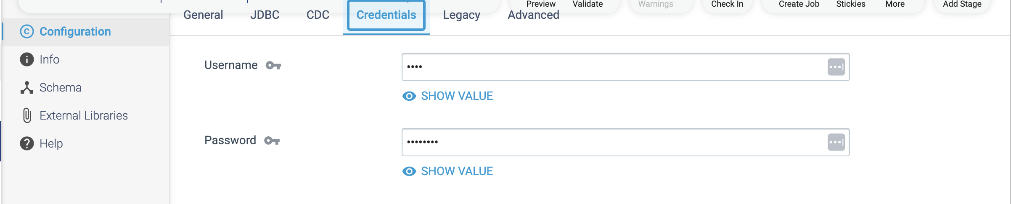

Step 4: When using JDBC versions older than 4.0, on the **Legacy Drivers** tab, optionally configure the following properties.

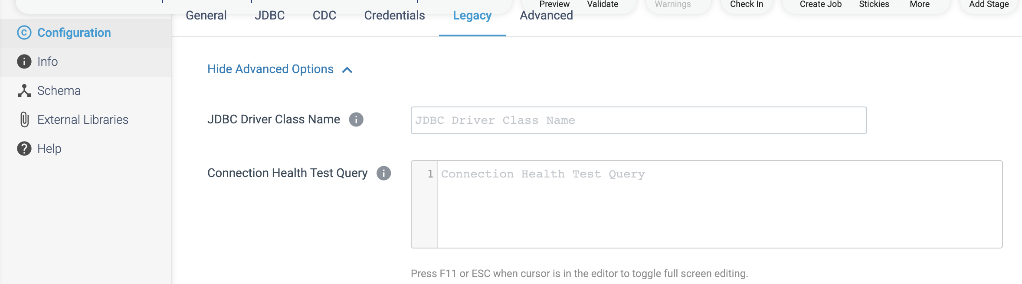

Step 5: On the **Advanced** tab, optionally configure advanced properties.  
The defaults for these properties should work in most cases.

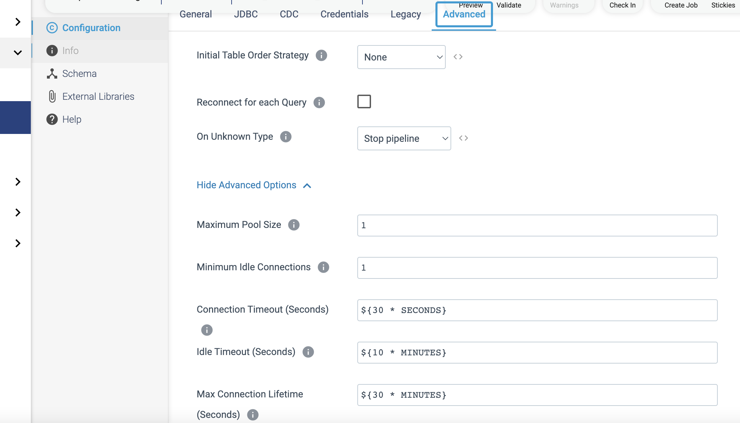

**ORIGIN NAME:** SQL Server Change Tracking

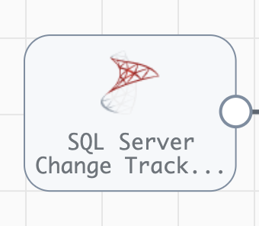

**Engine Type**: Data Collector

**Pipeline Name:** D_SQLChngeTrckng_Orgn_Splnk_Dest_Pipeline_CredStr

**Description:** The **SQL Server Change Tracking** origin processes data from Microsoft SQL Server change tracking tables.

We need to configure the **SQL Server Change Tracking** origin in a following way.

Step 1: Click on the **SQL Server Change Tracking** origin, to specify connection information.

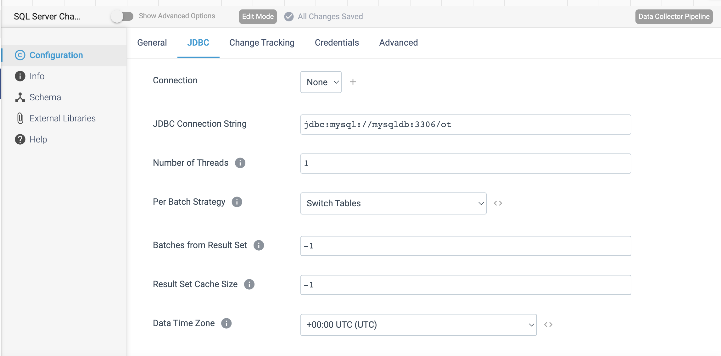

Step 2: Click on the Change Tracking tab to define groups of change tracking tables in the same database and any initial offsets to use. When we omit initial offsets, the origin processes only incoming data.

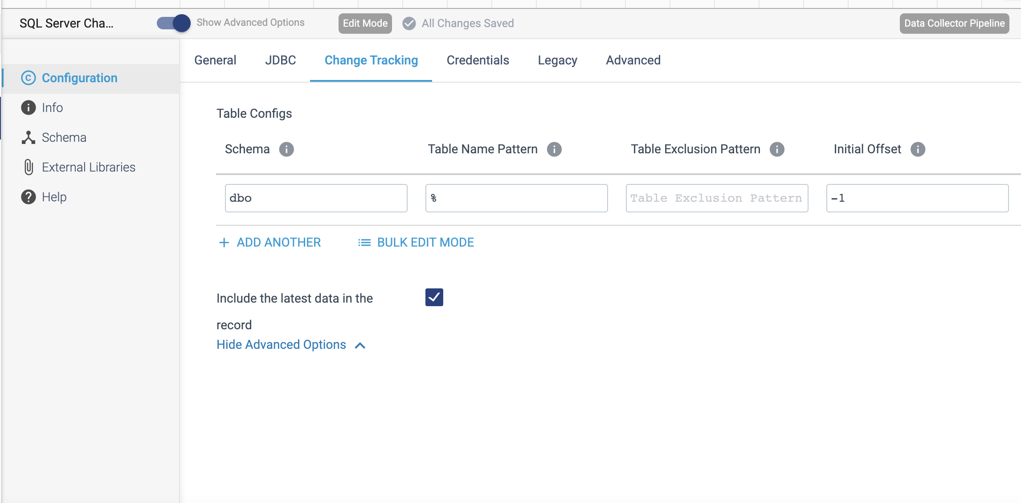

Step 3: Click on the **Credentials** tab to define the credentials.

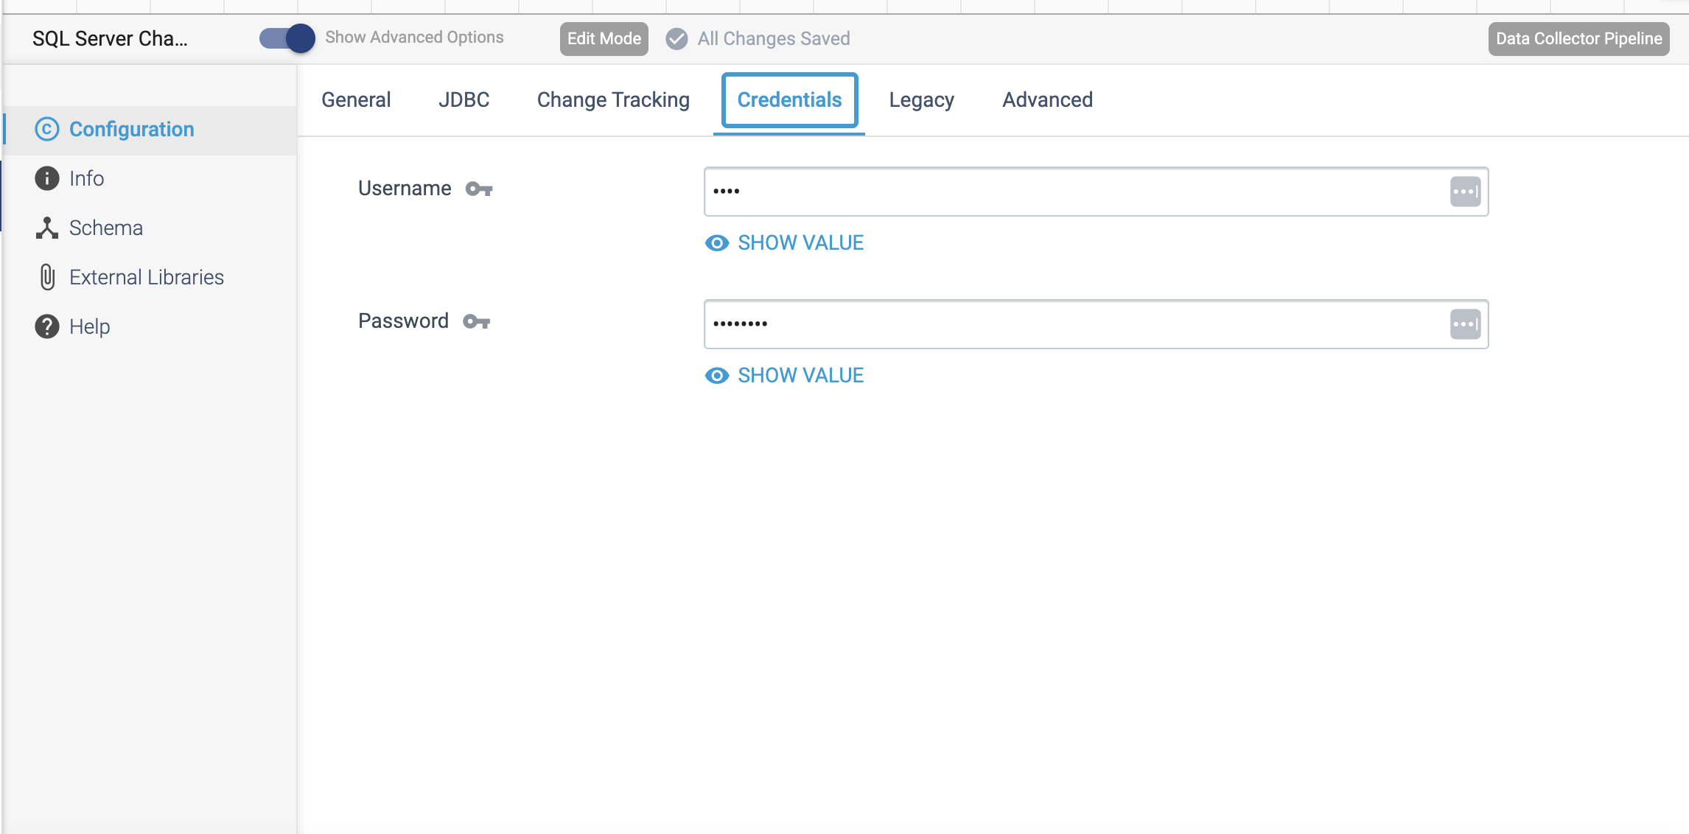

Step 4: When using JDBC versions older than 4.0, on the **Legacy Drivers** tab, optionally configure the following properties.

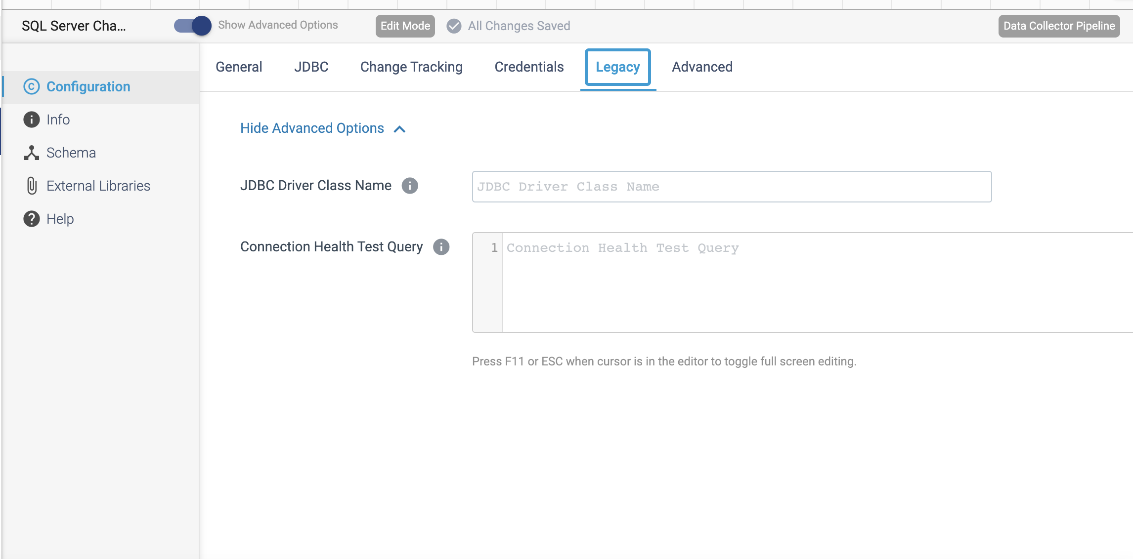

Step 5: On the **Advanced** tab, optionally configure advanced properties.  
The defaults for these properties should work in most cases.

